Laboratory simulation: Projectile Motion
Go to link: https://phet.colorado.edu/en/simulation/projectile-motion
PART A
Procedure:
- Set the cannon at angle θ = 60⁰ and set the speed of the projectile to 15 m/s . Launch the projectile and observe its trajectory.

- Use the virtual tape to measure the range (maximum x ) and the height (maximum y ) of the projectile. Record the values in Data table 1

DATA TABLE 1.
Angle, θ (degrees) | Speed, $v_{o}$ (m/s) | Range, x (m) | Height, y (m)

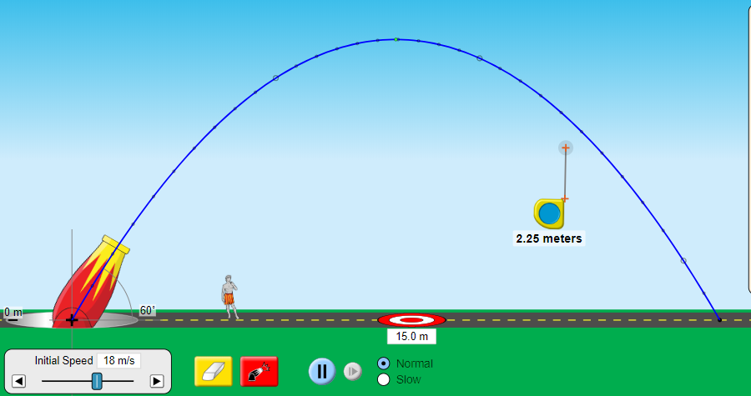
Simulation PHET

Procedure for Calculations:
- Calculate $v_{ox}$ and $v_{oy}$
$v_{ox}=v_{o }$cos θ

$v_{oy}=v_{o }$sin θ

- Calculate the time it takes for the projectile to reach the max height ( $g=9.8 m/s^{2}$ ) :

$$t_{up}=\frac{v_{oy}}{g}$$

- Calculate the total time of the flight $t_{total}=2 × t_{up}$

- Calculate x using equation

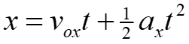

- Calculate y using equation

CALCULATION TABLE 1.
$$v_{ox}(m/s)$$ | $$v_{oy} (m/s)$$ | $t_{up}$(s) | $t_{total}$(s) | Range x (m) | Height y (m)

- Find the percentage error for Range x

$$\%err=\frac{\left|x_{th}- x_{exp}\right|}{x_{th}}×100\%$$

- Find the percentage error for Height y
$$\%err=\frac{\left|y_{th}- y_{exp}\right|}{y_{th}}×100\%$$

PART B
Procedure:
- Set the cannon at angle θ = 75⁰, and set the speed of the projectile to 18 m/s. Launch the projectile. Measure the range and record the value in Data Table 2

- Repeat the procedure in Step 1 for θ = 65⁰ and the angles in the table below:

DATA TABLE 2.

Angle, θ (degrees) | Range, x (m)
75⁰

65⁰

55⁰

45⁰

35⁰

25⁰

- Based on your measurements, at what angle was the range the greatest?

______________________________________

- For the angle in part 5, calculate Range x using the PART A calculation procedure.
CALCULATION TABLE 2.
$$v_{ox}(m/s)$$ | $$v_{oy} (m/s)$$ | $t_{up}$(s) | $t_{total}$(s) | Range x (m)

- Find the percentage error for Range x

$$\%err=\frac{\left|x_{th}- x_{exp}\right|}{x_{th}}×100\%$$

PART C
Challenge: Turn on ‘Air Resistance’. Investigate how the presence of air affects the trajectory of the projectile. How does the range of the projectile change?
________________________________________________________________________________
________________________________________________________________________________
________________________________________________________________________________
________________________________________________________________________________

