College of Applied Physics and Astronomy
Physics for Health Sciences Laboratory
Motion along a straight line with constant acceleration
(Free Fall)
A worksheet using https://phet.colorado.edu/sims/html/projectile-motion/latest/projectile-motion_en.html interactive simulation

Name: …………………………………. | ID:………………………………………….

Objectives:
- Study motion with uniform acceleration.
- Study the free fall motion as example for uniformly accelerated motion.
- Learn to analyze graphical results.

Theory:
A uniformly accelerated motion is the motion that undergoes along straight line with uniform (constant) acceleration. For an object falls freely from rest, it undergoes under the influence of gravity, and it will accelerate by the acceleration due to gravity g. The object’s motion can be described using the equation of one-dimensional motion with constant acceleration, which are:
$v=v_{o}+at$ (1)
$y=y_{o}+v_{o}t+\frac{1}{2}at^{2}$ (2)
Assuming that the object falls from rest (v_{o} = 0) and initial position y_{o} = 0, then the object’s speed and distance traveled can be described in the equations:
$y=\frac{1}{2}gt^{2}$ (3)
$v=gt$ (4)
Where v is the object’s speed, g is the acceleration due to gravity, t is the time interval, y is the distance traveled.
The motion of the free-falling object can be described graphically using the previous equations as follows:
The position time graph using equation (5), the curve is an opens parabola as shown in graph (1) where the slope of the tangent at a time is the instantaneous velocity of the object at that time.
And the acceleration due to gravity g can be determined using the formula.
g = 2×A ... (5)
where A is the factor of t² in the equation of the graph.
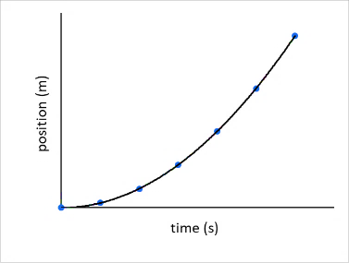

Graph (1)
The velocity time graph using equation (6), as the speed of the object is directly proportional with time, it will be a straight line as shown in graph (2).
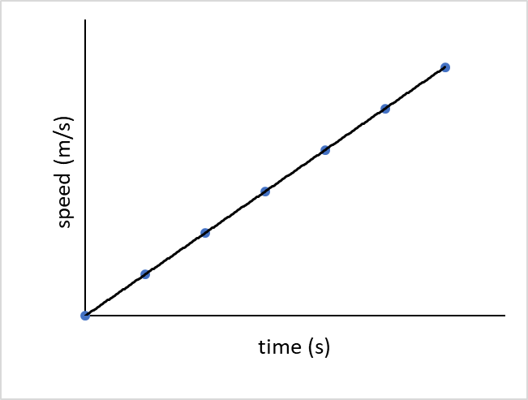

Graph (2)
Where the slope of the curve represents the acceleration of the object.
$slope=\frac{∆v}{∆t}=acceleration=g$
The area under the curve represent the distance traveled by the object during the time interval.
acceleration time graph the acceleration doesn’t change with time.
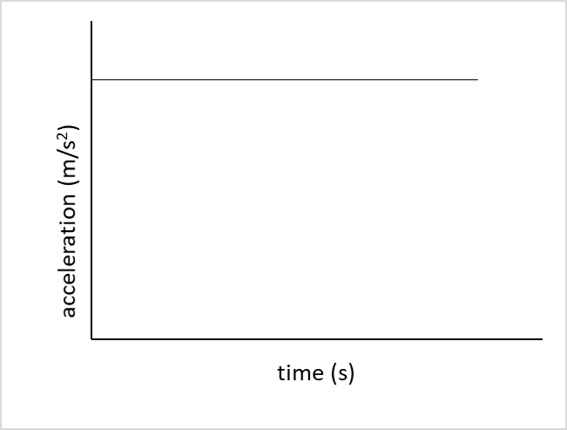

Graph (3)
The acceleration of the object is the mean value of the measured values.
Procedure:
- Visit Phet interactive simulation using the link below, then explore the simulation and find out the uses of each tap and panel so you get familiar with it.
https://phet.colorado.edu/sims/html/projectile-motion/latest/projectile-motion_en.html
- Fix the options in the right box as shown in graph (4). Th height of the cannon can change by dragging the plus sign. Then rotate the cannon so the angle is - 90˚.
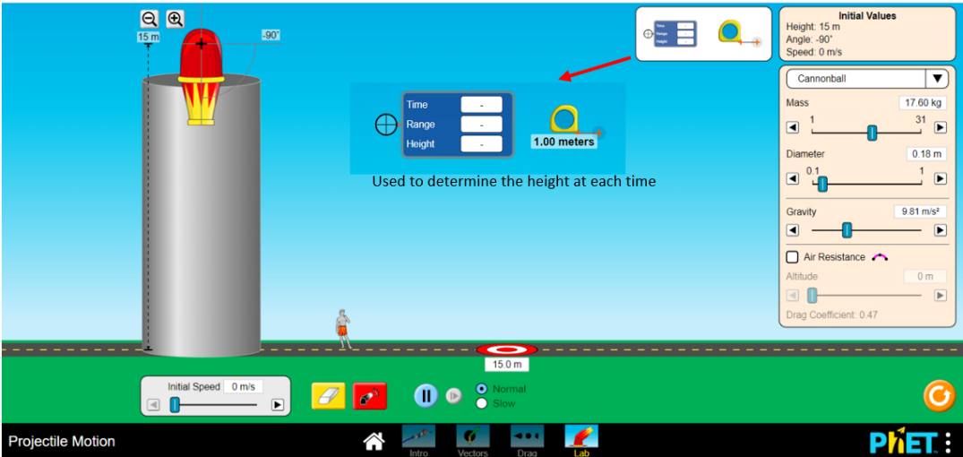

Graph (4)
- Click on the red button to release the cannonball from rest (Free Fall).
- Drag the the blue tool to determine the time with the corresponding height and fix it on the points for the path of the cannonball as shown in graph (5).
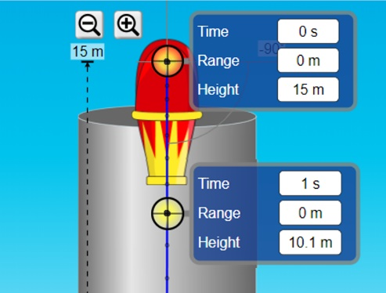

Graph (5)
- Record the time and the height in table (1).

Data analysis:
- Record your data for the height (y) and the time (t) in table (1).

Table (1)
t (sec) | y (m) | V (m/s)
- Using excel plot a graph for x vs t, then use the polynomial function (power 2).
- Display the equation of the graph.
- Derive the equation of the x vs t graph to get the velocity time equation.
- Use the v-t equation to calculate the speed of the object and record your answers in table (1).
- Plot v vs t graph and choose the linear fit, then display the equation of the graph.
- Derive the v-t equation and calculate the acceleration of the cannonball.
- Does the acceleration of the cannonball change with time? plot a vs t graph.
- Determine the acceleration of the cannonball using the three graphs:
- Position time graph:

- Velocity time graph:

- Acceleration time graph:

- Calculate the % error for the acceleration due to gravity (g = 9.81 m/s²) with each result in step 9.

- Calculate the area under the v-t curve. What does it represent?

