College of Applied Physics and Astronomy
Physics for Health Sciences Laboratory
Equilibrium of Forces at Body Joint
(static equilibrium)
Worksheet using https://phet.colorado.edu/sims/html/vector-addition/latest/vector-addition_en.html interactive simulation
Name: ……………………………………. ID: …………………………..

objectives:
- Learn how to represent vectors in space.
- Study the static equilibrium using vector analysis.
- Determine the resultant vector of adding two and three vectors.
  - Theory:
Any vector quantity can be represented as a line segment where its length represents the magnitude of the vector, and the angle θ represent the direction of the vector as shown in figure (1). A vector can be resolved into two components; x – component (a_{x}) and y – components (a_{y}), their magnitudes can be determined using the equations:
a_{x} = a cos θ ... (1)
a_{y} = a sin θ ... (2)
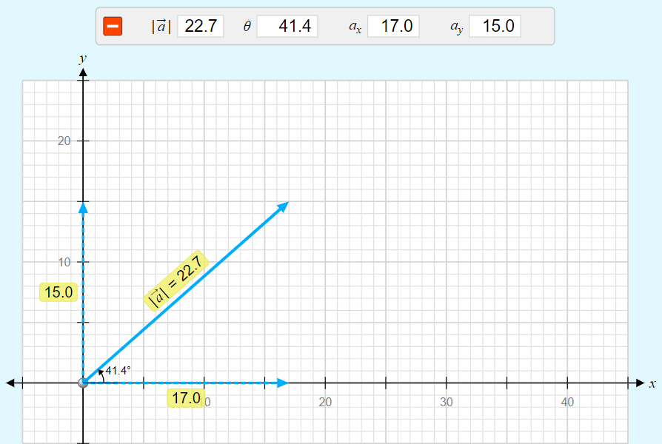

Figure (1)
Where a is the magnitude of vector $\vec{a}$ and ϴ is the angle the vector $\vec{a}$ makes with the positive x – axis counterclockwise. An object is at static equilibrium if the net force acting on it equal to zero. That means the forces applied on the object is balanced.
$\sum{\vec{F}}=0$... (3)
And the forces along x – axis and along the y – axis are balanced $\sum{F_{x}=0}$, and $\sum{F_{y}=0}$.
To determine the resultant force $\vec{F_{R}}$ for two or three forces when the object at static equilibrium, we can use three different methods:
- Experimental method using the force table.
The force table contains a black rod in the middle, a white ring as an object attached with four massless strings, each string connected with a hanger so you can hang masses on it. And the surface of the force table is a protractor, see figure (1).
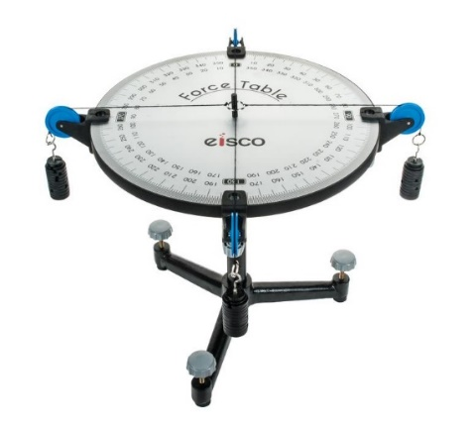

Figure (2)
Adding a mass on one of the hangers creates a force on the ring. The magnitude of this force equal to the weight of the added masses (F = mg), where m is the total mass hanged on the hanger and g is the acceleration due to gravity (g = 10 m/s²), while the angle that the string points on it is the direction of the force. If the ring touches the rod in the middle, that means the object is not at static equilibrium. For example; if two forces acting on the ring F1 and F2 then the forces is not balanced and the system is not at equilibrium. To satisfy the static equilibrium condition a balancing force (F_{B}) should be added to the force table as shown in figure (3).
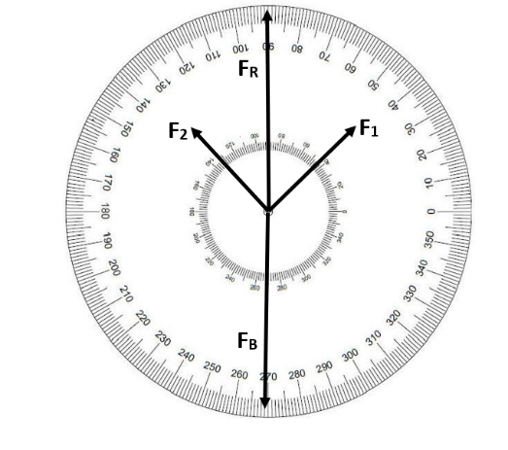

Figure (3)

$\vec{F_{1}} + \vec{F_{2}} +\vec{F_{B}} = 0$ ... (4)
The magnitude of the balancing force is equal to the magnitude of the resultant force:
$\left|\vec{F_{R}}\right|=\left|\vec{F_{B}}\right|$ ... (5)
and in the opposite direction. $θ_{B}= θ_{R}+180°$ ... (6)
where $θ_{R}$ is the angle (direction) of the resultant force with the positive x-axis counterclockwise, and $θ_{B}$ is the angle (direction) of the balancing force with the positive x-axis counterclockwise. When using the force table to find the resultant force, a balancing force need to be added to the force table to satisfy the static equilibrium condition. Then the resultant force and the balancing force are equal in magnitude and opposite in direction and can be calculated using equation 5 and 6.
- Analytical method.
To determine the resultant vector, each added vector should be resolved into x and y components. Then solving for the components of the resultant vector.
R_{x} = F_{1x} + F_{2x} ... (7)
R_{y} = F_{1y} + F_{2y} ... (8)
Where Rx is the x – component of the resultant force $\vec{F_{R}}$ , R_{y} is the y – component of the resultant force $\vec{F_{R}}$ , F_{1x} and F_{2x} are the x – components for the forces $\vec{F_{1}}$ and $\vec{F_{2}}$, F_{1y} and F_{2y} are the y – components for the forces $\vec{F_{1}}$ and $\vec{F_{2}}$ . The magnitude and direction of the resultant vector can be calculated using the formulas:
$|\vec{R}|=\sqrt{{\left(R_{x}\right)}^{2}+{\left(R_{y}\right)}^{2}}$ ... (9)
$θ_{R}= \tan^{-1}\left(\frac{R_{y}}{R_{x}}\right)$ ... (10)
- Graphical method.
In graphical method, the resultant vector is calculated using head to tail method. Starting with drawing the first added vector, then draw the second added vector so that the tail of second added vector is at the head of the preceding one. The resultant vector drawn from the tail of the first vector added to the head of the last vector added. The magnitude of the resultant vector is represented by the length of the line segment. While the direction is the angle the resultant vector made with the positive x-axis counterclockwise. In figure (4), plot (a) shows three vectors using Phet simulation, plot (b) shows the method of adding these vectors using head to tail method.

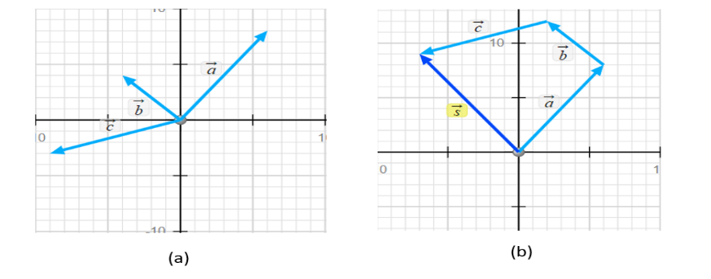

Figure (4)

Procedure
Before you start, visit the Phet interactive simulation using the link below to explore the uses of each part in the simulation.
https://phet.colorado.edu/sims/html/vector-addition/latest/vector-addition_en.html
Part I: the resultant of adding two forces (vectors).
In this activity consider vector $\vec{a}$as force ($\vec{F_{1}}$), vector $\vec{b}$ as force ($\vec{F_{2}}$), and vector $\vec{c}$ as the resultant vector ($\vec{F_{R}}$).
- Click on the link shown above and select equations option window at the bottom of the graph as shown in figure (5).
- Drag the origin of the graph paper to the middle of the graph.
- Click on base vector and select a_{x} = 6, a_{y} = 7, b_{x} = -3, b_{y} = 9. And fix the tail of the two forces $\vec{F_{1}}$ (vector $\vec{a}$) and $\vec{F_{2}}$ (vector $\vec{b}$ ) at the origin as in figure (5).
- Write the magnitude and direction of the forces $\vec{F_{1}}$ and $\vec{F_{2}}$ in table (1).
- Use head to tail method to find the resultant force F_{R} (vector c). and take a screen shot to your graph.
- Write the magnitude and direction of the resultant force F_{R} (vector c) in data analysis step 1.
(Note the equation selected is $\vec{a}+\vec{b}=\vec{c}$ ).
- Make the system at static equilibrium by selecting the equation $\vec{a}+\vec{b}+\vec{c}=0$.
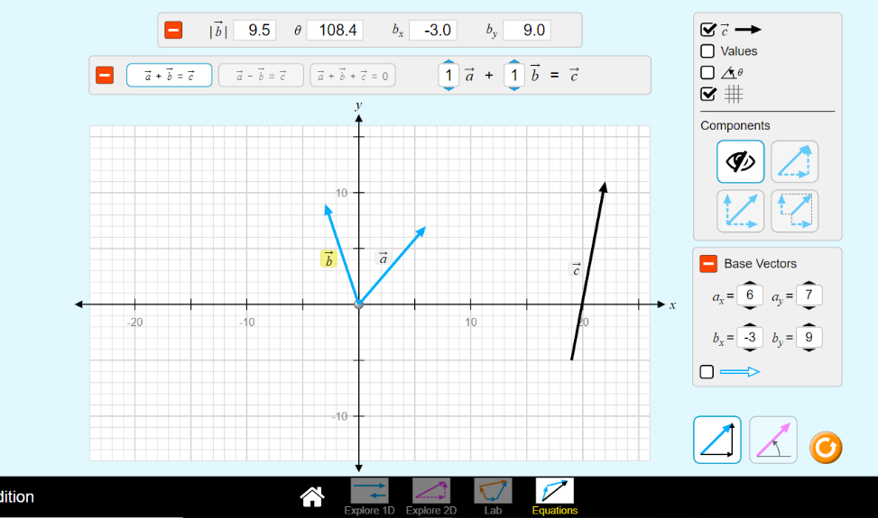

Figure (5)
- Write the magnitude and the direction of the balancing force $\vec{F_{B}}$ (vector $\vec{c}$) in table (1).
- Write the x and y components of $\vec{F_{1}}$ and $\vec{F_{2}}$ in table (2) using Phet simulation.

Part II: the resultant of adding three forces(vectors).
In this activity consider vector $\vec{a}$ as force ($\vec{F_{1}}$), vector $\vec{b}$ as force ($\vec{F_{2}}$), and vector $\vec{c}$ as force ($\vec{F_{3}}$). While vector $\vec{s}$ is the resultant vector ($\vec{F_{R}}$).
- Select “explore 2D” from the option window at the bottom of the graph.
- Drag the origin of the graph paper to the middle as shown in figure (6).
- Drag vector $\vec{a}$, $\vec{b}$, and $\vec{c}$ to the graph paper.
- Fix the magnitude and direction of each vector as selected in table (3).
Table (3)
Force | Magnitude (N) | Direction (degree)
F₁ (vector a) | 7.3 | 15.9˚
F₂ (vector b) | 9.2 | 77.5˚
F₃ (vector c) | 8.5 | 159.4˚
F_{R} (vector s)

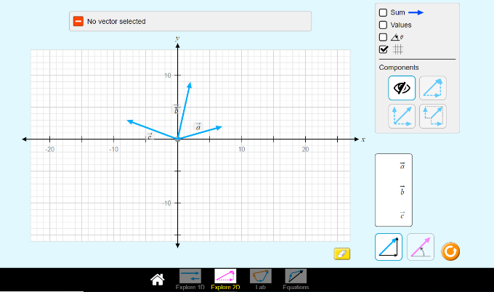

figure (6)
- Use head to tail method to add the forces (vectors) graphically.
- Select the sum option, then take a screen shot for your graph.
- Write the magnitude and the direction of the resultant force $\vec{F_{R}}$ (vector $\vec{s}$).
- Find the magnitude and direction of the balancing force $\vec{F_{B}}$ , then write your result in table (3).
Data analysis:
Part I: the resultant vector of adding two forces (vectors).
- Write the resultant vector using head to tail method (graphical method).
F_{R} = ...................... θ_{R} = ..........................
- Write your results in table (1) using the Phet simulation.
When $\vec{a}+\vec{b}+\vec{c}=0$.
Table (1)
Force (N) | Magnitude (N) | Direction (degree)
F₁ (vector a)
F₂(vector b)
F_{B} (vector c)

- What is the magnitude and direction of the resultant force ($\vec{F_{1}}$ + $\vec{F_{2}}$ + $\vec{F_{B}}$ ) in step (6).

- Calculate the resultant force of adding the two forces $\vec{F_{1}}$ + $\vec{F_{2}}$ using the data from phet simulation, then write your results in table (2).
Table (2): analytical method
Force | Magnitude (N) | Direction (degree) | X - component | Y – component
F₁
F₂
F_{R}

- What is the relation between the resultant force $\vec{F_{R}}$ ($\vec{F_{R}}$ = $\vec{F_{1}}$ + $\vec{F_{2}}$) and the balancing force $\vec{F_{B}}$?

- Calculate the percentage difference for the resultant force $\vec{F_{R}}$ between the results from analytical and graphical methods.

- Attach your graph paper from step 4.

Part II: the resultant of adding three forces(vectors).
- Write the resultant vector from graphical method in magnitude and direction.
F_{R} = ....................... θ_{R} = ..........................
- Find the magnitude and the direction of the balancing force$\vec{F_{B}}$ when the system at static equilibrium (($\vec{F_{1}}$ + $\vec{F_{2}}$ +$\vec{F_{3}}$ + $\vec{F_{B}}$ = 0). Using equations 5 and 6, then write your result in table (3).
Table (3)
Force | Magnitude (N) | Direction (degree)
F₁ (vector a) | 7.3 | 15.9˚
F₂ (vector b) | 9.2 | 77.5˚
F₃ (vector c) | 8.5 | 159.4˚
F_{B}

- Use the analytical method to find the resultant force $\vec{F_{R}}$, where $\vec{F_{R}}$ = $\vec{F_{1}}$ + $\vec{F_{2}}$ +$\vec{F_{3}}$ . Then write your answers in table (4).
Force | Magnitude (N) | Direction (degree) | X - component | Y – component
F₁ | 7.3 | 15.9˚
F₂ | 9.2 | 77.5˚
F₃ | 8.5 | 159.4˚
F_{R}

- Calculate the percentage difference for the resultant force $\vec{F_{R}}$ between the results from analytical and graphical methods.

- Attach your graph paper from step 6.

Questions:
- What is the difference between vector and scalar quantity? Give examples on both.

- What are the equilibrium conditions for an object of mass m?

- Two vectors quantities are said to be equal if ..........................
- Two forces applied on the ring of the force table, $\vec{F_{1}}$ by adding a mass 1.5 kg at 30˚, $\vec{F_{2}}$ by adding a mass 2.0 kg at angle 180˚.
- Use the analytical method to calculate the resultant force $\vec{F_{R}}$.

Force | Mass (kg) | Direction (degree) | X - component | Y – component
F₁ | 1.5 | 30˚
F₂ | 2.0 | 180˚
F_{R}

- Find the magnitude and direction of the balancing force $\vec{F_{B}}$ needed to keep the object at rest (static equilibrium).

- Use Phet interactive simulation to find the resultant force $\vec{F_{R}}$ in graphical method. Take a screen shot and attach it with the answer.

