

Worksheet (Forces at Equilibrium) Using Phet Simulation

**Dep. Of Applied Physics and Astronomy University of Sharjah**

**Name: ID#:**

This activity consists of two Parts:

Part one: Two forces acting on a ring using force table.

Part two: Three forces acting on a ring using force table.

To be familiar with vectors, magnitude, direction and vectors components, vectors addition by graphical and analytical methods using Phet simulation kindly, open the following link and play with it.

### <https://phet.colorado.edu/sims/html/vector-addition/latest/vector-addition_en.html>

**Objectives:**

In this experiment, you should learn the definition of a vector, and how to represent it in space. In addition, you should learn how to apply the rules for vectors addition both graphically and analytically.

**Apparatus:**

Force table with three to four pulleys, mass hangers, slotted masses, string, protractor, ruler, and sheets of graphic papers.

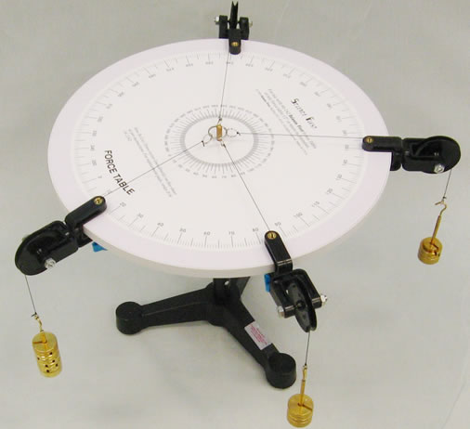

The resultant force (**FR**) of two Forces as an example **F1** & **F2** can be found by one of two methods: analytical or graphical method.

In the analytical method, each vector (Force) such as (**F**) which makes an angle (θ) with horizontal +x- axis is first resolved into two components. Those components are horizontal or x- component (Fx) and vertical or y- component (Fy). Those components are given by:



**F**

**Fx**

**Fy**

**Fx = F cos, Fy = F sin**

Consider the case of three vectors (Forces) **F1, F2, F3**,

FRx = F1x + F2x + F3x  & FRy = F1y + F2y + F3y

The magnitude of the resultant vector (FR) is found using the following formula, because the components Rx and Ry are at right angles:



and the angle (  ) that the

resultant makes with +x- axis is given by :

In the graphical addition method. The resultant vector is the vector drawn from the tail of the first vector to the head of the last vector

**C**



**R**

**B**

**A**

The polygon method is illustrated for the case of three vectors as follows:

**C**

**A**



**B**

To verify the objectives experimentaly we will use phet similation software and we will act on an object by two forces and then three forces, then we will find their resultant by finding practicaly the equilibrant force (**FE**). So, **FE**is the equilibrant force that must be applied in order to keep an object in equilibrium. The magnitude and direction of this **FE** can be found by trial and error experimentally. The resultant force **FR** can be found from knowledge that **FR** and **FE** have the same magnitude but opposite direction.

***Part one: Two forces acting on a ring using force table.***

*Use* ***F1****as vecror* ***d*** *and* ***F2*** *as vector* ***e*** *on phet simulation. And the circle in the middle thi sis the ring on the force table that you going to act on it by different forces.*

**Procedure** :

**Resultant of two vectors (forces)**

**Follw the link above, and open explore 2D screen, click on poler representation of the vector (the pink vector on the simulation) and now do the following steps.**

1. Fix the first vector (**F1**) on 20o angle and fix its magnitude to be 10N. *(vector* ***d****)*
2. The second vector (**F2**), fix it on 90o angle and control its value to be 8N. *(vector* ***e****)*

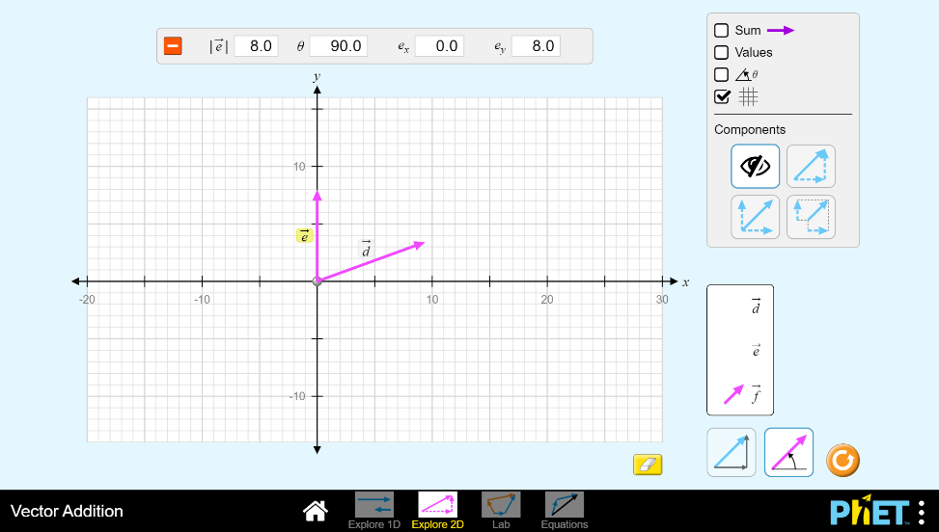

1. Use vector ***f*** as a third force (**FE**) acting on the ring, click on the sum option on the simulation screen to show you the sum of the three forces **F1**, **F2**and **FE**.
2. Use trial and error method to control vector ***f*** *(***FE**) in magnitude and direction where the resultant force vector must be close to zero. Stop changing vector ***f*** (**FE**) and then fill your findings below.

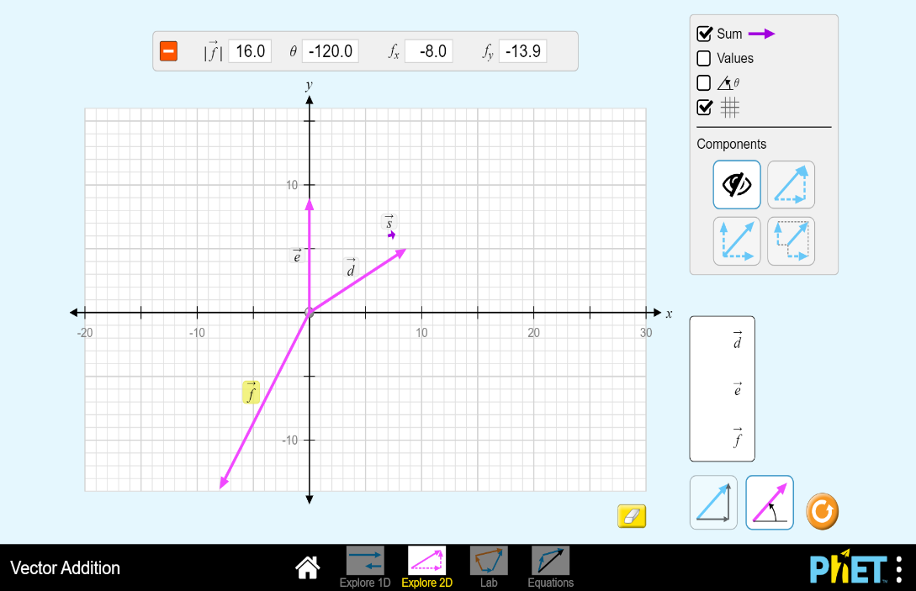

S is the sum of the three forces F1, F2 and FE (*d, e* and *f)*

*S is almost zero*

x-y components button

Polar vectors representation option.

**FE=………**

**θE=………**

1. Find the resultant force **FR**

(magnitude and direction)

**FRexp.=………**

**θRexp.=………**

#### Da ta Analysis part one:

1) Using Phet simulation click on the x-y components button shown above and then click on each vector shown on the graph paper to display the vectors’ components **F1x, F2x, F1y, F2y,** then record your values in table 1.

2) Use the analytical method to find **FR** (of the two forces **F1** and **F2**) magnitude and direction. Record your values in table 1.

3) Calculate the percentage error of the magnitude of the experimental value of **FRexp.** compared to analytical solution for **FR**.

**…………………………………………………………………………………………..**

**…………………………………………………………………………………………..**

**…………………………………………………………………………………………..**

4) Using phet simulation, move vector ***e*** and put it on head vector ***d*** (as you know head to tail method) and then find the resultant force (**FR**) of the two vectors ***d*** and ***e*** graphically. **(Attach a screen shot of the graphical method)**

**FR=……… θR=……… (Graphically)**

**5**) Calculate the percentage error of the magnitude of the graphical solution for FR compared to analytical solution for FR

**…………………………………………………………………………………………..**

**…………………………………………………………………………………………..**

**…………………………………………………………………………………………..**

Table 1

Analytical solution

|  |  |  |  |  |
| --- | --- | --- | --- | --- |
| **Force** | **Force (N)** | **Direction** | **x-component** | **y-component** |
| **F1** |  | **20o** |  |  |
| **F2** |  | **90o** |  |  |
| **FR** |  |  |  |  |

**FR=……… θR=………(analytically)**

***Part two: Three forces acting on a ring using force table.***

**Resultant of three vectors :**

**Follw the link above, and open explore 2D screen, click on poler representation of the vector (the pink vector on the simulation) and now do the following steps.**

1. The first vector (**F1**), fix it at approximetly 300. and control it’s value to be 6N. *(vector* ***d****)*
2. The second vector ( **F2**), fix it at 100o angle and control it’s value to be 8 N. *(vector* ***e****)*
3. The third vector ( **F**3) , fix it at 145o angle and control it’s value to be 11 N. *(vector* ***f****)*
4. Find the resultant force of these three forces using Phet simulation **FR**. record your values below.

*Just click on the sum button and then you will get the magnetude and the direction of the resultant vector of the three forces.*

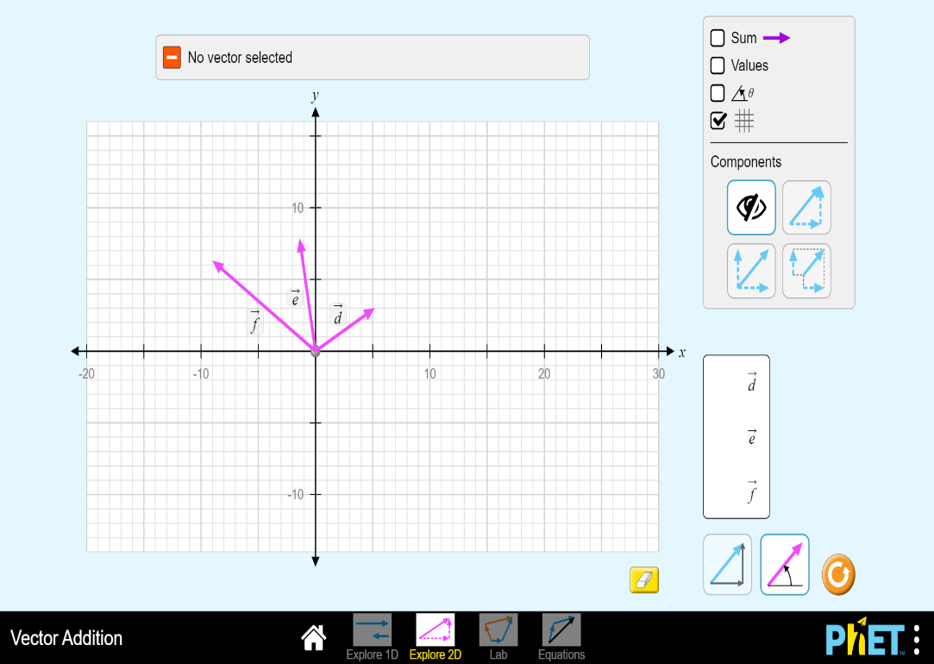

**FRexp.=………**

**θRexp.=………**

1. Write down the value of **FE** and it is direction.

**FE=………**

**θE=………**

#### Da ta Analysis part two:

1) Using Phet simulation click on the x-y components button shown above and then click on each vector shown on the graph paper to display the vectors’ components **F1x, F2x, F1y, F2y, F3x**, **F3y,**  then record your values in table 2.

2) Use the analytical method to find **FR** (of the three forces **F1**, **F2** and **F3**) magnitude and direction. Record your values in table 2.

3) Calculate the percentage error of the magnitude of the experimental value of **FRexp.** compared to analytical solution for **FR**.

**…………………………………………………………………………………………..**

**…………………………………………………………………………………………..**

**…………………………………………………………………………………………..**

4) Using phet simulation, move vector ***e*** and put it on head vector ***d*** then move ***f*** put it on head ***e*** (as you know head to tail method) and then find the resultant force (**FR**) of the three vectors ***d*** and ***e*** and ***f*** graphically. **(Attach a screen shot of the graphical method)**

**FR=……… θR=……… (Graphically)**

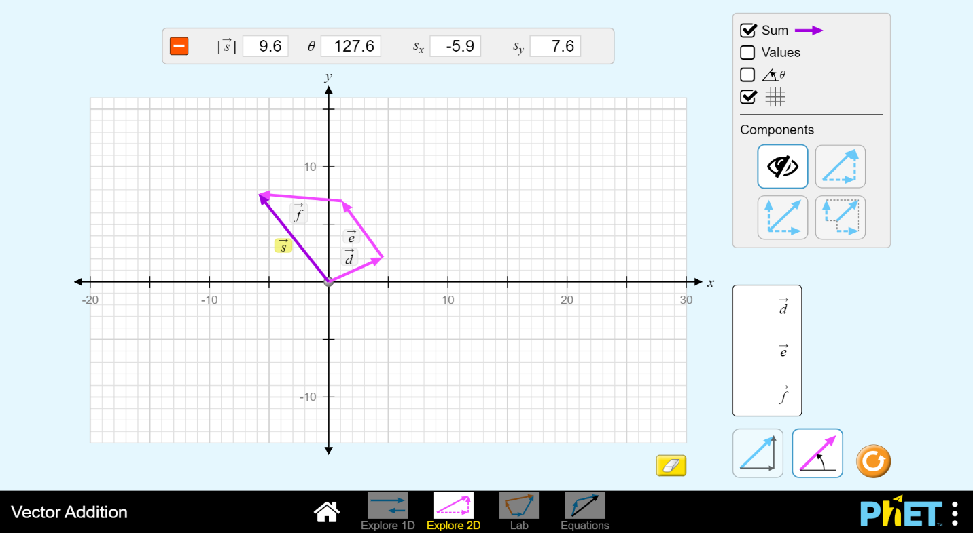

**5**) Calculate the percentage error of the magnitude of the graphical solution for **FR** compared to analytical solution for **FR**

**…………………………………………………………………………………………..**

##### Table 2

**Analytical solution**

|  |  |  |  |  |
| --- | --- | --- | --- | --- |
| **Force** | **Force ( N )** | **Direction** | **x-component** | **y-component** |
| **F1** |  | **30o** |  |  |
| **F2** |  | **100o** |  |  |
| **F3** |  | **145o** |  |  |
| **FR** |  |  |  |  |

**FR=……… θR=………(analytically)**

**Questions:**

1. What is the difference between vector and scalar quantity?
2. Classify each of the following physical quantities as vector or scalar:

a) Volume: b) Force: c) density:

d) Velocity e) distance f) acceleration

g) Mass h) speed i) weight

1. What are the conditions of equilibrium for given forces?
2. What are the conditions for the two vectors to be equal?
3. Two forces, one of 2 N and the other of magnitude 3 N applied to the ring of a force table. The direction of both forces is unknown. Which best describes the limitations on, the magnitude of the resultant force

