Period of a Pendulum

A pendulum is a bob hanging from a string that is made to swing back and forth. In the absence of friction and air resistance, the bob will repeat its motion indefinitely. The motion is a repetition of a “cycle.”

The time (in seconds) taken to complete a cycle is called the “period” of the pendulum.
In this experiment we will study the effect of different variables on the period of the frictionless swinging bob; that is we will try to see how we can change the period of oscillation.

AIM: To identify factors that affect the period of a pendulum

PROCEDURE:
Go to https://phet.colorado.edu/sims/html/pendulum-lab/latest/pendulum-lab_en.html
Click on INTRO.

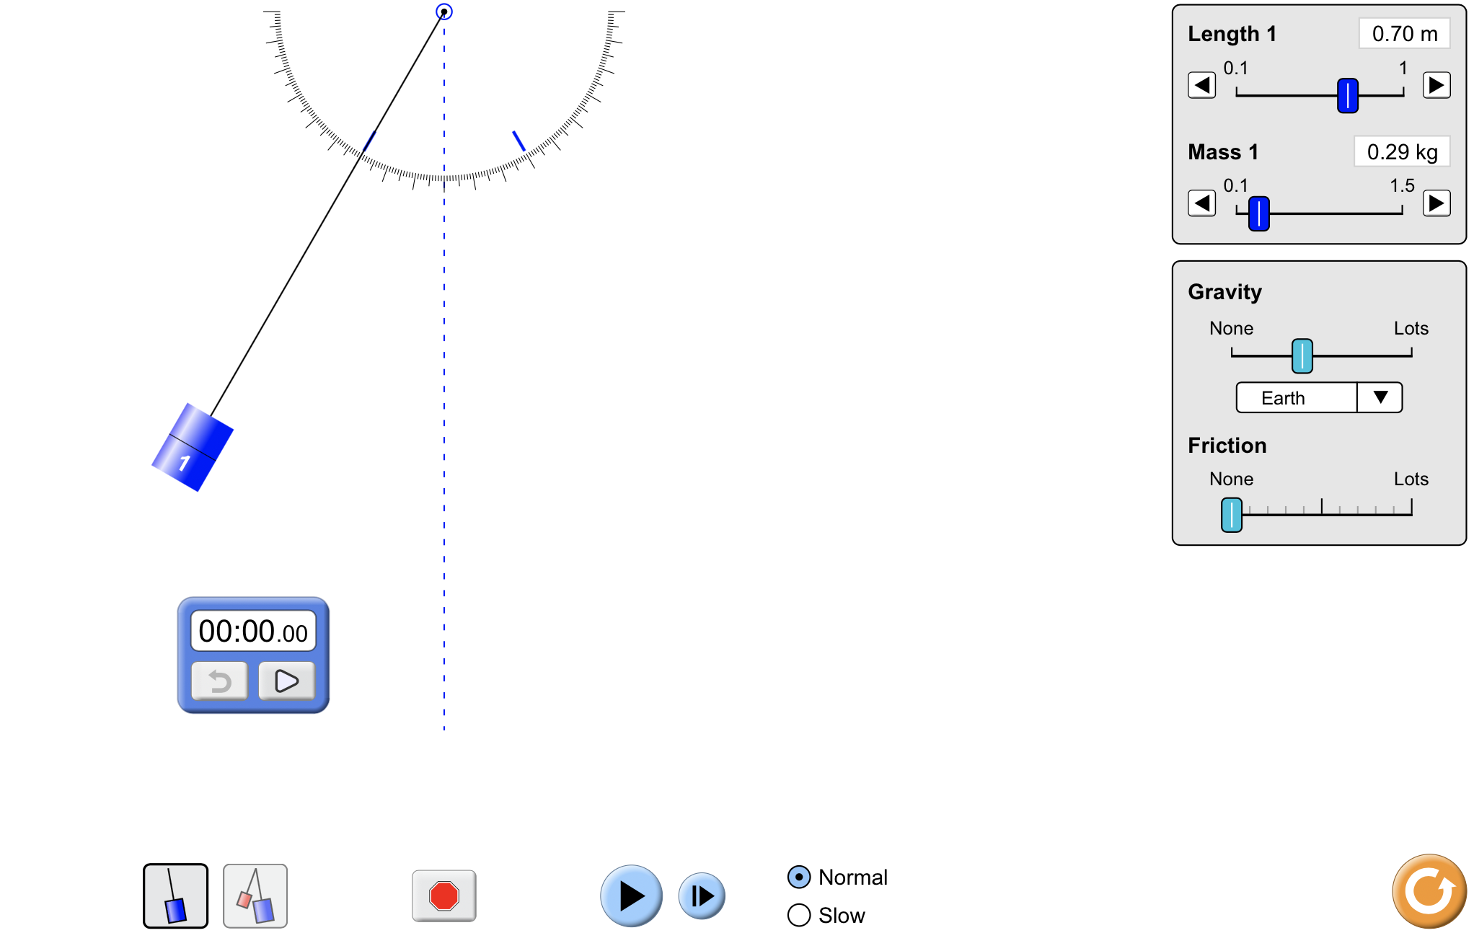

Set:
length = 0.7m
mass = 0.2 kg
gravity = Earth
Friction = None
Stopwatch = ON
Speed = Normal

1. Displace the mass to the side by about 30 degrees and let the mass swing. The mass moves from one extreme point, through the center, to the extreme point on the other side and then back to the starting point. Watch the repetitive pattern and figure out what you would define as one cycle. (There is more than one configuration that can be considered a cycle.)

2. Click on “Period Trace” to see a path that is one complete cycle. (There are more convenient paths that make up a cycle.

3. Set the mass into oscillations and practice finding the time taken for 10 oscillations using the stopwatch.

4. Once you are comfortable measuring the time for oscillations, start finding the time taken for 10 oscillations by changing the angle through which it is displaced. Do this twice for each angle of displacement and then take the average. The period is the time taken for once cycle, so divide the average value by 10 to get the period in the last data column. DO NOT CHANGE ANY OTHER PARAMETERS.
Note: t _{average} = (t₁ ₊ t₂) / 2

Table 1: Period measured by varying angle
Angle | Time for 10 oscillations |  |  | Period T (s)
(degrees | t₁ (s) | t₂ (s) | t _{average} (s) | T = t _{average} /10
30
25
20
15
5

When you vary the angle through which the pendulum oscillates you are changing the amplitude of oscillation.

Q1: Based on the data in table 1, does period depend on the amplitude of oscillation? Explain.

5. Now vary the length of the pendulum and measure the period like you did before. This time the angle of displacement will be 30 degrees for all trials.

Table 2: Period measured by varying length
Length | Time for 10 oscillations |  |  | Period T (s)
(degrees) | t₁ (s) | t₂ (s) | t _{average} (s) | T = t _{average} /10
0.70
0.60
0.50
0.40
0.35

Q 2: Does changing the length of the pendulum affect the period of oscillation? Explain.

6. Next vary the mass of the bob and find the period of oscillation. Keep the angle at 30 degrees and the length at 0.70m.

Table 3: Period measured by varying mass
Mass | Time for 10 oscillations |  |  | Period T (s)
(kg) | t₁ (s) | t₂ (s) | t _{average} (s) | T = t _{average} /10
0.2
0.5
0.75
0.9
1.1

Q 3: Does changing the mass of the pendulum affect the period of oscillation? Explain.

Q4. Summarize your results from table 1, 2 and 3. What factors affect the period of the pendulum and what factors do not affect the period?

Q 5. Can we find any other factor that might affect the period? Look at the possible variables in the program and see if you can find another one to vary. Does this affect the period of oscillation? Explain clearly or show your data below to support your answer.

7. In Q6 you have found which variables affect the time period. Graphing is another way to see the relationship between variables. It can also show if the two variables vary linearly, inversely, quadratically, etc.

Using the data from tables 1, 2 and 3, plot graphs of the following and figure out the relationship between the variables. Next to each of these, write down whether the relationship is linear, inverse, independent, quadratic or other.

(a) Period T vs mass _________
(b) Period T vs length of pendulum ____________
(c) Period T² vs (length of pendulum) ____________
(d) Period T vs amplitude/angle _____________

You can plot these on graph paper or use
https://phet.colorado.edu/sims/html/curve-fitting/latest/curve-fitting_en.html

