
Department of Applied Physics College of Sciences, University of Sharjah

Worksheet of Kirchhoff’s Law by using
PHET Simulation
Student Name: ………………………………………………………………………… ID: …………………………………………….
------------------------------------------------------------------------------------------------------------------------------------------
Title of the Experiment: Kirchhoff’s Law
Objectives:
To investigate Kirchhoff’s Laws: Kirchhoff’s Current Law (KCL) and Kirchhoff’s Voltage Law (KVL).
Apparatus: DC ‐ Power supply, voltmeter, ammeter, resistors, and connecting wires.
Theory and Background:
Kirchhoff’s laws follow from the laws of conservation of energy and conservation of charge. These laws are used to analyze electrical circuits, which contain combinations of batteries, resistors and capacitors. In this experiment, we are interested in investigating Kirchhoff’s laws for a direct current (DC) circuit, for which the electrical currents are constants in magnitude and direction.
The two Kirchhoff’s laws are referred to as Kirchhoff’s Current Law (KCL) and Kirchhoff’s Voltage Law (KVL).
Kirchhoff’s Current Law (KCL):
The sum of the currents entering any point, in a closed circuit, must equal the sum of the currents leaving it; or the algebraic sum of all currents at that point is zero. In other words,
ΣI = 0 ……..………….. (1)
This law is a restatement of charge conservation.
Kirchhoff’s Voltage Law (KVL):
The algebraic sum of the changes in potential around any closed path of a closed circuit is equal to zero. In mathematical terms, this statement can be expressed as:
Σε + ΣIR = 0 ……………… (2)
To do the experiment by using PHET interactive simulation follow the following steps:
Circuit 1:
- Click on the following link from PHET Colorado Simulation
https://phet.colorado.edu/en/simulation/circuit-construction-kit-dc

- Download Circuit Construction Kit: DC
- Click on Lab
- Choose Conventional Current
- Use the components in the left side to build the circuit shown below:
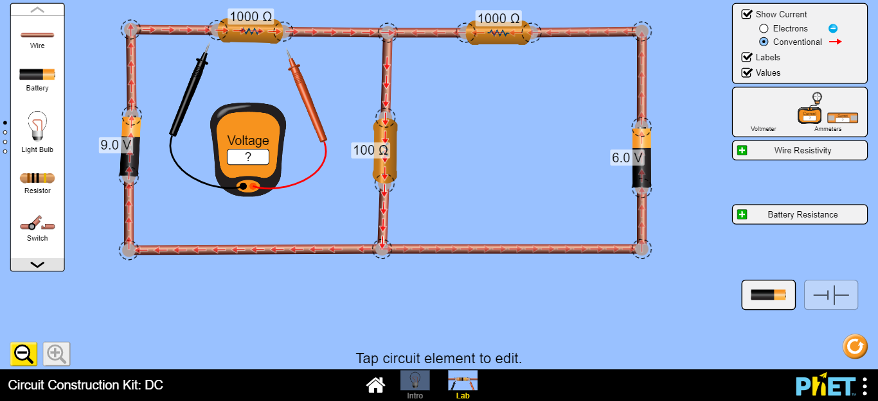
R₁
R₂
R₃
ε₁
ε₂

- Click on the resistor (R₁) and fix it at 1000Ω. That is R₁ = 1000Ω.
- R₂ = 1000Ω and R₃ = 100Ω
- Click on the Battery to the left (ε₁) and fix it at 9V, ε₁ = 9V.
- Click on the Battery to the right (ε₂) and fix it at 6V, ε₂ = 6V
- Click on the Voltmeter from the right side and drag it to measure (V₁) the voltage across R₁, (V₂) the voltage across R₂ and (V₃) the voltage across R₃.

- Click on the Ammeter from the right side and drag it and put it in series with R₁ to measure (I₁), with R₂ to measure (I₂) and with R₃ to measure (I₃). As you see below:
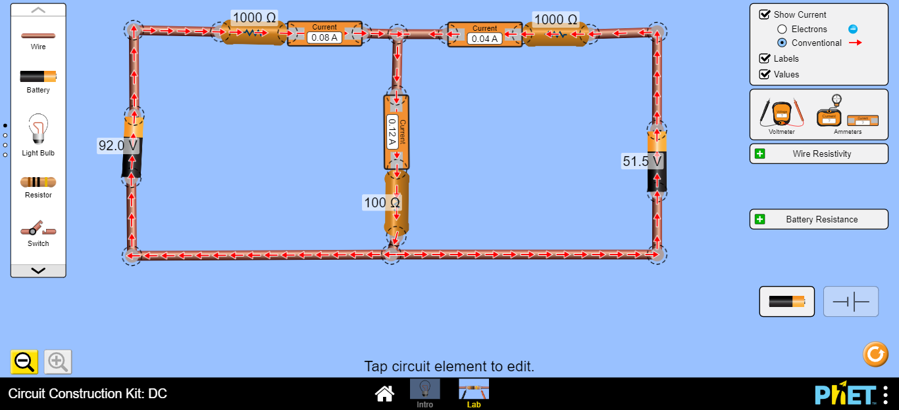
I₁
I₃
I₂
Note that:
I₁ + I₂ = I₃
Loop 1
Loop 2

- Record the values (I₁, I₂, I₃, V₁, V₂ and V₃ ) into table 1.
Table 1
ε₁ = …………………………… ε₂ = …….........................
Experimental results |  |  | Calculated results (use the loops)
R (Ω) | I (A) | V (volt) | R (Ω) | I (A) | V (volt)
1000 |  |  | 1000
1000 |  |  | 1000
100 |  |  | 100

Circuit 2:
- Click on the following link from PHET Colorado Simulation
https://phet.colorado.edu/en/simulation/circuit-construction-kit-dc

- Download Circuit Construction Kit: DC
- Click on Lab
- Choose Conventional Current
- Use the components in the left side to build the circuit shown below:
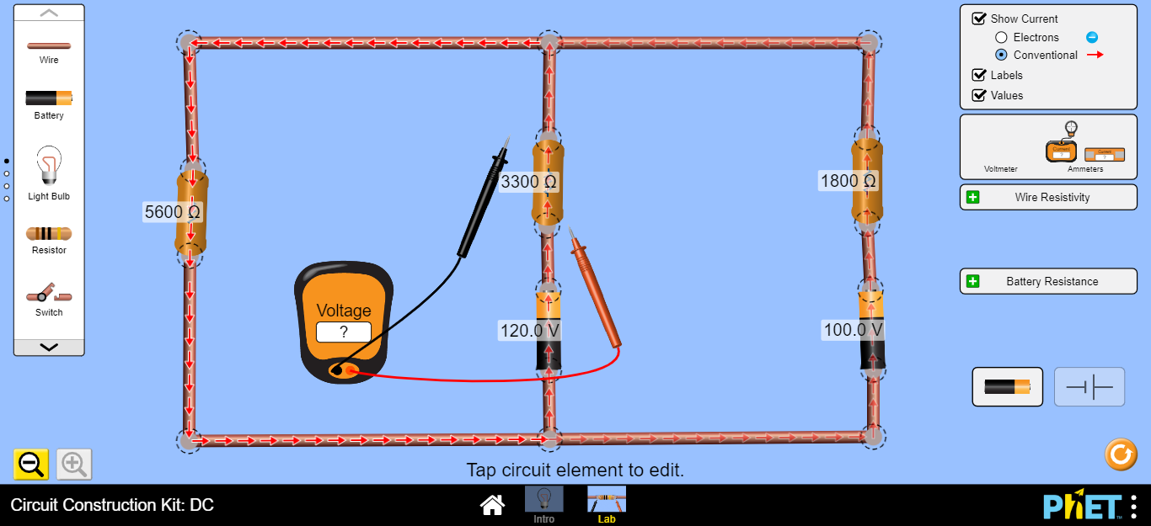
R₁
R₃
R₂
ε₁
ε₂

- Click on the resistor (R₁) and fix it at 5600Ω. That is R₁ = 5600Ω.
- R₂ = 3300Ω and R₃ = 1800Ω
- Click on the Battery to the left (ε₁) and fix it at 120V, ε₁ = 120V.
- Click on the Battery to the right (ε₂) and fix it at 100V, ε₂ = 100V
- Click on the Voltmeter from the right side and drag it to measure (V₁) the voltage across R₁, (V₂) the voltage across R₂ and (V₃) the voltage across R₃.

- Click on the Ammeter from the right side and drag it and put it in series with R₁ to measure (I₁), with R₂ to measure (I₂) and with R₃ to measure (I₃).
Record the values (I₁, I₂, I₃, V₁, V₂ and V₃ ) into table 2.

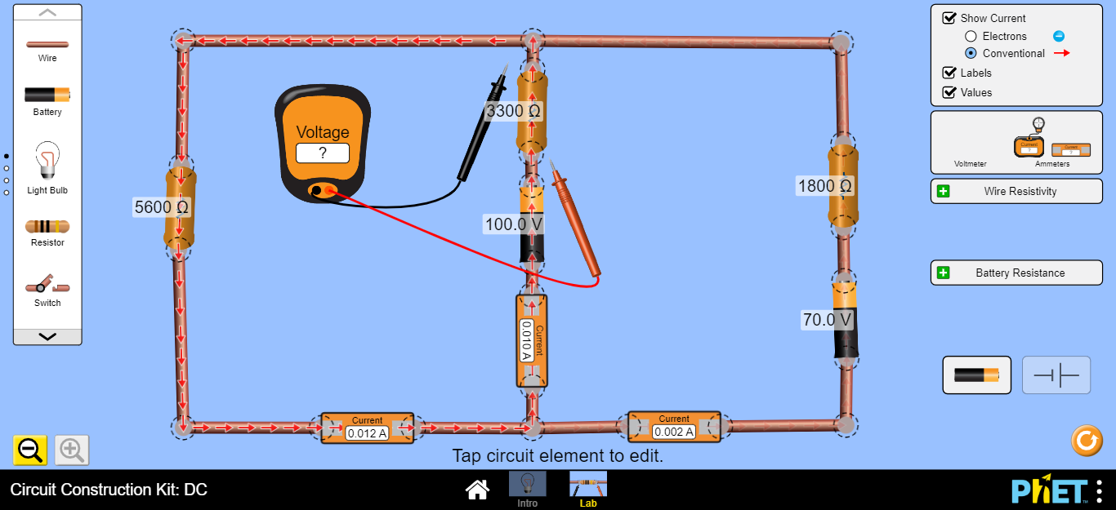
I₁
I₂
I₃

Table 2
Experimental results
R (Ω) | I (A) | V (volt)

Questions:
- Using your experimental results of I₁, I₂ and I₃. Has Kirchhoff’s current law (KCL) been satisfied? Explain.

- Circuit 1 and Table 1:

- Circuit 2 and Table 2:

- Using your experimental measurements of V₁, V₂ and V₃ from table (1) of the circuit (1), verify Kirchhoff’s voltage law (KVL) for each loop in circuit 2.

Conclusions:

