College of Applied Physics and Astronomy
Physics for Health Sciences Laboratory
Reflection, Refraction and Total Internal Reflection
Worksheet using https://phet.colorado.edu/sims/html/bending-light/latest/bending-light_en.html interactive simulation
Name: ……………………………………. ID: …………………………..

This experiment contains two parts to be done, which are:
Part I: reflection, refraction and Snell’s law.
This part defines the reflection and refraction laws of light and use Snell’s law to calculate the index of refraction of unknown material.
Part II: total internal reflection and critical angle.
This part defines the meaning of the critical angle and the total internal reflection and use the critical angle to calculate the index of refraction of a material.
objectives:
- Investigate the laws of reflection and refraction (Snell’s law).
- Determine the index of refraction of unknown material.
- Investigate the total internal reflection and critical angle.
  - Theory:
When a light beam encounters a surface (boundary) that separate two transparent mediums. The light interacts in three different ways; the light ray might be absorbed by the material, reflect, or refract as shown in figure (1).
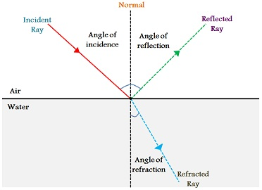
Figure (1)
Reflection of light:
Reflection happen’ s when the incident ray bounces back in the same medium. The angle between the Normal (the dotted line drawn at the incident point perpendicular to the boundary) and the incident ray called the incident angle. While the refracted angle is the angle between the Normal and the refracted ray.
The law of reflection state that the incident angle equals the reflected angle.
$θ_{i }=θ_{r}$ … (1)
Where $θ_{i } is$the incident angle, and $θ_{r}$ is the reflected angle. Click on the link below to examine formula (1).
https://phet.colorado.edu/sims/html/bending-light/latest/bending-light_en.html
Refraction of light:
Refraction is known as the bending of light ray when it transmits between two different mediums. Bending of light caused by the change in the speed of light when transmit from medium to another.
The law of refraction (Snell’s law) state that:
- The incident ray, the refracted ray and the Normal lie in the same plane.
- The ratio of the sine of the angle of incidence and sine of the angle of refraction is constant and it can be represented as:
$n_{1}\sin{θ_{i}}= n_{2} \sin{θ_{t}}$ … (2)
Where $θ_{t}$ is the refracted angle, $n_{1}$ is the index of refraction for medium 1, $n_{2}$ is the index of refraction for medium 2. The index of refraction is the ratio between the speed of light in vacuum ($c=3×{10}^{8} m/s)$ to the speed of light in a medium ($v).$
$n= \frac{c}{v}$ …. (3)
For vacuum and air, the speed of light is almost the same, so the index of refraction for air is equal to 1. While the speed of light in other mediums is less than the speed of light in vacuum and air, therefore the index of any other medium will be greater than 1. Table (1) shows the refractive indices of some transparent materials.
Table (1)
Material | Refractive index
Air | 1
water | 1.33
Glass | 1.5
Diamond | 2.4

Total internal reflection and the critical angle.
When the light ray transmits from a medium with high index of refraction (such as water or glass) to a medium with low index of refraction (such as air), the transmitted ray will bend away from the normal (ray 1), as shown in graph (2). In this case the refracted angle is greater than the incident angle. Increasing the incident angle will bend the transmitted ray a way from the normal until it reaches a point where the transmitted ray skims the boundary. This means that the refracted angle is 90˚. The incident angle in the medium with high index of refraction which cause a refracted (transmitted) angle of 90 ˚ in the medium with low index of refraction called the critical angle (ray 2).
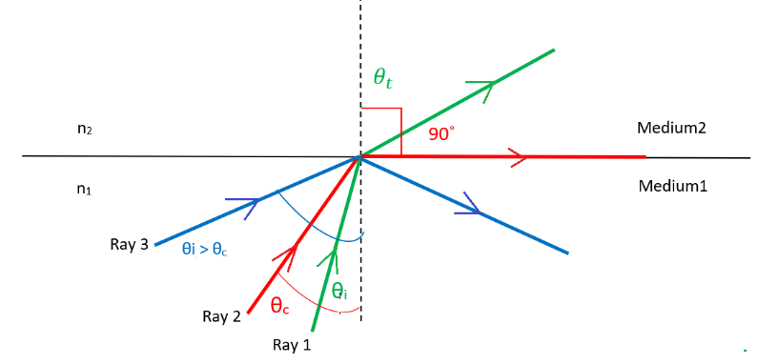
n₁ > n₂

Figure (2)
The critical angle can be calculated using the formula:
$\sin{θ_{c}=\frac{n_{2}}{n_{1}}}$ … (4)
Where $θ_{c}$ is the critical angle, n₁ is the index of refraction for medium 1 (where the incidence occurs), n₂ is the index of refraction for medium 2 (where the refraction occurs).
If the incident angle increases more than the critical angle the light will bounce back in the same medium and no light ray will transmit to the other medium, this phenomenon called the total internal reflection, and it follows the law of reflection.
Procedure
Part I: reflection refraction and Snell’s law.
In part I, a square object used to determine the index of refraction as shown in figure (3), two refractions occur; the external incidence when the light transmit from air to the object material. And the internal incidence when light ray transmits from the object to air.

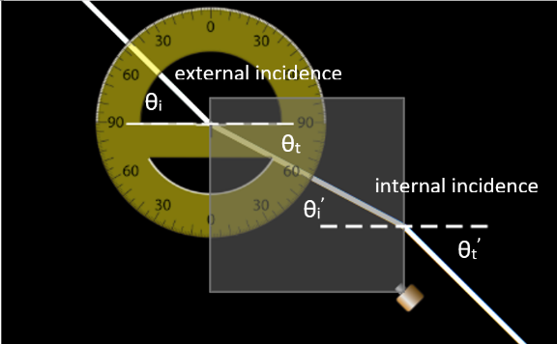

Figure (3)
- Open the link below and play with it to get familiar with the simulation in Phet.colorado.
https://phet.colorado.edu/sims/html/bending-light/latest/bending-light_en.html

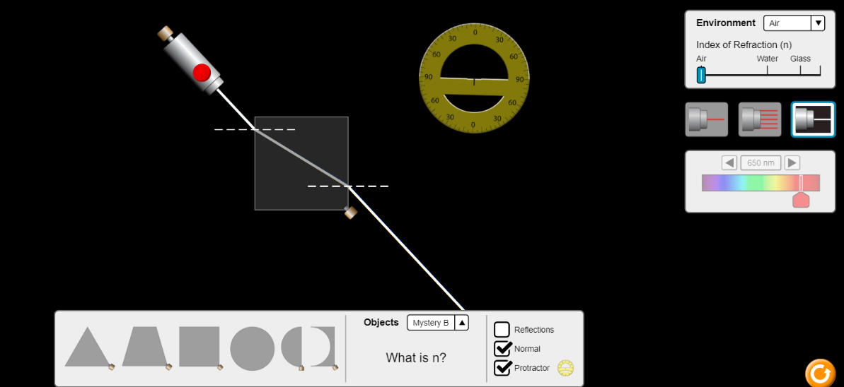

Figure (4)
- Choose the white ray option, normal, mystery B, and air for the environment. Then drag the protractor and the square shape as shown in graph (3).
- Click on the red button placed on the light source. Then move the light source in any direction until the light ray passes through the square material and have two refractions.

- Measure the incident and the refracted angles using the protractor. Then record your values in table (2).
- Change the incident angle by moving the light source so you get another refraction. then repeat step 4.
Table (2)
Trial (1) | Incident angle | Refracted angle | Index of refraction (n)
External incidence | θ_{i} = ...……………. | θt = ...…………….
Internal incidence | θ_{i} = ...……………. | θt = ...…………….
Trial (2)
External incidence | θ_{i} = ...……………. | θt = ...…………….
Internal incidence | θ_{i} = ...……………. | θt = ...…………….
Part II: total internal reflection and critical angle using the semicircular shape
in part II a semicircular object used to investigate the total internal reflection and the critical angle. the light transfer from air to object without any refraction, why? to satisfy the objective of this part you need only the internal incidence, explain?
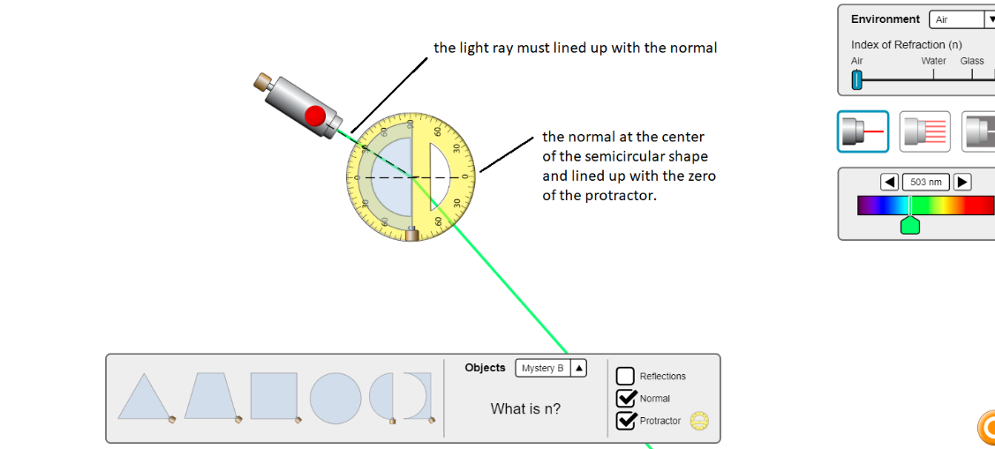

Figure (5)
- Drag the semicircular object and use the first red ray to the left as shown in figure (4).
- Increase the incident internal angle (from the semicircular object to air) until the light skim the surface of the semicircular object.
- Measure the incident angle, what does this angle represent for the material of the semicircular object?
- Determine the refractive index for the material (mystery B).
- Increase the incident angle more than the critical angle, what happens to the light ray?
Data analysis:
part I: reflection refraction and Snell’s law.
- What is the difference between the external and the internal incidence?

- What is the relation between the refracted angle in the internal incident and the incident angle in the external incidence?

- Calculate the refractive index (n) for the material (mystery B) and write your answers in table (2).
- Determine the average of the index of refraction in table (2).
Part II: total internal reflection and critical angle using the semicircular shape.
- What is the value of the critical angle for the semicircular object?

- Calculate the index of refraction using the critical angle.

- Compare your results for the index of refraction for mystery B material of the two parts using the % difference.

- Write in your own words, what is the total internal reflection?

Questions:
- A light ray is incident upon a plane interface between two materials. The ray makes an incident angle with the normal to the surface of 35° in a material with index of refraction n = 1.33. If the second material has an index of refraction n = 1.92, what is the refracted angle in that material?

- If a material has an index of refraction n = 1.5, what is the speed of light in this material?

