Bending of light
By P. Lamichhane

Name:
Partner’s Name(s):
Date:

Objective:
The objectives of this lab activities are :
- To study the law of reflection and refraction of light using different media
- To study the phenomenon and condition of total internal reflection
- To observe the dispersion of light by prism and refraction of light by different kinds of lens

Introduction:
The law of reflection of light states that when light bounces off from a surface, the angle of reflection is always equal to angle of incidence. Additionally, incident ray, reflected ray and normal all lie in the same plane.

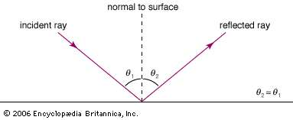

The law of refraction of light states that, when a ray of light passes from one medium to another medium, light bends towards or away from the normal. When a light ray passes from a rarer medium to the denser medium, light ray bends towards the normal. When light ray passes from denser to rare medium, it bends away from the normal. The Snell’s law for refraction is given by :
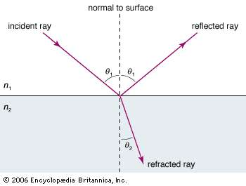

Picture Copyright to Britannica https://www.britannica.com/science/light/Reflection-and-refraction
$$n_{1} \sin{θ_{1}= n_{2} \sin{θ_{2} } }$$
Where, $n_{1}$ is the refractive index of one medium and $θ_{1}$is the angle of incidence. Similarly, $n_{2}$ is the refractive index of another medium and $θ_{2}$ is the angle of refraction.
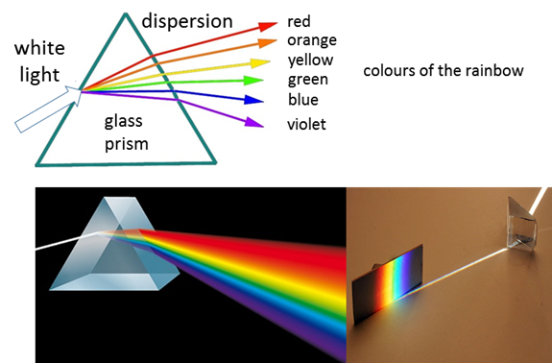
Picture Copy right to http://www.physics.usyd.edu.au/teach_res/hsp/sp/mod31/m31_rays.htm
When a ray of white light passes through a prism, it is separated into its component colors. This separation of visible light into seven colors is known as dispersion.
Procedure :
Go to https://phet.colorado.edu/en/simulation/bending-light and open the Bending Light Sim. Click on Intro. Press the red button to turn on laser which passes from one medium to another and learn how you can move the protractor and how to measure incident angles, reflected angles and refracted angles.

For each scenario, select the top and bottom material as specified in each data table. Record the index of refraction, n, for each material in the data table. Choose two incident angles between 5º – 85º for each scenario, and record the incident, reflected, and refracted angles in the table.
After filing in the table, draw the rays as they are in the sim. The following picture shows the simulation page.

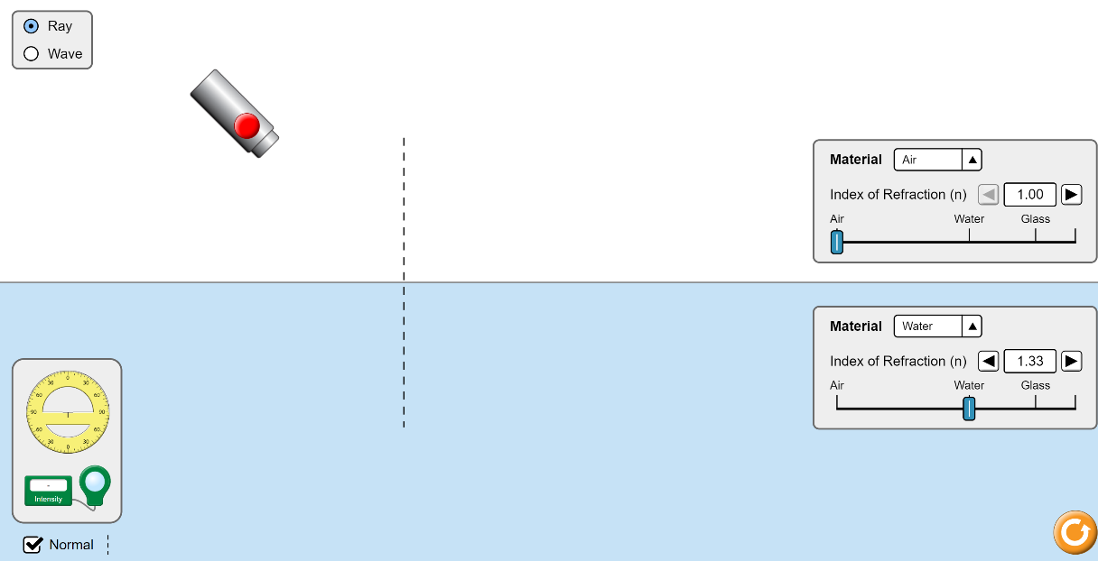

STUDY OF LAW OF REFLECTION OF LIGHT

Top Material: Air Top Index of Refraction (n): _____________
Bottom Material: Water Bottom Index of Refraction (n): _____________
- Flash the light at certain angle (with certain angle of incidence) so that light gets reflected and bounce back to the same medium with certain angle of reflection.
- After you complete the predictions, you can observe using the protractor and provide the observed refracted angle.
Trials | Incident Angle ($θ_{1})$ | Predicted Reflected Angle ($θ_{2})$ | Observed Reflected Angle( $θ_{2})$ | Comments
1
2
3
4
5

- Draw the ray diagram here for at least two different incident angles. Just focus on the incident ray and reflected ray NOT the refracted ray, we will study law of refraction later on.

STUDY OF LAW OF REFRACTION OF LIGHT

Top Material: Air Top Index of Refraction (n): _____________
Bottom Material: Water Bottom Index of Refraction (n): _____________
- Flash the light at certain angle so that light gets refracted and passes from one medium to another medium. Do it for 5 different incident angles.
Use the equations $n_{1} \sin{θ_{1}= n_{2} \sin{θ_{2} } }$
Use the equation to predict for $θ_{2}= \sin^{-1}({\frac{n_{1}}{n_{2}}*}\sin{θ_{1}) }$

- After you complete the predictions, you can observe using the protractor and provide the observed refracted angle.
Trials | Incident Angle ($θ_{1})$ | Predicted Reflected Angle ($θ_{2})$ | Observed Refracted Angle( $θ_{2})$ | Comments
1
2
3
4
5

- Draw the ray diagram here for at least two different incident angles.

STUDY OF LAW OF REFRACTION OF LIGHT

Top Material: Air Top Index of Refraction (n): _____________
Bottom Material: Glass Bottom Index of Refraction (n): _____________
- Flash the light at certain angle so that light gets refracted and passes from one medium to another medium. Do it for 5 different incident angles.
Use the equations $n_{1} \sin{θ_{1}= n_{2} \sin{θ_{2} } }$
Use the equation to predict for $θ_{2}= \sin^{-1}({\frac{n_{1}}{n_{2}}*}\sin{θ_{1}) }$
- After you complete the predictions, you can observe using the protractor and provide the observed refracted angle.
Trials | Incident Angle ($θ_{1})$ | Predicted Reflected Angle ($θ_{2})$ | Observed Refracted Angle( $θ_{2})$ | Comments
1
2
3
4
5

- Draw the ray diagram here for at least two different incident angles.

STUDY OF LAW OF REFRACTION OF LIGHT

Top Material: Water Top Index of Refraction (n): _____________
Bottom Material: Glass Bottom Index of Refraction (n): _____________
- Flash the light at certain angle so that light gets refracted and passes from one medium to another medium. Do it for 5 different incident angles.
Use the equations $n_{1} \sin{θ_{1}= n_{2} \sin{θ_{2} } }$
Use the equation to predict for $θ_{2}= \sin^{-1}({\frac{n_{1}}{n_{2}}*}\sin{θ_{1}) }$
- After you complete the predictions, you can observe using the protractor and provide the observed refracted angle.
Trials | Incident Angle ($θ_{1})$ | Predicted Reflected Angle ($θ_{2})$ | Observed Refracted Angle( $θ_{2})$ | Comments
1
2
3
4
5

- Draw the ray diagram here for at least two different incident angles.

STUDY OF LAW OF REFRACTION OF LIGHT

Top Material: Water Top Index of Refraction (n): _____________
Bottom Material: Air Bottom Index of Refraction (n): _____________
- Flash the light at certain angle so that light gets refracted and passes from one medium to another medium. Do it for 5 different incident angles.
Use the equations $n_{1} \sin{θ_{1}= n_{2} \sin{θ_{2} } }$
Use the equation to predict for $θ_{2}= \sin^{-1}({\frac{n_{1}}{n_{2}}*}\sin{θ_{1}) }$
- After you complete the predictions, you can observe using the protractor and provide the observed refracted angle.

Trials | Incident Angle ($θ_{1})$ | Predicted Reflected Angle ($θ_{2})$ | Observed Refracted Angle( $θ_{2})$ | Comments
1
2
3
4
5

- Draw the ray diagram here for at least two different incident angles.

STUDY OF LAW OF REFRACTION OF LIGHT

Top Material: Glass Top Index of Refraction (n): _____________ Bottom Material: Air Bottom Index of Refraction (n): _____________
- Flash the light at certain angle so that light gets refracted and passes from one medium to another medium. Do it for 5 different incident angles.
Use the equations $n_{1} \sin{θ_{1}= n_{2} \sin{θ_{2} } }$
Use the equation to predict for $θ_{2}= \sin^{-1}({\frac{n_{1}}{n_{2}}*}\sin{θ_{1}) }$
- After you complete the predictions, you can observe using the protractor and provide the observed refracted angle.

Trials | Incident Angle ($θ_{1})$ | Predicted Reflected Angle ($θ_{2})$ | Observed Refracted Angle( $θ_{2})$ | Comments
1
2
3
4
5

- Draw the ray diagram here for at least two different incident angles.

STUDY OF LAW OF REFRACTION OF LIGHT
Top Material: Glass Top Index of Refraction (n): _____________
Bottom Material: Water Bottom Index of Refraction (n): _____________
- Flash the light at certain angle so that light gets refracted and passes from one medium to another medium. Do it for 5 different incident angles.
Use the equations $n_{1} \sin{θ_{1}= n_{2} \sin{θ_{2} } }$
Use the equation to predict for $θ_{2}= \sin^{-1}({\frac{n_{1}}{n_{2}}*}\sin{θ_{1}) }$
- After you complete the predictions, you can observe using the protractor and provide the observed refracted angle.

Trials | Incident Angle ($θ_{1})$ | Predicted Reflected Angle ($θ_{2})$ | Observed Refracted Angle( $θ_{2})$ | Comments
1
2
3
4
5

- Draw the ray diagram here for at least two different incident angles.

Based on your data in the data tables, what patterns do you observe? Write at least three summary statements.
Total Internal reflection:
Flash the light at certain angle so that light gets refracted and passes from one medium to another medium with refracted angle is 90⁰.
Use the equations $n_{1} \sin{θ_{1}= n_{2} \sin{θ_{2} } }$
Use the equation to predict for $θ_{1}= \sin^{-1}({\frac{n_{2}}{n_{1}}*}\sin{θ_{2}) }$
When you plug $θ_{2}$= 90⁰ , corresponding value for $θ_{1 }$is called critical angle. When you increase the incident angle, the ray undergoes total internal reflection.
Predict the critical angle for the following condition and check the predicted angle using the simulation. Make sure to provide necessary screen shot here.
- Glass – water interface ( rays pass from Glass to Water)
Predicted $θ_{1 }$for critical angle = $θ_{C}$ = _____________

- Glass – air interface (rays pass from Glass to air)
Predicted $θ_{1 }$for critical angle = $θ_{C}$ = _____________

- Water to air interface ( rays pass from Water to air)
Predicted $θ_{1 }$for critical angle = $θ_{C}$ = _____________
After you complete the predictions, you can observe using the protractor and provide the observed refracted angle.

Trials | Predicted Angle ($θ_{C})$ | Observed Angle ($θ_{C})$ | Comments
Glass – water interface
Glass – air interface
Water to air interface

Discussion questions: Is it possible for total internal reflection if light passes from air to Glass, why or why not? Provide answer with reasons:

Prepare a formal lab report, attach this worksheet as well and submit online.

