SPEED OF A MECHANICAL WAVE

OBJECTIVE: | - To measure the speed of a wave in a medium.  - To describe the relationship between the frequency and the wavelength of a wave travelling in a given medium.  - To determine the relationship between the speed of a wave and the tension in the rope.
MATERIALS | Wave on a String PhET simulation
ONLINE RESOURCES | Wave on a String PhET simulation: https://phet.colorado.edu/sims/html/wave-on-a-string/latest/wave-on-a-string_en.html
PROCEDURE
Speed of a “Rope Wave” | - Open the Wave on a String PhET simulation.  - Set the following parameters:  Simulation PAUSED  Damping None  Tension High  Rope’s End No End  Source Oscillate  Ruler Enabled  Amplitude 0.5 cm  - Set the frequency of oscillation to 1.5 Hz. Run the simulation by clicking on the Play/Pause button. Measure the wavelength of the wave, using the ruler and the Play/Pause button.  - Using the parameters in (1), increase the frequency to 3 Hz. Determine the wavelength of the wave. Summarize your data in Data Table 1.  Data Table 1  Frequency Wavelength Speed  1.5 Hz 4 cm 6 cm/s  3.0 Hz 2cm 6 cm/s  Guide Questions:  - How did you measure the wavelength of the wave?  Measure the distance between two consecutive peaks.  - What happened to the wavelength of the wave when the frequency increased from 1.5 Hz to 3.0 Hz? What happened to the speed?  Wavelength decreased.  - For a rope of uniform density (and tension), what relationship exists between the frequency and the wavelength of the wave?  For a wave travelling in a given medium, the frequency is inversely proportional to the wavelength of the wave.
Speed and Tension | - Set the following parameters:  Simulation PAUSED  Damping None  Rope’s End No End  Source Oscillate  Ruler Enabled  Stopwatch Enabled  Amplitude 0.5 cm  Frequency 1.5 Hz  - Set the Tension to “Low” (value = 1 unit). Run the simulation. Using the ruler determine the speed of the wave by measuring the time it takes for the wave to travel by 3 cm. (Hint: Use the “Pause/Play/Step button”)  - Repeat (2) for “Medium” (value = 9 units) and “High” (value = 25 units) Tension. Summarize your calculations in Data Table 2  Data Table 2  Tension Distance Travelled, d (cm) Time Elapsed, t (s) Speed, v (cm/s) v²  Low 1 unit 3 2.4 1.25 1.56  Medium 9 units 3 0.8 3.75 14.06  High 25 units 3 0.48 6.25 39.06  - Using a spreadsheet, plot the values of the Tension against the values of v². Describe the graph formed.  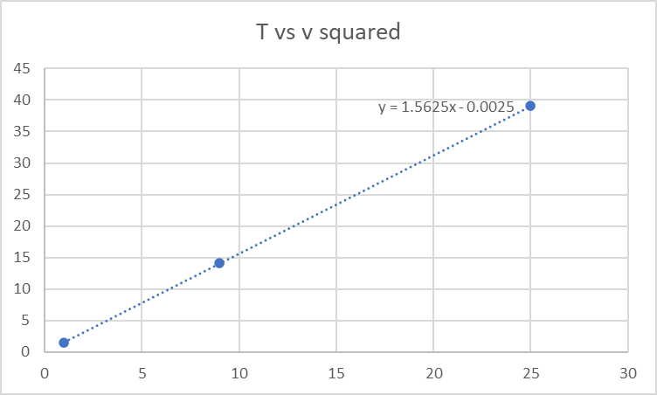  The graph is a straight line.  Guide Questions:  - Describe what you did in determining the speed of the wave.  - What is the effect of increasing the tension in the rope on the speed of the wave?  Increasing the tension increases the speed of the wave.  - Approximately how many times did the speed change when the tension is increased by a factor of 9 (e.g. T_{medium}/T_{low} = 9)? 9 times  - Approximately how many times did the speed change when the tension is increased by a factor of 25 (e.g. T_{medium}/T_{low} = 25)? 25 times  - What does the graph of T vs. v² suggest about the relationship between the tension in the rope and the speed of the wave?  - The square of the speed is proportional to the tension in the rope.  $$v^{2} ∝T$$
CONCLUSION(S) | Answers may vary
GOING FURTHER | What is the effect of the amplitude of oscillation on the speed of the wave? Use the Wave on a Rope simulation to write/develop a procedure to investigate the effect of the amplitude on the speed of the wave.  Answers may vary

