FACTORS AFFECTING THE FREQUENCY OF A
SIMPLE HARMONIC OSCILLATOR

OBJECTIVE: | To investigate the dependence of the frequency of oscillation on the following physical quantities: amplitude, spring constant and mass.
MATERIALS | masses-and-springs-en.html, spreadsheet
ONLINE RESOURCES | Masses and Springs PhET simulation: https://phet.colorado.edu/sims/html/masses-and-springs/latest/masses-and-springs_en.html
PROCEDURE
Frequency and Amplitude of Oscillation | - Open the Masses and Springs PhET simulation. Select LAB.  - Set the following parameters:  Simulation PAUSED  Mass 50 g  Spring Constant “Large”  Mass Equilibrium Enabled  Movable Line Enabled  Gravity Earth  Damping None  Simulation Speed Slow  - Hook the 50-g mass and adjust the position of the movable line tracer 20 cm below the equilibrium line. This will be the starting position of the 50-g mass.  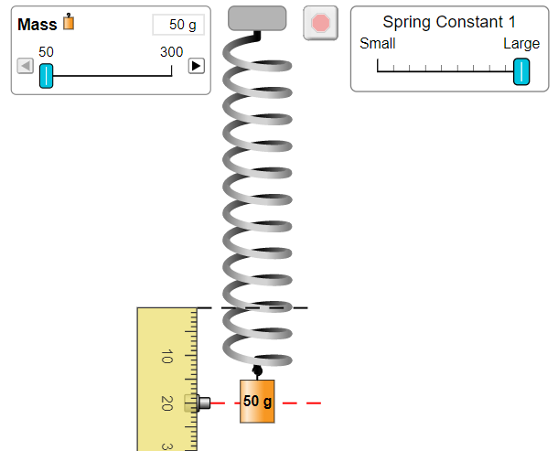  - Start the simulation by clicking on the Pause/Play button. Using the built-in stopwatch, determine the time it takes the 50-g mass to make 10 complete oscillations. Make two trials.  - Adjust the starting position to 40 cm and repeat procedure no. 4. Record your measurements and calculations in Data Table I.  Data Table 1  Starting Position Time for 10 complete oscillations (s) Frequency (Hz)  Trial 1 Trial 2 Ave.  20 cm  40 cm  QUESTIONS:  - What does the starting/initial position of the 50-g mass represent?  - What happens to the length of the path travelled by the 50-g mass when the starting position is increased from 20 cm to 40 cm? What happens to its speed?  - Does the starting position of the object affect the frequency of the object-spring system? Explain.
Frequency and Spring Constant | - Set the following parameters:  Simulation PAUSED  Mass 50 g  Spring Constant 1 1 unit from “Small”  Mass Equilibrium Enabled  Movable Line Enabled  Gravity Earth  Damping None  Simulation Speed Slow  Starting position from equilibrium line 30 cm  - Run the simulation by clicking on the Start/Stop button. Determine the frequency of oscillation of the 50-g mass.  - Using the same parameters in (1), make several trials, each time, increasing the spring constant by 2 units from “Small” until the spring constant = 9 units. In each trial, make sure that the starting position is always kept at 30 cm below the equilibrium line. Summarize your measurements in Data Table 2.  Data Table 2  Spring constant k Frequency of Oscillation  1  3  5  7  9  - Using a spreadsheet, plot the values of the frequency against the values of the spring constant. Describe the graph formed.  - Plot the values of f² against the values of k. Describe the graph formed.  QUESTIONS:  - What happens to the frequency of oscillation of the mass-spring system as the spring constant increases?  - What does the graph of f² against k suggest about the relationship between the frequency and the spring constant? Explain
Frequency and Mass | - Set the following parameters:  Simulation PAUSED  Mass 50 g  Spring Constant 1 LARGE  Mass Equilibrium Enabled  Movable Line Enabled  Gravity Earth  Damping None  Simulation Speed Slow  Starting position from equilibrium line 30 cm  - Run the simulation. Determine the frequency of oscillation of the 50-g mass.  - Using the parameters in (1), make several trials, in each time increasing the mass of the object by 50 g until the mass equals 300 g. For each trial, make sure to set the starting position from the equilibrium line to 30 cm. Enter your measurements in Data Table 3  Data Table 3  Mass (g) Frequency of Oscillation (Hz)  50  100  150  200  250  300  - Plot the values of the frequency against the values of the mass. Describe the graph formed.  - Plot the values of f² against the values of 1/m. What is the shape of the graph?  QUESTIONS:  - What happens to the frequency of oscillation as the mass of the oscillator increases?  - What does the graph of f² against 1/m suggest about the relationship between f and m? Explain.
CONCLUSION(S)
GOING FURTHER | In the simulation, the mass of the blue and the red weights are not known. Develop a procedure on how you will determine the masses of these objects.

