

Worksheet (conservation of Mechanical Energy) Using Phet Interactive Simulation

**Dep. Of Applied Physics and Astronomy University of Sharjah**

**Name: ID#:**

To be familiar with mechanical energy, kinetic energy and , potential energy, velocity, x component of the velocity, y component of the velocity, height from zero potential energy level, the distance traveled in vertical direction, the horizontal distance travelled by the object, the acceleration due to gravity, and other controllers using Phet simulation kindly, open the following link and play with it.

<https://phet.colorado.edu/en/simulation/legacy/energy-skate-park>

**Objectives:**

The objective of this experiment is to study the law of conservation of energy.

**Theory:**

Energy is defined as the ability to do work. It is measured in joules (J). Energy exists in many forms like mechanical, electrical, magnetic, nuclear, etc. The total energy of a system is conserved according to the law of conservation of energy.

In this experiment we are going to apply this law to mechanical energy. In the absence of any non-conservative force, the total mechanical energy is conserved. This mechanical energy (E) consists of two parts: kinetic energy (K) and potential energy (U). The kinetic energy also consists of two parts which are translational and rotational. But in this experiment, we will consider only the translational part of the kinetic energy. Also, there are many types of potential energy, but we will consider only the gravitational potential energy. This potential energy (U) depends on the position of the object and the reference we take. As an example, if the floor is the reference, then for an object of mass (m) at a height (y) above the reference (the floor), the potential energy is given by: U = mgy, where (g) is the acceleration due to gravity.

The kinetic energy (K) of an object of mass (m) and moving with speed (v) is given by: .The total mechanical energy is given by E = U+K.

In the absence of non-conservative forces, the total mechanical energy is conserved and then,

 , which represents the principle of conservation of mechanical energy.

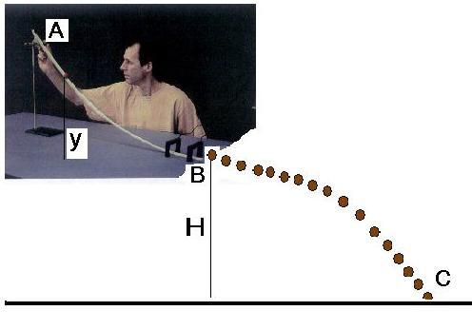In the figure shown

EA=EB=EC

To verify the principle of conservation of mechanical energy open the following link and do the following steps

<https://phet.colorado.edu/en/simulation/legacy/energy-skate-park>

1. From the link window, click on the arrow and then open the simulation window. You can change the track as you like by clinking on the blue circles, choose zero reference potential energy and choose the skater shape and drag the meter to the play area and now you are ready to start your experiment and collect data.
2. Place the track as shown in the figure below, fix the simulation speed less than the middle point.
3. Record in table 1 the mass of the skater and the height H (H=constant)

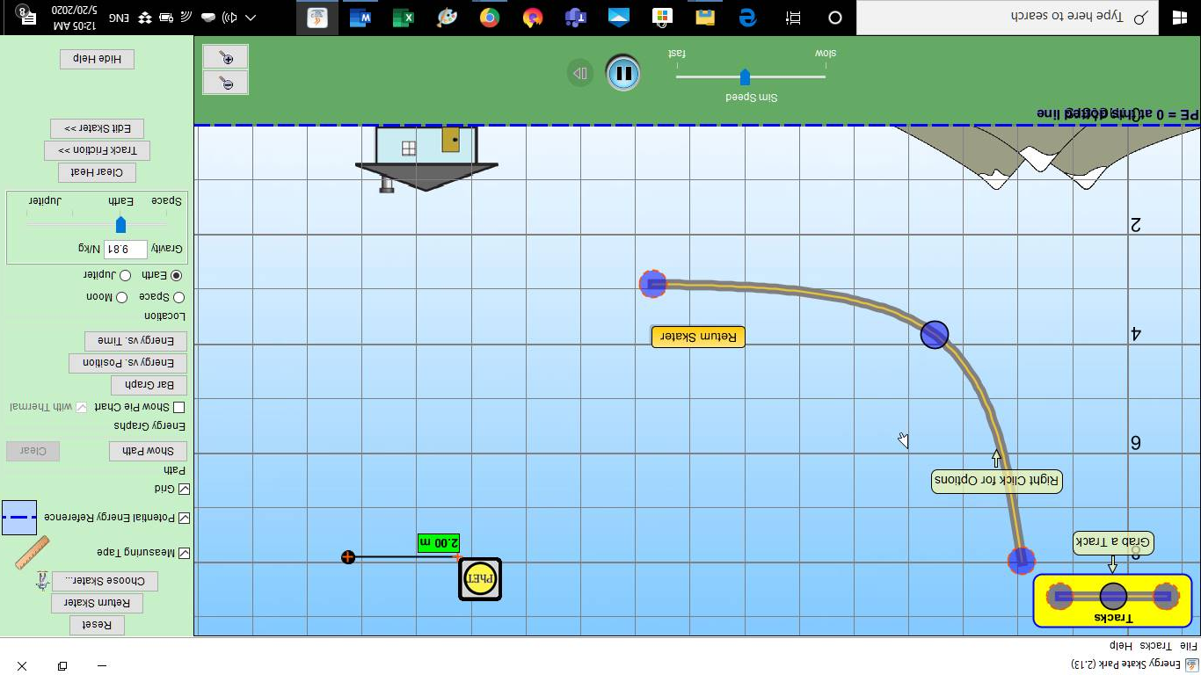

C

B

A

O

H

Y

Meter

1. Set the skater at point A (y=8m), Run the experiment and measure x (the horizontal distance between O and C).
2. Change y to 7m and the release the skater, then measure new x.
3. Repeat step 5 for different y and record your data in table 1.

**Data Analysis:**

1. At point (A) the ball only has potential energy (U). Calculate (U) for each value of (y) then calculate EA= UA. Record your results in table 1.
2. At point (C) on the floor where the ball hits the timer plate, it only has kinetic energy (KC), so EC = KC.
3. The speed (vC) at point (C) has two components, the horizontal (vCx) and the vertical (vCy). Calculate (vCx) and (vCy) for each value of (y).
4. Calculate 
5. Calculate the kinetic energy at point (C). Record your data in table 2.
6. At point (B) the ball has both potential (U) energy and kinetic energy (K). Determine the speed at point ( B ). (VB =VCX, horizontal projection).
7. Calculate the kinetic energy at (B) for each value of (y).
8. Calculate the potential energy at B. (UB=mgH=constant)
9. Calculate the total energy (EB) at point (B).Record your results in table 3.

11- Calculate EA – EB, and EB – EC and record your results in table 4.

12- Compare the values of EA, EB, and EC for the same value of (y), then write your conclusion.

***Note: fill the all constant values in the side table***

|  |  |  |  |
| --- | --- | --- | --- |
| y (m ) | KA ( J ) | UA = mg ( y) ( J ) | EA ( J ) |
| **8** | **0** | **4800** | **4800** |
| **7** | **0** | **4200** | **4200** |
| **6** | **0** | **3600** | **3600** |
| **5** | **0** | **3000** | **3000** |
| **4** | **0** | **2400** | **2400** |

**Table 1**

|  |  |
| --- | --- |
| ***Constant quantities*** | |
| ***g*** | ***9.81m/s2*** |
| ***m*** | ***60Kg*** |
| ***H=*** | ***3m*** |
| ***UB*** | ***1800J*** |
| ***KA*** | ***0*** |
| ***Uc*** | ***0*** |
| ***VBy*** | ***0m/s*** |
| ***Tb-c*** | ***0.7746*** |
| ***Vcy*** | ***7.756*** |

**Table 2**

**(at point B, horizontal projection, VBy=0**

**For different y and constant H, Vcy=(2gH)1/2=constant**

**UC=0**

**Vcy=gt, then t for each y is constant (t=Vcy/g)**

**Vcx=x/t**

|  |  |  |  |  |  |  |  |  |
| --- | --- | --- | --- | --- | --- | --- | --- | --- |
| y  (m) | X  (m) | t  ( s ) | Vcx  (m/s) | | (m/s) 2 | (m/s )2 | (m/s)2 | |
| **8** | **7.64** | **0.7756** | **9.85** | | **97.02** | **60.156** | **457.176** | |
| **7** | **6.86** | **0.7756** | **8.845** | | **78.23** | **60.156** | **138.386** | |
| **6** | **5.97** | **0.7756** | **7.7** | | **59.3** | **60.156** | **119.456** | |
| **5** | **4.75** | **0.7756** | **6.12** | | **37.45** | **60.156** | **97.606** | |
| **4** | **3.46** | **0.7756** | **4.46** | | **19.9** | **60.156** | **79.756** | |
|  |  |  |  | |  |  |  | |
| KC(J) | | | | EC (J) | | | |
|  | | | |  | | | |
|  | | | |  | | | |
|  | | | |  | | | |
|  | | | |  | | | |
|  | | | |  | | | |
|  | | | |  | | | |
|  | | | |  | | | |

**Table 3**

**VB=Vcx**

|  |  |  |  |  |
| --- | --- | --- | --- | --- |
| (m/s) | (m/s)2 | UB (J) | KB(J) | EB= UB + KB  (J) |
|  |  |  |  |  |
|  |  |  |  |  |
|  |  |  |  |  |
|  |  |  |  |  |
|  |  |  |  |  |
|  |  |  |  |  |
|  |  |  |  |  |

**Table 4**

|  |  |  |  |  |  |
| --- | --- | --- | --- | --- | --- |
| y ( m ) | EA ( J ) | EB ( J ) | EC ( J ) | EA-EB ( J ) | EB-EC ( J ) |
|  |  |  |  |  |  |
|  |  |  |  |  |  |
|  |  |  |  |  |  |
|  |  |  |  |  |  |
|  |  |  |  |  |  |
|  |  |  |  |  |  |
|  |  |  |  |  |  |

Write your comments Regarding the total mechanical energy at A, B, and C.

………………………………………………………………………………………………………………

………………………………………………………………………………………………………………

………………………………………………………………………………………………………………

**Questions**

1. Define the energy, and name five of its forms.

………………………………………………………………………………………………………………

………………………………………………………………………………………………………………

………………………………………………………………………………………………………………

1. What is the difference between conservative and non-conservative force? Give an example of each force.

………………………………………………………………………………………………………………

………………………………………………………………………………………………………………

………………………………………………………………………………………………………………

1. Write the principle of conservation of energy.

………………………………………………………………………………………………………………

………………………………………………………………………………………………………………

………………………………………………………………………………………………………………

4- What does each of the quantities (EA-EB)and ( EB-EC ) represent?

………………………………………………………………………………………………………………

………………………………………………………………………………………………………………

………………………………………………………………………………………………………………

5- Write the sources of errors in this experiment.

………………………………………………………………………………………………………………

………………………………………………………………………………………………………………

………………………………………………………………………………………………………………