RESOLUTION OF VELOCITY AND PROJECTILE MOTION

Lab Manual Owner: ___________________________

Name of Team Members:

Date: ___________________________

RESOLUTION OF VELOCITY (VECTOR)

* Find x- and y- components of the following velocity (Same velocity, using different angles) in three different ways.

Picture 1

30 m/s

40 0



1. Using the information of Picture 1.

* X -component = ___________________________
* Y -component = ___________________________

Picture 2

30 m/s

50 0



1. Using the information available in Picture 2.

* X-component = ___________________________
* Y-component = ___________________________

30 m/s

140 0



Picture 3

1. Using the information available in Picture 3.

* X-component = ___________________________

* Y-component = ___________________________

1. Write comments on what you have found when you measured the x-component and y-components of the same velocity in different ways, are the answers the same? Or different? Why?
2. Now go to <https://phet.colorado.edu/en/simulation/projectile-motion>

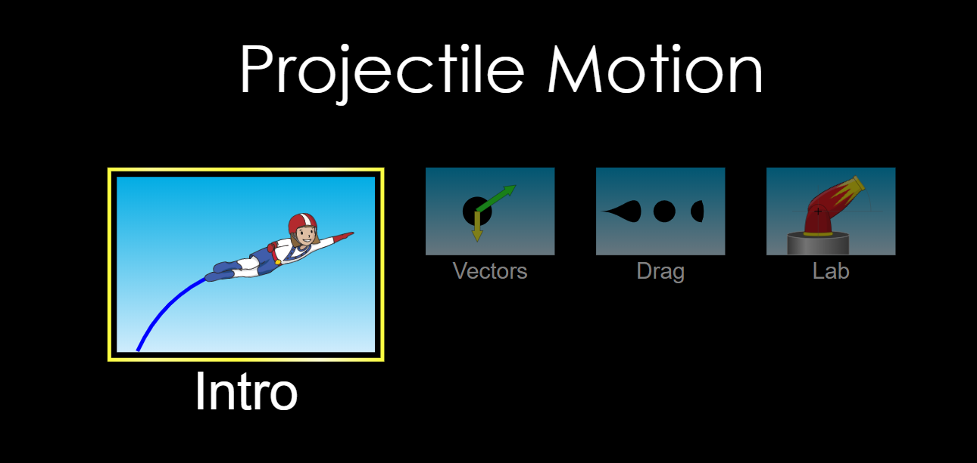 Click the Lab.

Picture 4

1. 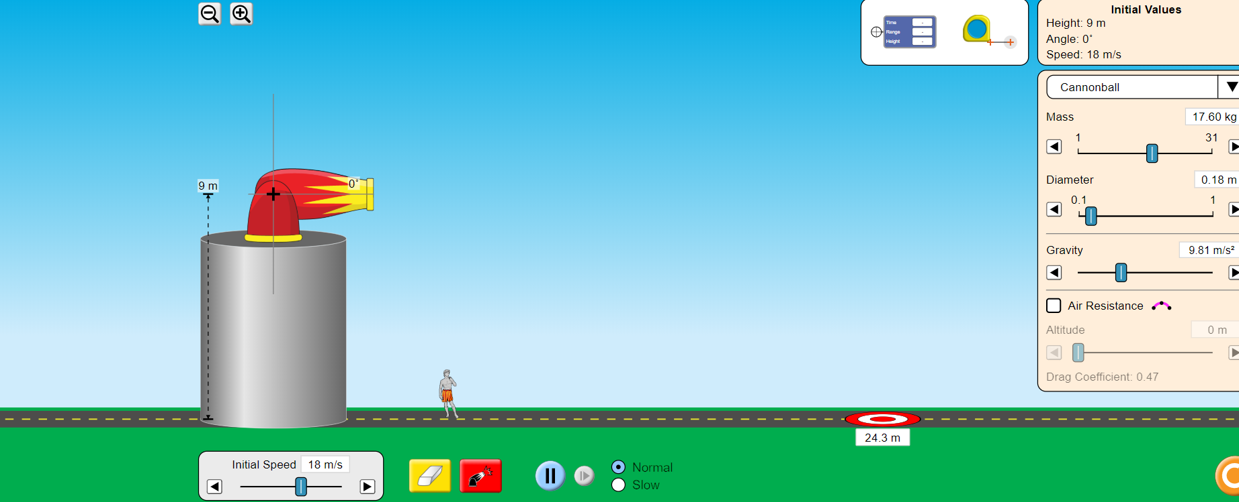 Range Prediction when fired horizontally from a height (At 00 ):

Picture 5

Raise the launcher at certain Height (Your choice but keep between 5-10 meter) as shown in figure (Above). Find out the time it should take for the steel ball to hit the ground using the formula.

$$y_{f }- y_{i } =V_{oy}+\frac{1}{2} a_{y} t^{2}$$

$Since$ $a_{y} is g$, and Vertical Displacement is height, using sign convention you get,

$$Height \left(Y\right)=V_{oy}+\frac{1}{2} g t^{2}$$

[Use magnitude of g = 9.81 m/s2]

You know the height, initial vertical component of velocity is zero as you are launching the projectile horizontally, so solve for time of flight now.

Initial vertical component of velocity is zero ($V_{oy}$ = 0).

Time: t = $\sqrt{\frac{2h}{g}}$ in seconds.

T (Time of flight) = _____________ seconds [Result A]

This time t is theoretical value expected ignoring the air friction and considering g is constant as we do when we derived equations in projectile motion.

1. Experimental Time of Flight Measurement:

Launch the projectile with certain initial velocity in horizontal component, in the figure above (Picture 5) it is 18 m/s but you can change it by yourself (It is necessary to record it, it will be useful later on), put this box at the point where the projectile lands, and check the time.

Picture 6

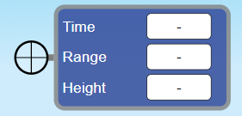

T (Time of flight) = _____________ seconds [Result B]

Calculate the % difference in theoretical value and experimental value.

%Diff = $\frac{Result A\left(Theoretical Value\right)-Result B(Experimental Value)}{Result A \left(Theoretical Value \right)}× 100\%$

Once you have time (t) of flight, now predict the range using the formula: The Range is the displacement in horizontal direction.

$$Range \left(R\right)=V_{ox}+\frac{1}{2} a_{x} t^{2}$$

Note that ax = 0 (Discuss with in your group why we assume ax = 0) =>

R = v0x × t where V0X  is nozzle velocity. (This is theoretical value of Range).

Use nozzle velocity and theoretical calculation of time.

Range (R) = v0x × t = _____________ m (Result C)

1. Experimental Value of Range: Shoot and find out the Experimental value of Range using the box below again as you did for time.

Range = Experimental value = _____________ m (Result D)

Compare with your prediction. Discuss within the group (In the formal report) how accurate you are.

Picture 7

%Diff = $\frac{Result C\left(Theoretical Value\right)-Result D(experimental Value)}{Result C\left(Theoretical Value \right)}× 100\%$

1. Repeat this experiment for different heights in each trial and fill the following table. Time of flight will change accordingly but keep the initial velocity same for all trials.

Initial Velocity (V0x) = _____________ m/s

| Trial | Height (m) | Time of flight (Theoretical in seconds) **(A)**  t = | Time of flight (Experimental)  (seconds) **(B)** | Predicted Range (R)  Range (R) = v0x × t  **(C)** | Experimental Range (R)  **(D)** | % diff (A and B) | % diff (C and D) |
| --- | --- | --- | --- | --- | --- | --- | --- |
| 1 |  |  |  |  |  |  |  |
| 2 |  |  |  |  |  |  |  |
| 3 |  |  |  |  |  |  |  |
| 4 |  |  |  |  |  |  |  |
| 5 |  |  |  |  |  |  |  |
| 6 |  |  |  |  |  |  |  |

1. Prediction of Range in the Symmetrical Track of Projectile. Place the launcher so that its height is zero. Now, Predict the range for different launching angle using equation given in the table. Use the same initial speed for all the data points now.

Initial velocity Vi = ……………………… m/s

Table: Prediction (Do not use the launcher, use the calculator and fill the table), Use V as given in the launcher and g = 9.81 m/s2 as usual.

|  |  |  |
| --- | --- | --- |
| Trial | Launching Angle | Range (In m) |
| 1 | 150 |  |
| 2 | 250 |  |
| 3 | 350 |  |
| 4 | 450 |  |
| 5 | 550 |  |
| 6 | 900 |  |

1. 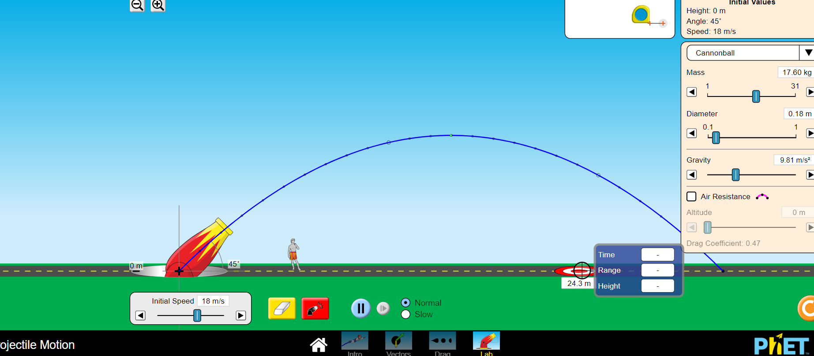Experimental Value of Range in the symmetrical track of projectile. Measure the Experimental value of Range.

Initial velocity Vi = ……………………… m/s

Picture 8

Table: Experimental value (Use the launcher and record the Range in meters).

|  |  |  |
| --- | --- | --- |
| Trial | Launching Angle | Experimental Value of Range (In m). |
| 1 | 150 |  |
| 2 | 250 |  |
| 3 | 350 |  |
| 4 | 450 |  |
| 5 | 550 |  |
| 6 | 900 |  |

Are your results here consistent with the picture shown below (Picture 9)? Note that Picture 9 is shown for initial velocity at 50 m/s, so your range will be different, did you get the maximum range at 450? What about 350 and 550 degrees?

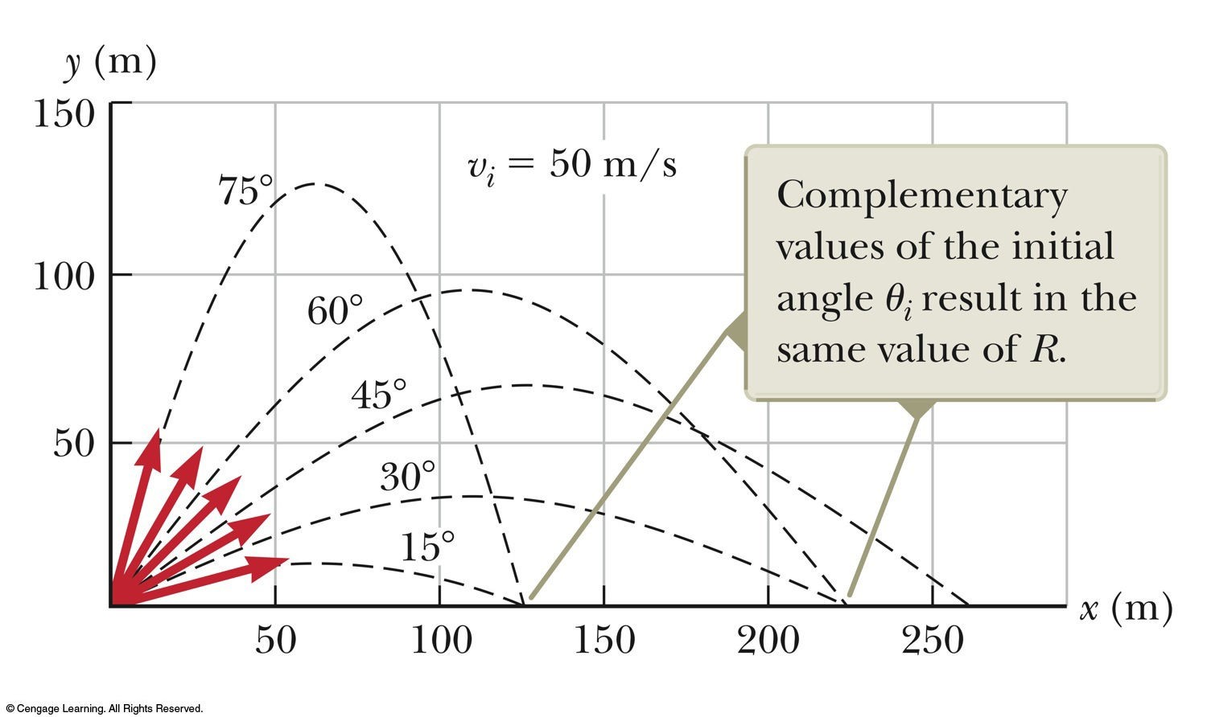Now, you are done, prepare a very nice formal lab and attach this work sheet in there!

Picture 9

*Picture 9 : copy right reserved by : Serway, Raymond A. Physics For Scientists & Engineers with Modern Physics. Philadelphia :Saunders College Pub., 19861983.*

Going Further:

Repeat above experiments with **AIR RESISTANCE ON** and discuss what you observed.