

Worksheet (Free Fall) Using Phet Interactive Simulation

**Dep. Of Applied Physics and Astronomy University of Sharjah**

**Name: ID#:**

To be familiar with Free Fall motion, initial velocity, the distance traveled in vertical direction, the acceleration due to gravity, using Phet simulation kindly, open the following link and play with it.

<https://phet.colorado.edu/sims/html/projectile-motion/latest/projectile-motion_en.html>

### Measuring the Acceleration due to Gravity (g)

**Objectives:**

In this experiment you are going to study the nature of free fall motion by observing the position versus time, then to determine the acceleration of gravity (g) .

**Theory:**

The acceleration that you are going to determine in this experiment is known as the acceleration of free fall. or the acceleration due to gravity. Its value is often taken as 9.81 m/s2 and given the special gravity acceleration symbol (g).

If an object is dropped from a certain height (y) and falls for a time (t), then its equation of motion can be written as:

****Where Vo is the initial velocity which is equal to zero if the object falls from rest, and the previous equation can be rewritten as:

To verify the objective of this part using phet interactive simulation, do the following:

1. Open the following link:

<https://phet.colorado.edu/sims/html/projectile-motion/latest/projectile-motion_en.html>

1. From the home page of this link, click on lab, from lab window use the provided controllers to adjust the height (y) and the velocity of the lunched ball, the mass, the objects shape (see the Figure ). Adjust the first height at 14m and the velocity must be at zero (Free Fall). Release the ball and use the time meter (control the time meter and fix it at the final point of the ball) to measure the time needed for the ball to travel 14m in vertical direction. Record your data in table 1.
2. Change the height (y) to 13m, release the ball and measure the time needed to travel 13m in the vertical direction. Record the new values in table 1.
3. Repeat step 3 to fill table 1.

Timer meter

Velocity

controller

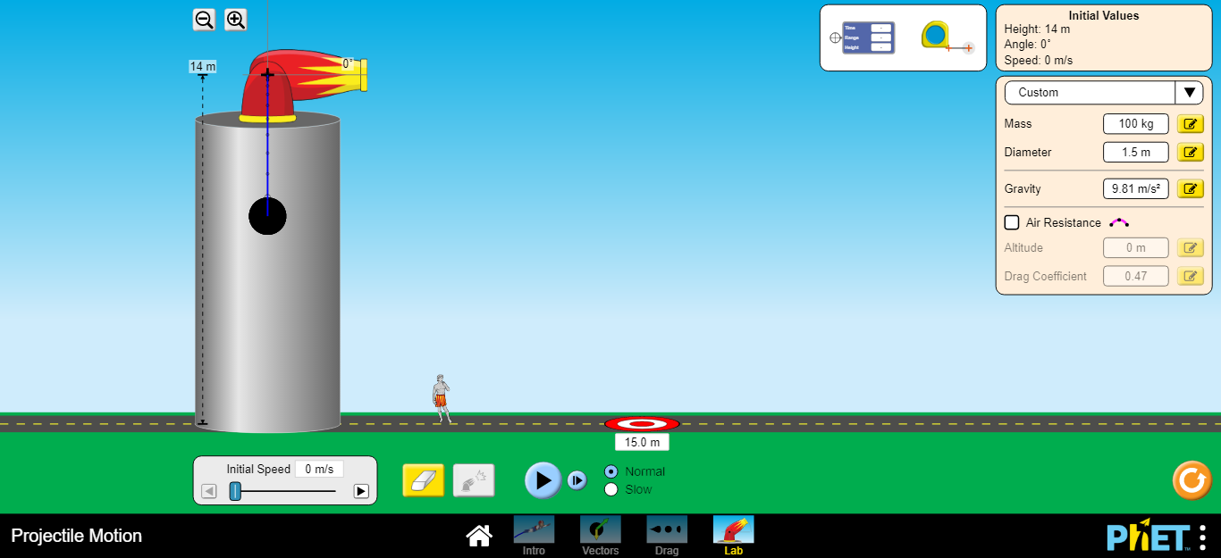

You can control the height (y) by clicking on the + sign on the canon and then move it up or down to change y.

Time meter, click on the +sign and drag it to the final point

Velocity controller

Final point of the ball

**Data Analysis:**

1. Complete table 1, Calculate ½ **t**2.
2. Use Excel software to plot the relationship between ½ **t**2 and y.
3. From the graph find the acceleration of gravity (g) which is equal to the slope.

#### Table 1

|  |  |  |
| --- | --- | --- |
| **y(m)** | **t(s)** |  |
| **14** |  |  |
| **13** |  |  |
| **12** |  |  |
| **11** |  |  |
| **10** |  |  |
| **9** |  |  |
| **8** |  |  |
| **7** |  |  |
| **6** |  |  |
| **5** |  |  |
| **4** |  |  |

**Slope = gexp =**



**Questions:**

1. What is a free fall?

2) When we say g = 9.81 m/s2, what does this mean?

1. Will the value of (g) change greatly in different parts of Sharjah city? Why?

4) Convert the value of g from **m/s2** to cm**/s2** .

5) An object is thrown up from the surface of earth, determine the direction of the acceleration in the following cases:

1. The object is going upward. ( )
2. The object at its maximum height. ( )
3. The object is going downward. ( )