

Worksheet (Projectile Motion) Using Phet Interactive Simulation

**Dep. Of Applied Physics and Astronomy University of Sharjah**

**Name : ID#:**

This activity consists of four parts.

Part one: Ball lunched horizontally from height h.

Part two: Ball lunched by an angle with horizontal (investigate V, a, and F).

Part three: Ball lunched by an angle with horizontal (measure Vx at different positions throughout the object flight)

Part four: Initial velocity and the rang of a projectile.

To be familiar with projectile motion, change projection angle, initial velocity, the distance traveled the components of the velocity and acceleration, and the range of the projectile Using Phet simulation kindly, open the following link and play with it.

<https://phet.colorado.edu/sims/html/projectile-motion/latest/projectile-motion_en.html>

**Part I**

**Objectives:**

In this part, you are going to show that the time of flight of a ball launched horizontally is independent of its initial speed.

**Theory:**

A ball which is launched horizontally (vertical component of its velocity = 0) off a table from a height (h) takes the same amount of time (t) to reach the ground as a ball that drops from rest at the same height. This time does not change as the initial velocity is varied and is given by the equation:

 , where g is the acceleration due to gravity = 9.8 m/s2

To verify the objective of this part using phet interactive simulation, do the following:

1. Open the following link:

<https://phet.colorado.edu/sims/html/projectile-motion/latest/projectile-motion_en.html>

1. From the home page of this link, click on lab, from lab window use the provided controllers to adjust the height (h) and the angle of the projectile at 0o and record them in table 1.
2. Use the velocity controller and the distance measuring icon to measure (x) and control the initial horizontal velocity (vo). Record x and vo in table 1.
3. Calculate the time of flight of the ball using x and vo where t is given by:

t= vo/x

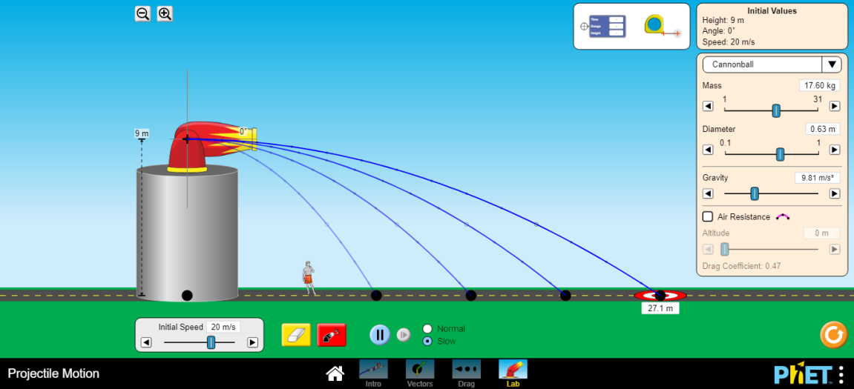

**Table 1**

|  |  |  |
| --- | --- | --- |
| X (m) | (m/s) | T (s) |
|  | 8 |  |
|  | 12 |  |
|  | 16 |  |
|  | 20 |  |

|  |
| --- |
| ***your comments*** |
|  |

**Part II**

**Objectives:**

In this part you are going to verify the following: *(vx=constant, ax=0, ay=9.8m/s2, Fx=0, Fy=mg, vy=voy+ayt)*

Thought-out the projectile flight

**Theory:**

For a projectile motion, the horizontal and vertical motions are independent. In the vertical direction, the projectile accelerates downward as gravity pulls on it. But in the horizontal direction, there is no acceleration and the horizontal component of the velocity is constant if friction is neglected.

*So we can easily say the force is constant and equal the weight of the lunched object, the acceleration of the object is directed down ward and has constant value equal g and the velocity along the x-axis is constant “no acceleration along the horizontal direction“ but the velocity of the projectile along y-axis is variable and depends on the projectile position.*

To verify the objective of this part using phet interactive simulation, do the following:

1. Open the following link:

<https://phet.colorado.edu/sims/html/projectile-motion/latest/projectile-motion_en.html>

1. From the home page of this link, click on vectors, from vectors window use the provided controllers to adjust the height (h=0) and the angle of the projectile at 30o and the initial velocity to be 18m/s.
2. From the side controllers setting, click on components and choose the velocity, Run the software and write your comments regarding the velocity components. (Take screen shot during the projectile motion and attach it to your report.

………………………………………………………………………………………………………

………………………………………………………………………………………………………

1. Repeat step 3, click on components and choose the acceleration, Run the software and write your comments regarding the acceleration components.(take screen shot during the projectile motion and attach it to your report.

………………………………………………………………………………………………………

………………………………………………………………………………………………………

1. Repeat step 3, click on components and choose the force, Run the software and write your comments regarding the force components.(take screen shot during the projectile motion and attach it to your report.

………………………………………………………………………………………………………

………………………………………………………………………………………………………

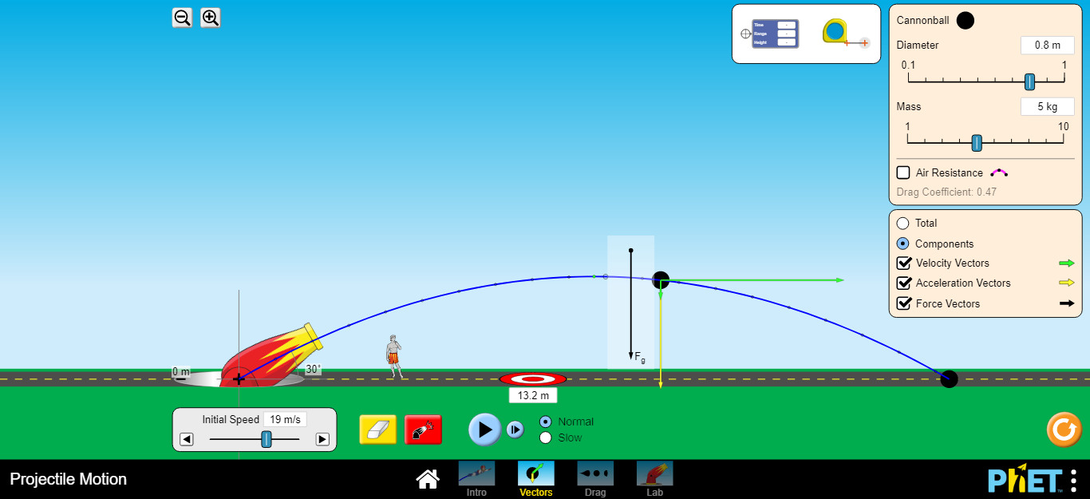

**Part III**

**Objectives:**

In this part you are going to calculate the horizontal component of the velocity of a projectile throughout its flight.

To verify the objective of this part using phet interactive simulation, do the following:

1. Open the following link:

<https://phet.colorado.edu/sims/html/projectile-motion/latest/projectile-motion_en.html>

1. From the home page of this link, click on Intro. Screen, from intro. Screen use the provided controllers to adjust the height (h=0) and the angle of the projectile at 30o and the initial velocity to be 15m/s.
2. Run the software, and get the projectile trajectory.
3. Use the time, range and height meter to measure the time and the x- positon (range at that time instant) of the projectile every o.1sec. Starting from the initial point throughout its flight. Fill your data in the table 2.

**Data Analysis: Part III**

1. Calculate the actual value for the horizontal velocity using the initial speed vo and the projection angle θ. Record your values in table 2.
2. For each position calculate the horizontal velocity. Record your values in table 2.

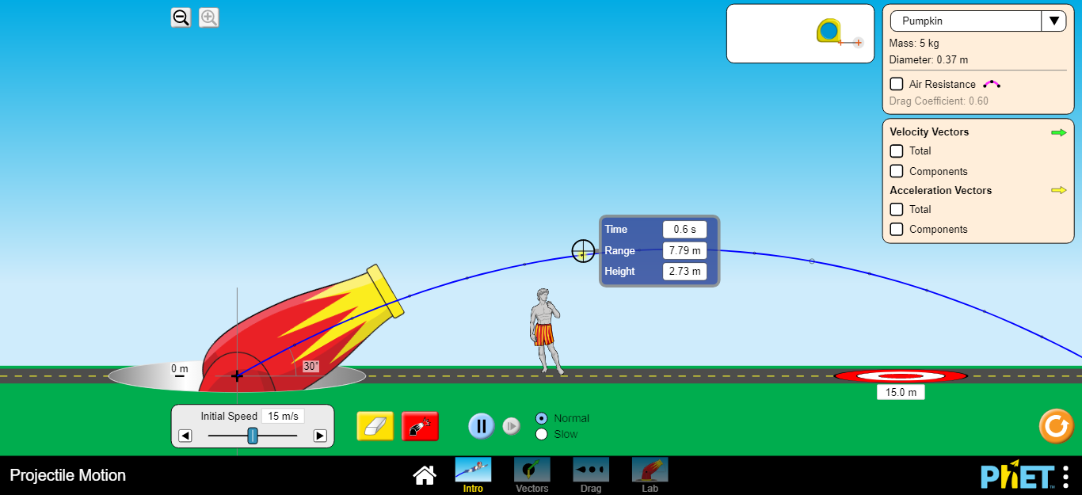

**Table 2**

|  |  |  |
| --- | --- | --- |
| θ **= 30o ,** = 15m/s **, =** | | |
| Time (s) | X(m ) | (m/s) |
| 0.1 |  |  |
| 0.2 |  |  |
| 0.3 |  |  |
| 0.4 |  |  |
| 0.5 |  |  |
| 0.6 |  |  |
| 0.7 |  |  |
| 0.8 |  |  |
| 0.9 |  |  |
| 1 |  |  |

|  |
| --- |
| ***your comments*** |
|  |

**Part IIII**

**Objectives:**

In this part you are invited to study the relationship between the angle of the projectile and its range.

**Theory:**

For a projectile the range (R) depends on the angle of projection (θ) and the initial velocity () as seen from the equation  , where (g) is the acceleration due to gravity. Using this equation, if you plot the relationship between (R) as an ordinate and (sin2θ) as the abscissa you will get a straight line of slope  , so you can find the acceleration due to gravity using this plot.

To verify the objective of this part using phet interactive simulation, do the following:

1. Open the following link

<https://phet.colorado.edu/sims/html/projectile-motion/latest/projectile-motion_en.html>

1. From the home page of this link, click on lab, from lab window place the projectile canon at height h=0, adjust the magnitude of the initial velocity of the lunched object at 20m/s.
2. Adjust the first angle to 25o. Record you data in table 3.
3. Run the software, measure the projectile range (R), record the angle and the range in table 3.
4. Change the angle as shown in table 2, and repeat step3.

**Data Analysis: Part IIII**

1. Calculate (sin2θ).
2. Draw the relationship between (θ) and (R) using (R) as the ordinate.
3. Draw the relationship between (R) and (sin2θ) using (R) as the ordinate.
4. Calculate the slope of this straight line.
5. From the slope calculate the acceleration due to gravity.
6. 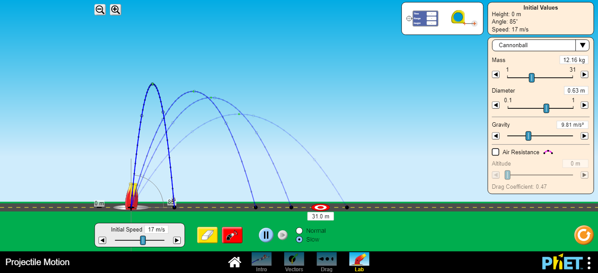Calculate the percentage error in the measured quantity g.

**Table 3**

|  |  |  |
| --- | --- | --- |
| (m/s) | | |
| θ | Sin (2θ) | R (m) |
| 25 |  |  |
| 30 |  |  |
| 35 |  |  |
| 40 |  |  |
| 45 |  |  |
| 50 |  |  |
| 55 |  |  |
| 60 |  |  |
| 65 |  |  |
| 70 |  |  |
| 75 |  |  |
| 80 |  |  |
| 85 |  |  |
| 90 |  |  |

**Slope = = **

*Note: Attach the graphs to your activity*

**Questions:**

1. Derive the following two equations:  , and 

………………………………………………………………………………………………………

………………………………………………………………………………………………………

………………………………………………………………………………………………………

1. Refer to your range and angle graph. What angle corresponds to the maximum range? Explain why this particular angle produces the maximum range.

………………………………………………………………………………………………………

………………………………………………………………………………………………………

4- If a ball is dropped from the same height and at the same time as the ball that was shot horizontally (see figure), which ball would hit the ground first? Explain.









