

Worksheet (Uniformly Accelerated Motion) Using Phet Interactive Simulation

**Dep. Of Applied Physics and Astronomy University of Sharjah**

**Name : ID#:**

To be familiar with control and read a set of physical quantities like angle of the ramp, the coefficient of static friction, and the speed of the object at the end of the ramp, the distance travelled along the ramp using Phet simulation open the following link and play with it.

<https://phet.colorado.edu/en/simulation/legacy/the-ramp>

**Objectives:**

In this experiment you are going to use a linear frictionless ramp to study the nature of uniformly accelerated motion by observing the position versus time of a uniformly accelerated object. The study of the motion of an object on the ramp will be used to accomplish the determination of an experimental value for the acceleration due to gravity (g).

**Theoretical Background:**

When an object undergoes one dimensional uniformly accelerated motion, its velocity increases linearly with time. If it is assumed that the initial velocity of the object is zero at time t=0, then its velocity at any later time (t) is given by v =a t where a is the acceleration which is assumed to be constant in magnitude and direction . Consider a time interval between t = 0 and any later time (t). then, the displacement (*X* ) of the object during the time interval (t) is



given by

**Thus, this latest equation states that if an object is released from rest, its displacement is directly proportional to the square of the elapsed time. Now, consider a glider that is placed on an air track as shown below in (Fig1). It is raised at one end to form an inclined plane with an angle θ .**

**The object moves down the ramp with acceleration (a) that is simply a component of gravity (g). The acceleration due to gravity points directly downwards but it can be resolved into two components that are perpendicular and parallel to the ramp.**

**The component parallel to the ramp is equal to the acceleration (a) and is given by a = g sin θ.**

g



**d**

**y**



**[1]**

To satisfy the objectives do the following steps.

Open the following link to collect your data.

<https://phet.colorado.edu/en/simulation/legacy/the-ramp>

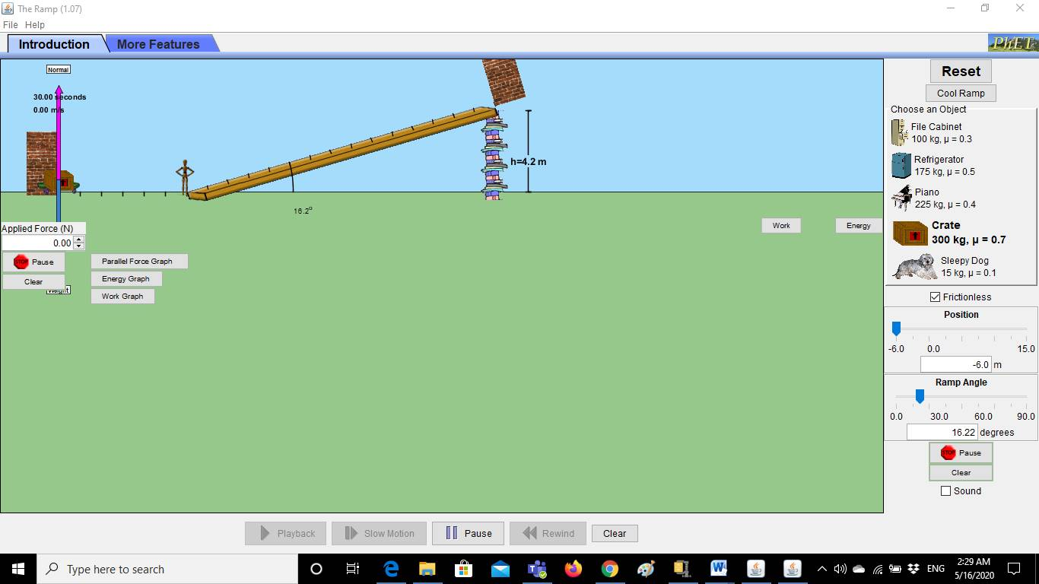



1. Control the height (y) of the ramp, and record it in table below.
2. Control angle (θ) between the ramp and the horizontal level, and record it in table below.
3. Choose your object from the list of objects provided on phet simulation the ramp sim; select the friction surface option to keep the object at rest at the selected position on the ramp.
4. Control the distance that will be travelled along the ramp by the object using the position controller *X* =15m.
5. Once you fixed (*X*), check on frictionless check square to allow the object to slides down the ramp from zero initial velocity.
6. At the end of the ramp read the velocity from the velocity meter displayed on the sim window.
7. Record the measurements as shown in the table below.
8. Calculate the time needed for the sliding object to travel the distance x along the ramp using the following equation:
$$X=(\frac{v_{o}+v_{f}}{2})t$$

9. Repeat steps 5 to 10 and fill you data in the table below.

**Data Analysis:**

1- Use excel software to draw a graph between *X* Vs t2

2- Perform a linear best fit to the data of *X* versus t2, with t2 as the abscissa and *X* as the ordinate .

3- The slope of this fit should be equal to (**a**/2) where **a** is the glider’s acceleration.

4- Calculate the gravity g where .

$$g=\frac{a}{sinθ}$$

|  |  |  |  |
| --- | --- | --- | --- |
|  | **y(m)=** | **sin θ=** | **θ=** |
| *X* (m) | *V* **(m/sec)** | **t (sec)** | t**2 (sec)2** |
| **15** |  |  |  |
| **13** |  |  |  |
| **11** |  |  |  |
| **9** |  |  |  |
| **7** |  |  |  |
| **5** |  |  |  |

**Slope = aexp.=**

**gexp. =**



*Attach the graph to your activity*

***Questions:***

1) A glider on an air track has a uniform acceleration of 0.18 m/s2.What is its velocity after 3 seconds , if it is released from rest.

1. If you draw the relationship between x and t, what is the expected shape of the graph.