

Worksheet (Kirchhoff’s laws) using Phet simulation

**Dep. Of Applied Physics and Astronomy University of Sharjah**

**Name : ID#:**

This activity consists of two Parts

Part one : KCL

Part two: KVL

To be familiar with build up an electrical circuit circuits using Phet simulation open the following link and play with it.

<https://phet.colorado.edu/sims/html/circuit-construction-kit-dc-virtual-lab/latest/circuit-construction-kit-dc-virtual-lab_en.html>

**Objectives**

The objectives of this remote lab are to investigate Kirchhoff’s laws KCL and KVL.

**Part one: KCL**

*The sum of the currents entering any point, in a closed circuit, must equal the sum of the currents leaving it; or the algebraic sum of all currents at that point is zero*. In other words,

ΣI = 0 ……..………….. (1)

This law is a restatement of charge conservation.

To study and satisfy this law experimentally follow the following steps.

1. Use the DC Power supply, the resistors and the connecting wires provided on the simulation software to build up the circuit below

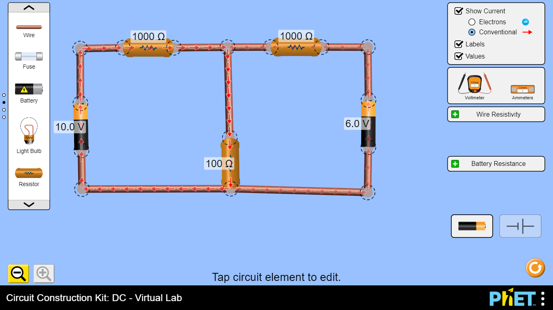

R1 R2

R3

ε1 ε2

R1

R2

R3

ε1

ε2

**Circuit I**

1. Change the power supplies output and the resistor values and observe the currents directions that are changes according to their values.
2. Connect the Ammeters in series with each resistor (as shown below) to measure the current flowing through each resistor record your values in table 1.

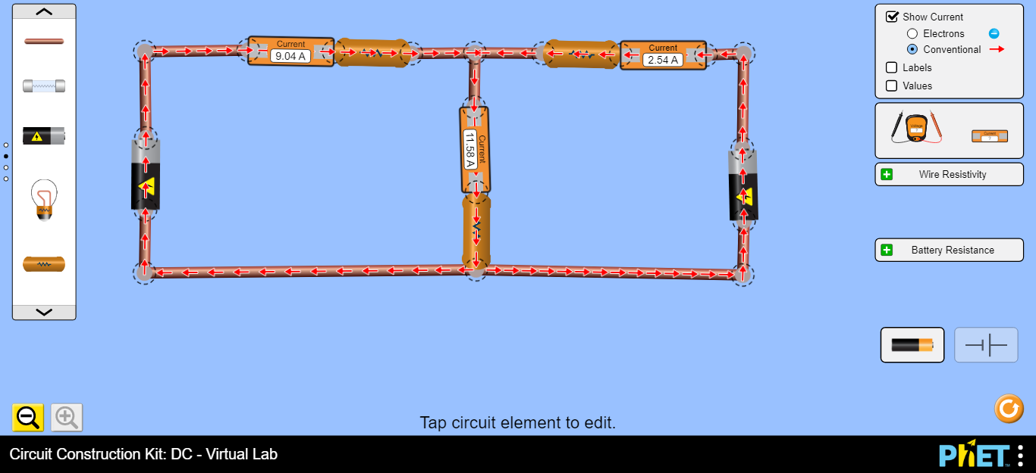

Loop 1

Loop 2

ε2

ε1

I1

I2

I3

1. Is Kirchhoff’s current law satisfied? Explain your answer.

………………………………………………………………………………………………

………………………………………………………………………………………………

………………………………………………………………………………………………

**Part Two: KVL**

*The algebraic sum of the changes in potential around any closed path of a closed circuit is equal to zero. In mathematical terms, this statement can be expressed as:*

Σε + ΣIR = 0 ……………… (2)

This law is a restatement of energy conservation.

To study and satisfy this law experimentally follows the following steps.

1. Connect the voltmeter in parallel with each resistor (as shown below) to measure the voltage drop across it; fill your data for the voltages in the table 1.

IV1

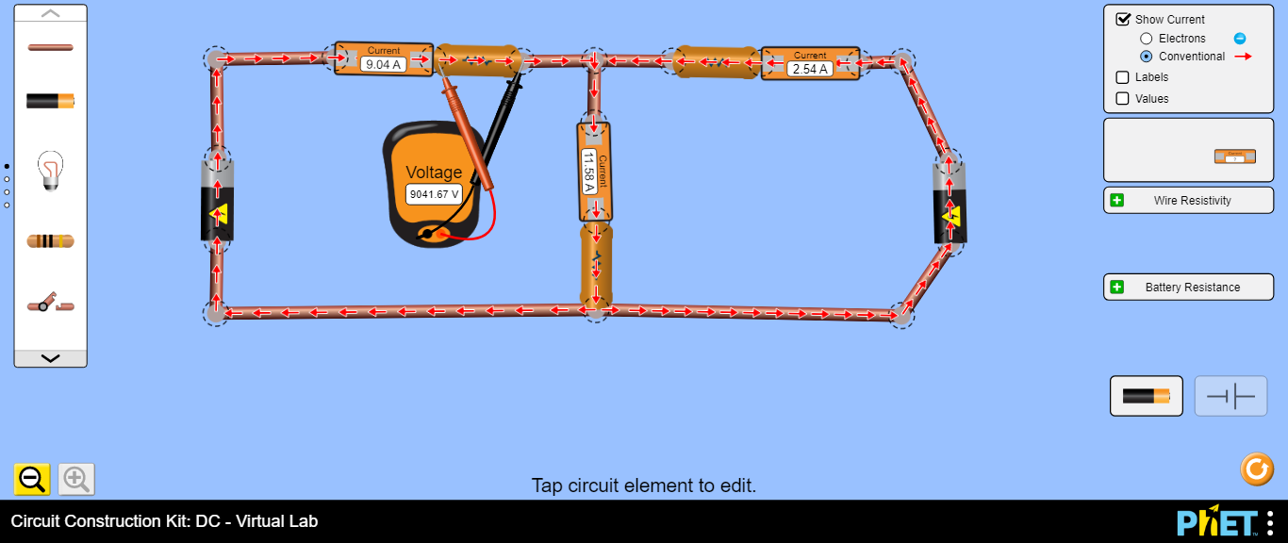

Measuring the voltage drop across R1

V2

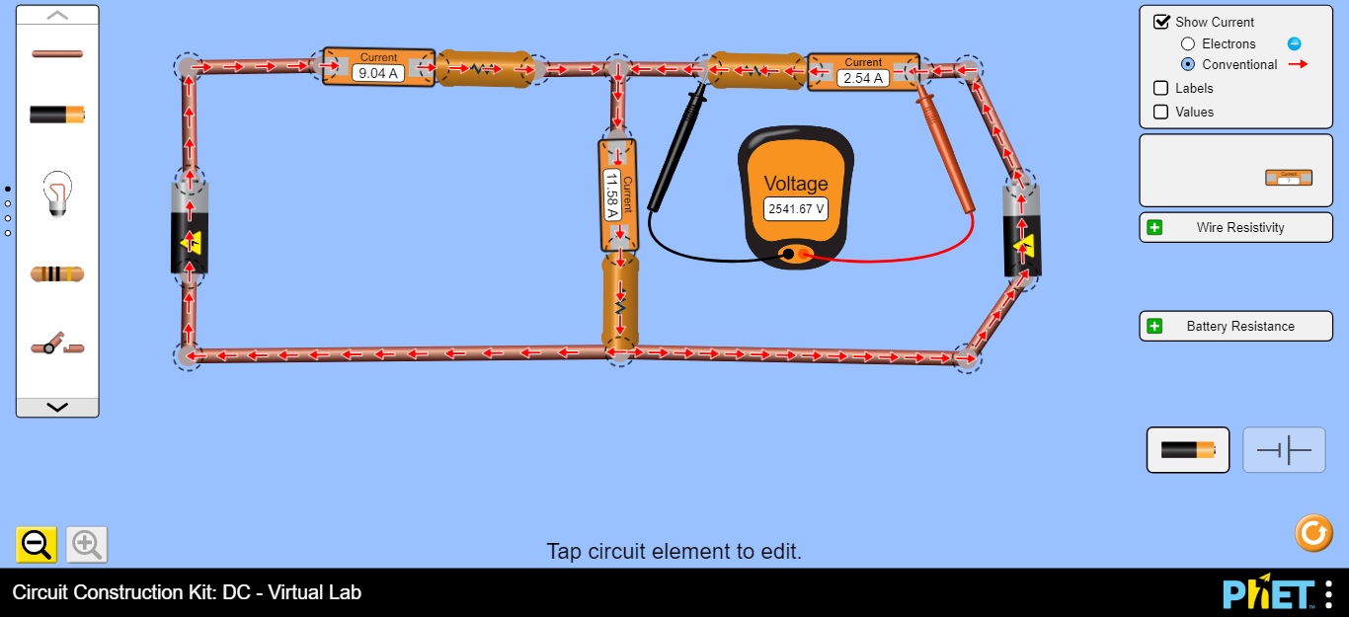

Measuring the voltage drop across R2

Measuring the voltage drop across R3

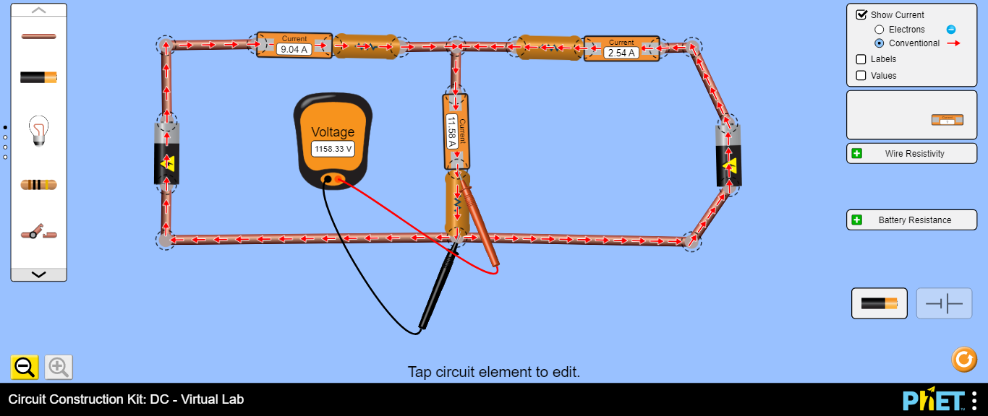

*Note: the readings of the Ammeters and Voltmeters shown on the devices are not the ones related to your correct circuit, you have to measure your own values according to your circuits.*

**Data Analysis and Discussion**

**Circuit 1:**

1. Using both KCL & KVL, calculate the currents & voltages of each resistor shown in Circuit I, and record the results in Table 1 below.

Kirchhoff’s equations are as following:

I1+I2 =I3 ( KCl) …………… eq. 1

ε1-I1R1-I3R3=0 (KVL loop 1)……. .eq.2

ε2-I2R2-I3R3=0 (KVl loop 2)………eq. 3

***Equations solution by substation***

…………………………………………………………………………………………………………

…………………………………………………………………………………………………………

…………………………………………………………………………………………………………

…………………………………………………………………………………………………………

…………………………………………………………………………………………………………

…………………………………………………………………………………………………………

…………………………………………………………………………………………………………

…………………………………………………………………………………………………………

…………………………………………………………………………………………………………

…………………………………………………………………………………………………………

…………………………………………………………………………………………………………

…………………………………………………………………………………………………………

…………………………………………………………………………………………………………

…………………………………………………………………………………………………………

**Table 1**

|  |  |  |  |  |  |
| --- | --- | --- | --- | --- | --- |
| ε1 = …………………. ε2 = ………………… | | | | | |
| **Experimental results** | | | **Calculated results** | | |
| R (kΩ) | I (mA) | V (volt) | R (kΩ) | I (mA) | V (volt) |
| 1 |  |  | 1 |  |  |
| 1 |  |  | 1 |  |  |
| 0.1 |  |  | 0.1 |  |  |

1. From Table 1, are there any differences between the experimental and the calculated values (for voltages & currents)? If so, explain why. Also find their percentage error.

………………………………………………………………………………………………………………

………………………………………………………………………………………………………………

………………………………………………………………………………………………………………

………………………………………………………………………………………………………………

………………………………………………………………………………………………………………

1. Using your Experimental values of I1, I2 and I3. Has Kirchhoff’s current law (KCL) been satisfied? Explain.

………………………………………………………………………………………………………………

………………………………………………………………………………………………………………

………………………………………………………………………………………………………………

………………………………………………………………………………………………………………

1. Using your experimental measurements of V1, V2 and V3 verify Kirchhoff’s voltage law (KVL) for each loop in circuit 1.

………………………………………………………………………………………………………………

………………………………………………………………………………………………………………

………………………………………………………………………………………………………………

………………………………………………………………………………………………………………

***Extra circuit***

For extra practice on Kirchhoff’s laws, connect circuit II and do currents and voltages measurements using the ammeter and the voltmeter and show your findings on the table below.

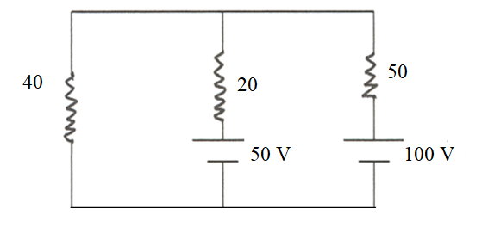

Ω

Ω

Ω

|  |  |
| --- | --- |
| **Quantity** | **Value** |
| R1 | 20Ω |
| R2 | 40Ω |
| R3 | 50Ω |
| I1 (through R1) | …….. |
| I2 (through R2) | …….. |
| I3 (through R3) | …….. |
| V1 | …….. |
| V2 | …….. |
| V3 | …….. |

**Circuit II**