Prelab question: Use pages 582 - 587 and lecture
- (pg 582) Fission is the use of to cause a large nucleus to
- (pg 583,) A chain reactions is

- (pg 585,) Critical mass is

- (pg 585,) Control rods are

Video lecture
- What is needed / used to start a fission reaction______________
- What is the principal element used in nuclear fission?
- What special property does this element have?
- What three main parts make up the reactor core in a nuclear power plant?

- Why are nuclear power plants required to have a containment structure around the reactor?

- Why can nuclear reactors never produce a chain reaction?

- What is the same about nuclear reactors and nuclear weapons?

- What is the major DIFFERENCE between nuclear reactors and weapons?

- Identify and name each of the following:
a. ¹₀n
b. ²³⁵U
c. ²³⁸U
d. ²³⁹Pu

Download and open the fission simulation. Click on the “CHAIN REACTION” tab
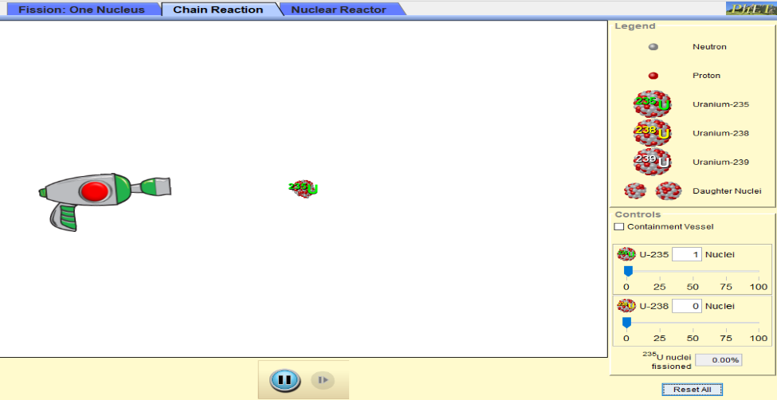
Identity of particles
Number of each isotope present
Move blue tab to change

Reset button
Click and hold on the end of the gun to aim, click red button on gun to fire neutron

- Add about 20 atoms of Uranium- 238 (yellow). Slide the blue tab for U-238 over. Click the red button on the gun to fire a neutron at the U-238. Fire several neutrons at different atoms of U-238. Click and hold on the end of the gun to change the aim.
- What happens to U-238 when a neutron hits the atom?
- Click “reset all”. Add about 20 atoms of Uranium- 235 (green). Slide the blue tab for U-235 over. Click the red button on the gun to fire a neutron at the U-235.
- What happens to U-235 when a neutron hits the atom?
- Repeat step 3, do all the U-235 split when only one neutron is fired from the gun?
- Repeat step 3, however, now set the blue tab for U-235 to 50 atoms.
- How many of the U-235 are left after one neutron is fired from the gun?
- Click “reset all”. Repeat step 6 several time until you have reached critical mass. Remember critical mass is when there are enough atoms present to cause a chain reaction where all nuclei are split.
- What number to you need to have present for critical mass?
- Is this reaction controlled or uncontrolled Fission?
- Why is uranium-235 the only isotope of uranium that can be used as fuel for a nuclear weapon?

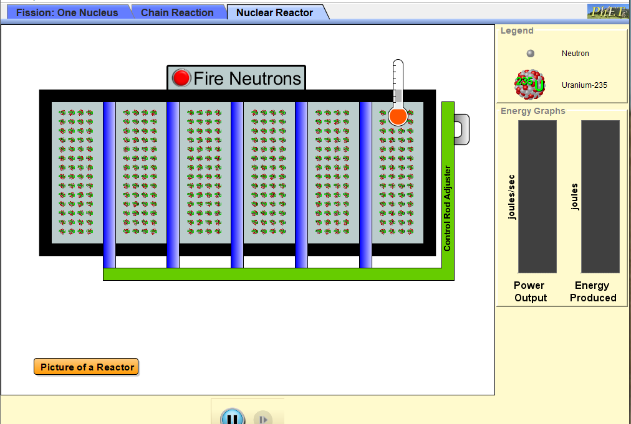
Click on the “NUCLEAR REACTOR” tab, BLUE rods are the control rods. The GREEN atoms are U-235
- Click the red button to fire and neutron into the core. Why is this called a “controlled fission reaction”?

- Use green handle labeled “CONTROL ROD ADJUSTER” to lower the blue control rod all the way down. Click the red button again to add another neutron. What happens to the uranium atoms?

- Click the “RESET NUCLIE”. Click the red button to add a neutron. Adjust the control rods up into the reactor.
- Repeat step 3 several times, changing how far the control rods are inserted into the reactor
- What happens to the neutron that hit the control rods?
- What happens to the neutron that hit the U-235?
- Why are they called control rods?

