You will be using the Phet simulation, “build an atom” if the canvas link does not work, use the link above. Click on the lithium box labeled SYMBOLS to begin
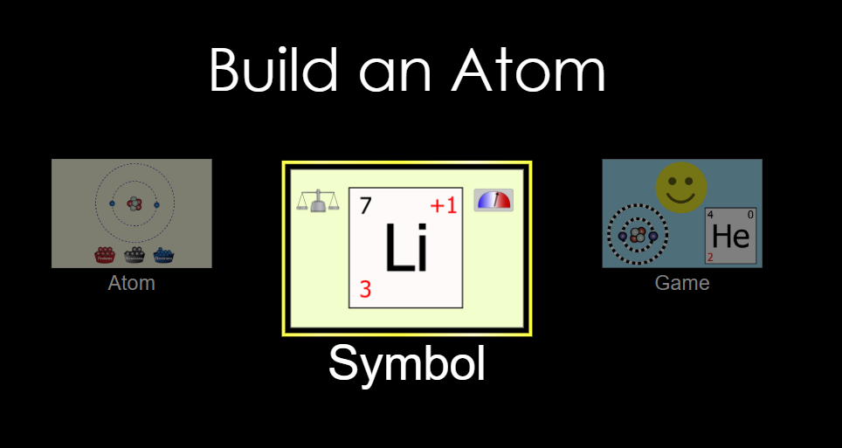
- Add one proton.
- Where in the atom does it go?
- What is the symbol of the element?
- What is the mass?
- What is the charge?
- Add one neutron.
- Where in the atom does it go?
- What is the symbol of the element?
- What is the mass?
- What is the charge?
- Add one electron.
- Where in the atom does it go?
- What is the symbol of the element?
- What is the mass?
- What is the charge?
- Click the STABLE/UNSTABLE box at the bottom. Is this isotope stable or unstable?
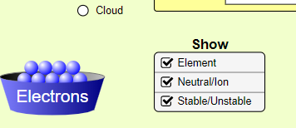
- Take the number of protons divided by number of neutrons, what does it equal: p/n =
- Add one more neutron.
- Is the atom still stable?
- What is the value of p/n? p/n =
- Add one more proton.
- What element is formed?
- What is the symbol of the element?
- What is the mass?
- What is the charge?
- Is the atom stable?
- What is the value of p/n? p/n =
- Add one more proton.
- What element is formed?
- What is the symbol of the element?
- What is the mass?
- What is the charge?
- Is the atom stable?
- What is the value of p/n? p/n =
- Add more electron. Does the number of electron determine if an atom is stable?

- Add one more neutron.
- Is the atom stable?
- What is the value of p/n? p/n =
- Build an isotope of fluorine that is stable
- How many protons?
- How many neutrons?
- What is the value of p/n? p/n =
- What determines the mass of the isotope?
- What determines what element it is?
- What determines if an isotope is stable?

