

**Dep. Of Applied Physics and Astronomy University of Sharjah**

**Capacitors II**

**Name : ID#:**

**Construct the following electrical circuit (Capacitor), using PhET simulation, or using the following link.**

<https://phet.colorado.edu/en/simulation/legacy/capacitor-lab>

Today we will be exploring the energy stored in a capacitor, behavior of capacitors with and without dielectrics, and the capacitor connection (series and parallel). You will complete the virtual lab using the Capacitor Lab from Phet, data analysis software (Excel) and this document. Each member of the lab group must complete this important assignment.

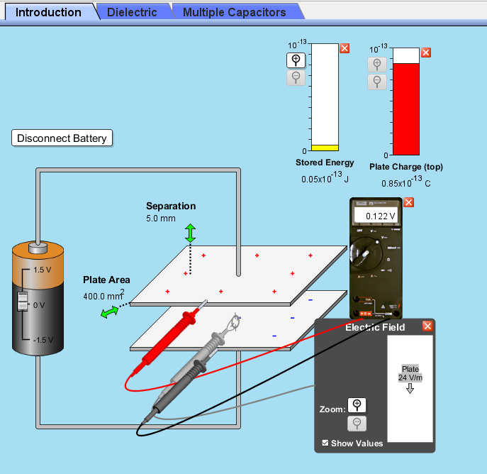

**First part**

**Energy stored in the capacitor versus Voltage**

1. Open the (<https://phet.colorado.edu/en/simulation/capacitor-lab>)
2. Set the plates to the minimum area (400.0 mm2), maximum separation (5.0 mm) and maximum
3. Using the provided meters ( charge, energy, Electric field E, and voltmeter) in the simulation complete the following data table
4. Calculate the capacitance using, this the real value.
5. Increase the voltage from the battery and record the values of the voltage across the capacitor(V), Charge on the plate(Q), and energy stored (U)

|  |  |  |  |  |  |  |  |  |
| --- | --- | --- | --- | --- | --- | --- | --- | --- |
| Separation d ( m) Plate Area A ( m2) Capacitance  ( F) | | | | | | | | |
| Trial | Potential difference V (V) | Charge Q (C) | Stored Energy U (J) | Electric Field between plates E (V/m) | V2 ( volt)2 | Q2 (C2) | E2(V/m)2 | Stored Energy Density *u*(J/m3) |
| 1 |  |  |  |  |  |  |  |  |
| 2 |  |  |  |  |  |  |  |  |
| 3 |  |  |  |  |  |  |  |  |
| 4 |  |  |  |  |  |  |  |  |
| 5 |  |  |  |  |  |  |  |  |
| 6 |  |  |  |  |  |  |  |  |
| 7 |  |  |  |  |  |  |  |  |
| 8 |  |  |  |  |  |  |  |  |
| 9 |  |  |  |  |  |  |  |  |
| 10 |  |  |  |  |  |  |  |  |

1. Use Excel to plot the relationship between (V2, U), using V2 in the most left column in Excel.
2. Use the equation, to determine C0 using the slope of the graph.
3. Compare this value of C0 with C0 in the table. Calculate the percentage error.
4. Attach the graph to your data report.
5. Use Excel to plot the relationship between (Q2, U), using Q2 in the most left column in Excel.
6. Use the equation, to determine C0 using the slope of the graph.
7. Compare this value of C0 with C0 in the table. Calculate the percentage error.
8. Attach the graph to your data report.
9. Use Excel to plot the relationship between (E2, u), using E2 in the most left column in Excel.
10. Use the equation, to determine  using the slope of the graph.
11. Compare this value of  with  =8.85x10-12 F/m. Calculate the percentage error.

**Second part**

**Dielectrics and Capacitance**

1. Open the (<https://phet.colorado.edu/en/simulation/capacitor-lab>)
2. Click on the “Dielectrics” tab.
3. Set the plates to the area A between (195- 205 mm2), separation d between (7.5- 8.5 mm), maximum positive battery voltage (1.5 V) and minimum dielectric constant (1) with zero offset to begin. See fig. below.

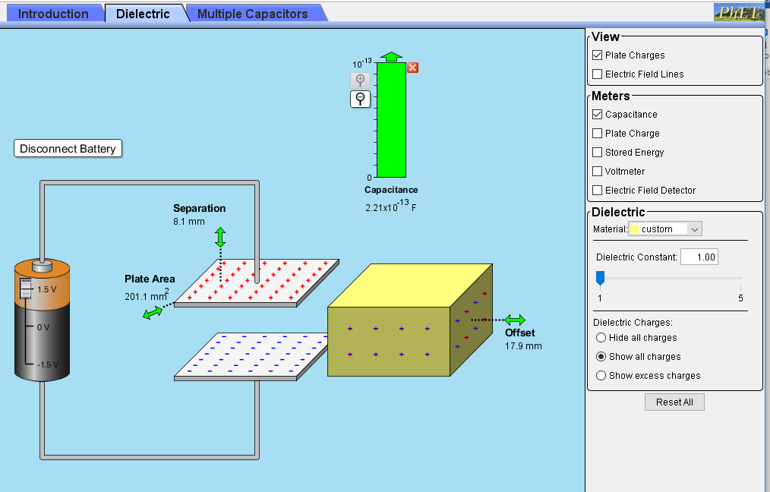

1. Determine the value of  and compare it to the value from the par chart.
2. Insert the dielectric material in the capacitor, and determine the value of the capacitance C (in F)
3. Change the value of the dielectric constant K then complete the following data table (keep the plate separation and area constant through all trials)

|  |  |  |
| --- | --- | --- |
| C0 = F | | |
| Trial | Dielectric Constant  K | Capacitance (F)  C |
| 1 | 1 |  |
| 2 | 1.5 |  |
| 3 | 2 |  |
| 4 | 2.5 |  |
| 5 | 3 |  |
| 6 | 3.5 |  |
| 7 | 4 |  |
| 8 | 4.5 |  |
| 9 | 5 |  |

1. Draw the best fit using Excel between (K, C), and find the slope of the line.
2. Attach the graph to your lab report.
3. Use the equation, determine C0 and compare it to the value.
4. Calculate the percentage error in C0.

**Third part**

**Dielectrics and Capacitance (Battery Connected)**

1. Open the (<https://phet.colorado.edu/en/simulation/capacitor-lab>)
2. Click on the “Dielectrics” tab.
3. Set the plates to the area A between (195- 205 mm2), separation d between (7.5- 8.5 mm), maximum positive battery voltage (1.5 V) and minimum dielectric constant (1) with zero offset to begin.
4. Using the provided meters (charge, energy, Electric field E, and voltmeter) in the simulation complete the following data table

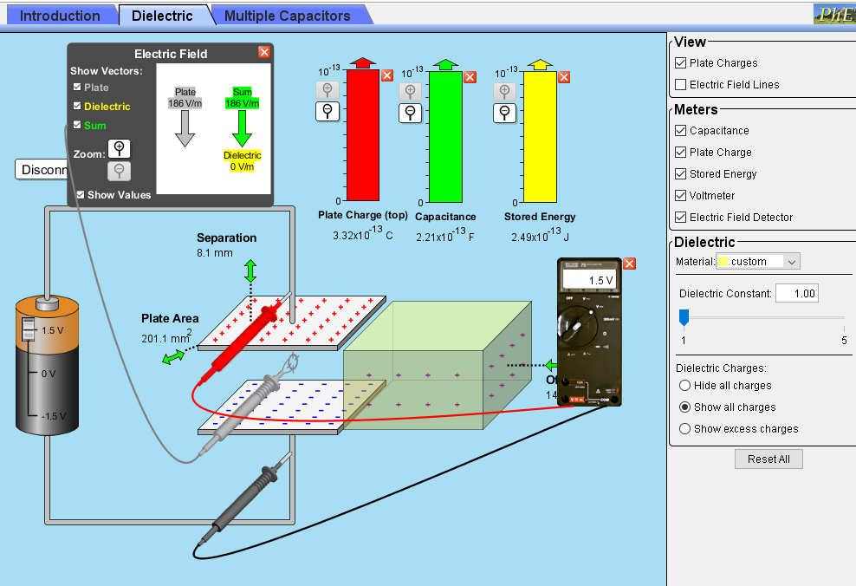

1. In the table below record the values of Capacitance C0, Electric field E0, stored energy U0, and charge on p late Q0 and potential difference V0.
2. Slide the dielectric inside the capacitor and record the values shown in the table below.

|  |  |  |  |  |  |  |  |  |
| --- | --- | --- | --- | --- | --- | --- | --- | --- |
| C0  = F , E0 = V/m , Q0 = C , U0 = J , V0 = V | | | | | | | | |
| Trial | Dielectric Constant  K | Capacitance C (F) | Stored Energy  U (J) | Plate Charge Q (C) | Electric Field between the plates E0 (V/m) | Electric Field in Dielectric Ei (V/m) | Sum Electric Field between E (V/m) | V ( Volt) |
| 1 | 1 |  |  |  |  |  |  |  |
| 2 | 1.5 |  |  |  |  |  |  |  |
| 3 | 2 |  |  |  |  |  |  |  |
| 4 | 2.5 |  |  |  |  |  |  |  |
| 5 | 3 |  |  |  |  |  |  |  |
| 6 | 3.5 |  |  |  |  |  |  |  |
| 7 | 4 |  |  |  |  |  |  |  |
| 8 | 4.5 |  |  |  |  |  |  |  |
| 9 | 5 |  |  |  |  |  |  |  |

1. Analyze the data above and answer the following questions. You may want to create graphs to better explain relationships between variables. Attach any graphs or figures you create with the data to explain your responses.
2. How does the dielectric constant affect capacitance?
3. As the dielectric constant increases, how does the total stored energy change?
4. Does the dielectric constant affect the amount of charge stored on the plate? If so, what is the relationship?

**Fourth part**

**Dielectrics and Capacitance (Battery Connected)**

1. Open the (<https://phet.colorado.edu/en/simulation/capacitor-lab>)
2. Click on the “Dielectrics” tab.
3. Set the plates to the area A between (195- 205 mm2), separation d between (7.5- 8.5 mm), maximum positive battery voltage (1.5 V)
4. 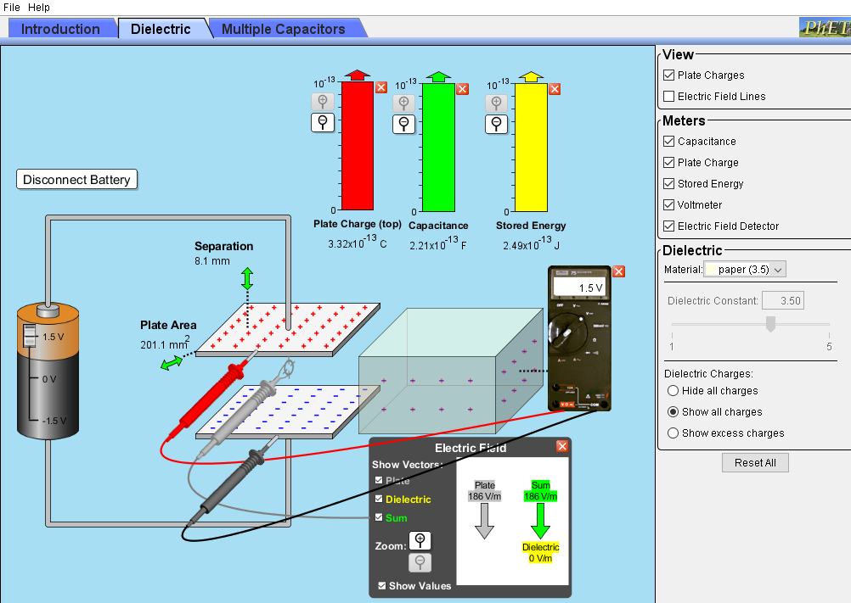Using the provided meters (charge, energy, Electric field E, and voltmeter) in the simulation complete the following data table
5. In the table below record the values of Capacitance C0, Electric field E0, stored energy U0, and charge on p late Q0 and potential difference V0.
6. 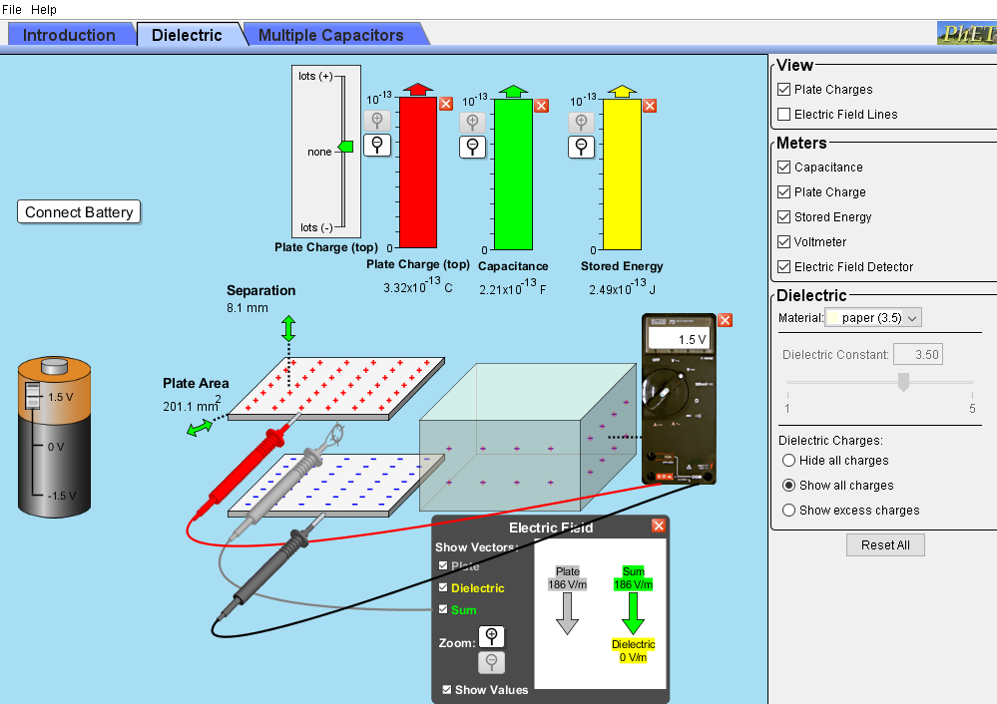Disconnect the battery from the capacitor.
7. Select the material of dielectric constant to be paper (K= 3.5), slide it inside the capacitor, then record the values of the quantities in the table below

|  |  |  |  |  |  |
| --- | --- | --- | --- | --- | --- |
| K= 3.5 (paper) | Q(pC) | C (pF) | V(V) | E(V/m) | U(J) |
| Connected Battery without Dielectric |  |  |  |  |  |
| Disconnected Battery with dielectric |  |  |  |  |  |

1. Use the formulas to check and comment on your results. Where Q, C, V, E, and U with dielectric and C0, E0, U0, Q0 and V0 without dielectric.



1. Comment on your results.

**Fifth part**

**Series Connection**

1. Open the (<https://phet.colorado.edu/en/simulation/capacitor-lab>)
2. Click on the “Multiple Capacitors” tab.
3. Click on three capacitor in series button.
4. Move the voltage slide to maximum and measure the voltage across the battery with the voltmeter Vmax=………………………..V,click on three capacitors in series
5. 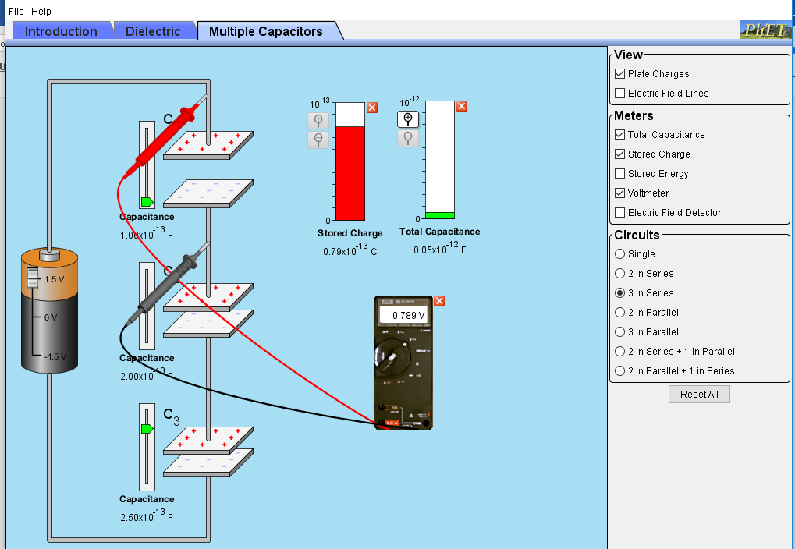Change the settings on the 3 capacitors to : C1= 1pF, C2= 2pF, C3= 2.5pF , as shown below
6. Now measure the voltage across each capacitor. V1= ______            V2=_____           V3=____
7. What is the relationship of voltages?
8. Using the stated capacitance (1.0x10-13 F, 2.0x10-13 F, 2.5x10-13 F) find the charge on each

capacitor. q1=____                  q2=____              q3=____

1. Comment on your results of the stored charge with q1, q2, and q3.
2. What is the total capacitance in Farads? Read meter.
3. Use formula to find the total capacitance

**Sixth part**

**Parallel Connection**

1. Open the (<https://phet.colorado.edu/en/simulation/capacitor-lab>)
2. Click on the “Multiple Capacitors” tab.
3. Click on three capacitor in series button.
4. Move the voltage slide to maximum and measure the voltage across the battery with the voltmeter Vmax=………………………..V . click on three capacitors in parallel.
5. Change the settings on the 3 capacitors to : C1= 1pF, C2= 2pF, C3= 2.5pF , as shown below

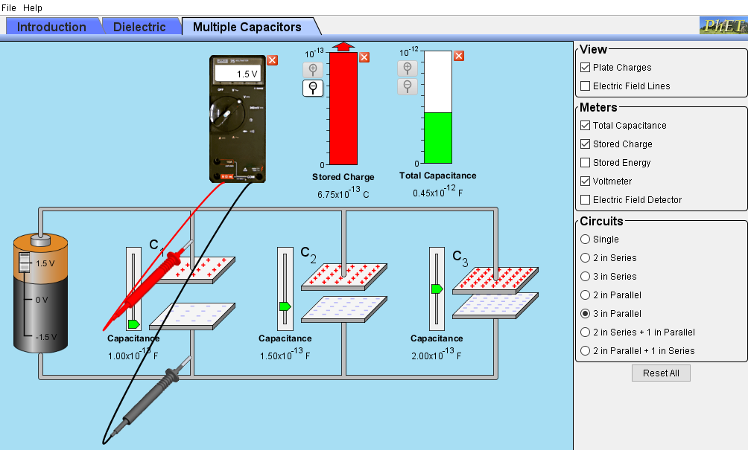

1. Now measure the voltage across each capacitor. V1= ______            V2=_____           V3=____
2. What is the relationship of voltages?
3. Using the stated capacitance (1.0x10-13 F, 2.0x10-13 F, 2.5x10-13 F) find the charge on each

capacitor. q1=____                  q2=____              q3=____

1. Comment on your results of the stored charge with q1, q2, and q3.
2. What is the total capacitance in Farads? Read meter.
3. Use formula to find the total capacitance and compare to bar chart.