Dep. Of Applied Physics and Astronomy University of Sharjah
Capacitors 1
Name : ID#:
Construct the following electrical circuit (Capacitor), using PhET simulation, or using the following link.
https://phet.colorado.edu/en/simulation/legacy/capacitor-lab
You have to play and enjoy using this simulation to be familiar with, because we are going to use during this period. We have three parts to do using this simulation
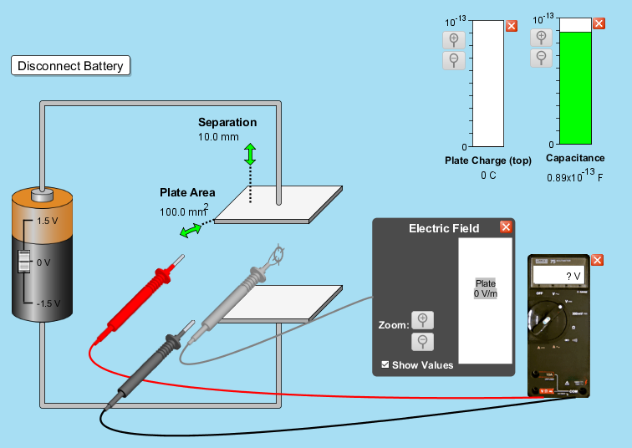

First Part: Capacitance and Area C=↋₀A/d:
In this part the distance, d, between the plates is kept constant d= 10x10⁻³m and the area of the plates is changed. You are to record the values for area (in m²) and the capacitance C (in F). Take at least eight values of A and C, and then fill the table below:
d= 10x10⁻³ m
A (m²) | C (F)

- Use Excel to plot the relationship between A and C.
- Draw the best straight-line equation and determine its slope.

- From the slope, determine the value of the permittivity of free space ↋_{ᵒ}.

4- Determine the percentage error using the real value ↋_{ᵒ}=8.85X10⁻¹² C²/N.m²

Second Part: Capacitance and distance C=↋_{ᵒ}A/d:
In this part the area, A, of the plate is kept constant A= 100x10⁻⁶ m² and the distance d between the plates is changed. You are to record the values for distance (in m) and the capacitance C (in F). Take at least eight values of d and C, and then fill the table below by calculating (1/d):
A= 100x10⁻⁶ m²

d (m) | 1/d ( m⁻¹) | C (F)

- Use Excel to plot the relationship between (1/d) and C.
- Draw the best straight-line equation and determine its slope.

- From the slope, determine the value of the permittivity of free space ↋_{ᵒ}

4- Determine the percentage error using the real value ↋_{ᵒ=} 8.85X10⁻¹² C²/N.m²

Third Part: Capacitance and Charge & Voltage:CV=Q
- Connect the circuit shown in the first part.
- Set the real value of the capacitor C=0.89x10⁻¹³F.
- Change the value of the power supply V, then record the values for the charge Q (in C) and the potential difference V ( in V)

Capacitance real from PhET (0.89x10⁻13)F

V(Volts) | Q(C)

- Plot the relationship between Q and V (first column) using Excel, and then determine the value of the slope.

- From the slope determine the value of C ( in F)

- Calculate the percentage error in your result.

Fourth Part: Voltage and Electric field V=Ed:
- Connect the power supply across the capacitor and record it value V(in volt)
- Record the value of the distance d (in m) between the plates of the capacitor.
- Use the formula V=Ed, to determine the electric field (E) between the plates
- Calculate the charge Q ( in C) of the capacitor using the formula E=Q/A↋_{ᵒ}

- Compare the value of charge with the value shown from PhET.
C(F) | V(V) | d(m) | E | A | Q
PhET
Calculations

