PhET Simulation – Virtual Physics Lab Experiments on DC Circuits. (Physics 1 @ RC)
Get your camera ready, and open the EMBEDDED LINK forPhET DC – Virtual Lab in the Lab Link):
On all the following parts, click the conventional current option and values option on the right side, and use the variety of circuit parts on the left side of the screen. Do a minimum of three of the following activities.

Part 1: Given the following circuit with a 10 volt battery and 2 identical light bulbs, and find the resistance of each of the light bulbs and create the circuit in PhET with ammeters to show the three different currents. Include your work and an image of your completed circuit.
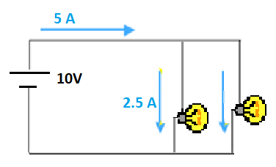

Part 2: Use Kirchhoff’s Laws to find the magnitude and direction of the current through each of the resistors and $∆V_{BA}$. Then, create the following circuit in PhET and use the voltmeter and three ammeters to confirm your findings. Show your work, and include a picture of the completed circuit from PhET.
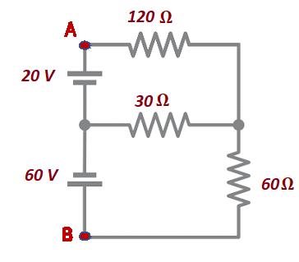

Part 3: Construct the following circuit in PhET and find the current leaving the battery. Take a picture of the PhET circuit. Then use equivalent resistor theory to find the equivalent resistance of the circuit.
Create a new PhET circuit with the one resistor with a value equal to the equivalent resistance and see if you get the same current leaving the battery (to 2 sig fig). Include both images and your work with your answer.
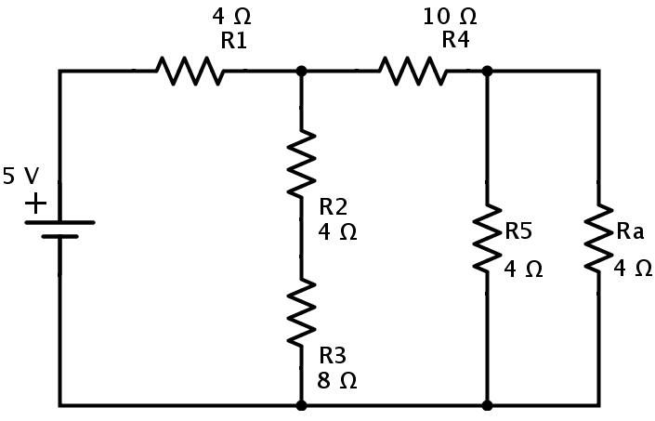

Part 4: On the left of the PhET DC Circuit page, there are many other circuit items available. Use the down arrow to find the pencil at the bottom. Design and construct a circuit to confirm the resistance of the pencil. Use formulas, etc. and show your work. Take a picture of the final circuit and your work.

Part 5: You are designing a house in Istanbul where the mains has a constant 220 volt supply. You want to install a new refrigerator that requires 3025 Watts of Power. You have 5A, 10A, 15A and 20A fuses available.
(a) Which fuse should you use for the refrigerator circuit?
(b) Since Refrigerators should never be off, you want to install a couple kitchen lights on the same circuit with the refrigerator so you can confirm that the refrigerator has power. Each light is a 60 W light bulb. What is the maximum number of bulbs you can install on the circuit with the refrigerator, with the fuse you have selected?
(c) What is the resistance of the refrigerator and each of the light bulbs?
(d) Create the circuit on the sim with resistors for the circuit with one refrigerator and two bulbs. Take a picture that includes one fuse of the size you choose and appropriate resistors for one refrigerator and two lights. See if the fuse blows!

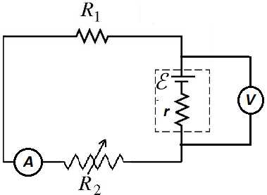
Part 6: In this lab, you will be collecting data to confirm the value of the internal resistance of the battery in the circuit shown.
Construct the following circuit:
Note that R₁ is a resistor with a fixed resistance, and R₂ have the ability to vary its resistance. Set the following values:
R₁= 10$Ω$
$ε$= 25 V, with r = 2.5 $Ω$
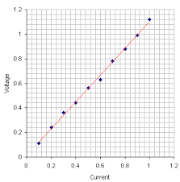
You will vary the resistance of R₂, and record the resultant current and voltage across the battery. Plot a graph using the formula $V=ε-Ir$ to find the internal resistance r, with five different currents and voltages. The graph should look something like this one:

