Name_____________________________
Period ____Date____________
Activity: Strong vs. Weak Acids (Targets 11.3, 11.7, 11.8)
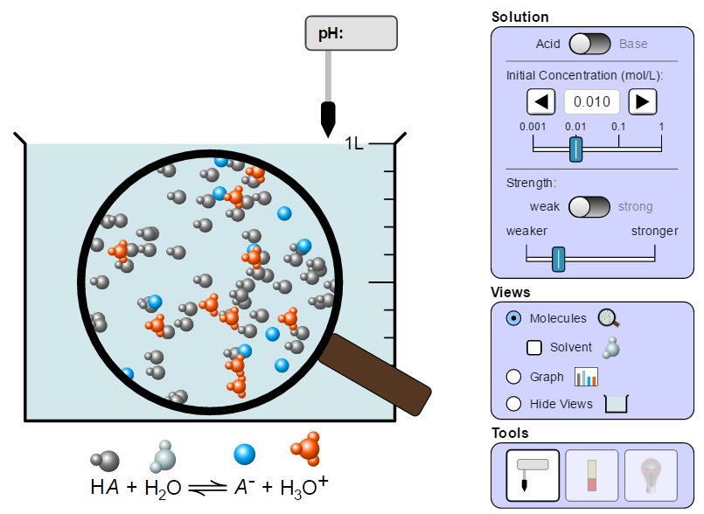
Instructions:
- Go to the following simulation: https://phet.colorado.edu/sims/html/acid-base-solutions/latest/acid-base-solutions_en.html
- Click on “My Solution”

Pre-lab:
- Write the dissociations for the follow acids:

HCl (strong): _______________________________________

HC₂H₃O₂ (weak): ____________________________________

- What is the difference in how strong and weak acids dissociate in water?
__________________________________________________________________________________
__________________________________________________________________________________

Graph for Strong Acid
Part A: Strong Acid dissociations versus Weak Acid Dissociations
- In the simulation, use the slider and set the initial concentration to 0.010 M and set the acid strength to “strong”.

- Under Views, click molecules. How do the numbers of molecules of the molecular acid compare to the number of cations and anions?
___________________________________________________
___________________________________________________

- Under views, click Graph. Sketch the bar graph in the box provided. Ignore water.

Graph for Weak Acid
- Under view click back to “molecules”. Now change the acid strength to “weak”. How does the weak acid bar graph differ from the strong acid? Why?
___________________________________________________
___________________________________________________
___________________________________________________
___________________________________________________

- Under views, click Graph. Sketch the bar graph to the right. Ignore water.

- Summary Questions: Which has more [H+] in solution – the strong or weak acid? How do you know from looking at pH that this solution has more [H+]? (Hint: Is the solution more acidic or less acidic?)
___________________________________________________
___________________________________________________
___________________________________________________
___________________________________________________
Part B: pH, [H+] for strong acids versus weak acids.
- In the simulation, set initial concentration to 0.0010 M and set the strength to “strong”. Under views, click “molecules”.
- Move the pH probe into the beaker. Record the pH in the table below.
- Change the strength to “weak”. Record the pH in the table below.
- Repeat for the other concentrations listed in the table below.
Initial Concentration | pH for Strong Acid | pH for Weak Acid
0.0010 M
0.010 M
0.10 M
1.0 M

- In general, what happens to pH as acid concentration increases?
______________________________________________________________________
______________________________________________________________________
______________________________________________________________________

- Compare the strong acid and the weak acid at the same concentration.
  - How do their pHs differ?
______________________________________________________________________
______________________________________________________________________
______________________________________________________________________

  - Explain why the pH for a strong acid would be different from a weak acid. Relate how they dissociate, their [H+] and their pHs.
______________________________________________________________________
______________________________________________________________________
______________________________________________________________________

