Name_____________________________
Period ____Date____________
Activity: Exploring pH relationships

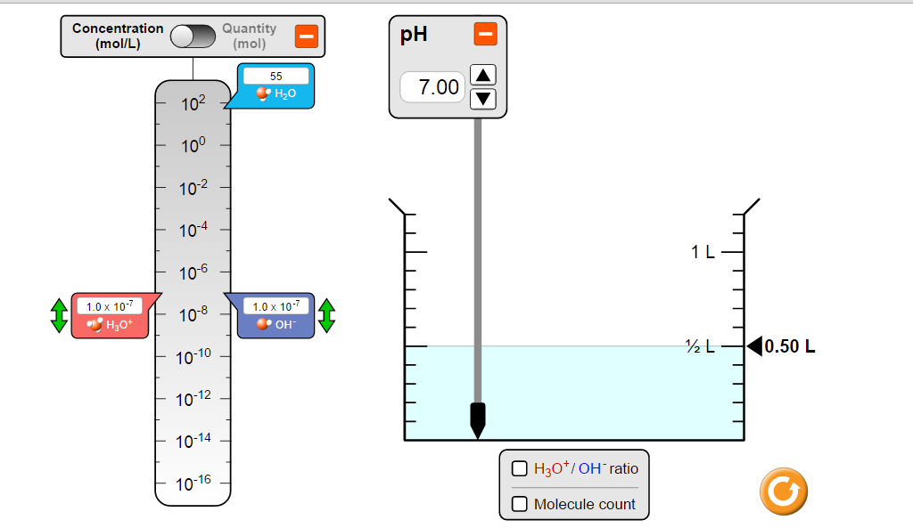
Instructions:
Go to the following simulation: https://phet.colorado.edu/sims/html/ph-scale/latest/ph-scale_en.html

Part A: Relationship between pH, [H+], [OH-]
- Click on “My Solution” button at the bottom center of your screen. This part of simulation lets you change the pH of the solution to see how [H+] and [OH-] change. Adjust the pH to the following and record the corresponding [H+] and [OH-]. For the second to last column, multiply [H+] and [OH-] together.
pH | [H+] | [OH-] | [H+] x [OH-] | Acidic? Basic? Neutral?
1.00
4.00
7.00
10.00
13.00

- How did you know if a solution was acidic? Name two ways to determine if a solution is acidic.

- How did you know if a solution was basic? Name two ways to determine if a solution is basic.

- What is the relationship between [H⁺] and pH?

- What is the relationship between [OH⁻] and pH?

- Look at the exponents on the concentrations for [H⁺] and compare it the pH. What is the pattern?

- Look at the exponents on [H⁺] and [OH⁻] in the table above. Compare them. What do you notice?

- Look at the second to last column of your table above, where you multiplied [H+] and [OH-]. What did you notice about your answers? What does this remind you of?

Teacher check. Show you are on the right track and get your teacher’s initials. ______________
- Now use the simulation to fill in the table below and answer the questions. For the second to last column, multiply [H+] and [OH-] together.
pH | [H+] | [OH-] | [H+] x [OH-] | Acidic, Basic, or Neutral
2.99
4.95
8.05
10.23
- Is the relationship between [H+] and pH still the same as the previous table?

- Is the product of [H+] and [OH-] still the same as the previous table?

- How does this table and the previous one differ?

Part B: The Power of Hydrogen – Read carefully
The term pH stands for the power (as in exponent) of hydrogen. Exponential functions in math are related to logarithmic functions. Therefore, the relationship between {H+] and pH is a logarithmic function mathematically speaking.

If you are given [H+], you can calculate pH using: pH = - log₁₀[H⁺] (note the negative sign)

Example:
If you were give the [H+] = 1.0 x 10⁻² M, the pH would the negative of that exponent which would be “2”.
But the [H+] isn’t always so perfect that you wouldn’t need a calculator. Locate the log function on your calculator and try the following.
- Determine the pH of a solution whose [H⁺] is 5.00 x 10⁻¹² M. Show your work.

- Use the simulation to check your answer by dragging the [H+] slider to this concentration and seeing what the pH is.

If you are given pH, you can calculate [H+] using: [H⁺] = 10^{-pH} (note the negative sign)
Example: If you were give the pH of 3.00. The [H+] would be 10⁻³ which we would write as 1 x 10⁻³ M.
But pH is not always a nice number like that you wouldn’t ever need a calculator. Locate the 10^{x} button on your calculator and try the following.
- Determine the [H+] concentration of a solution with a pH of 3.45. You must write this answer in proper scientific notation where the exponent is a whole number.

- Use the simulation to check your answer by setting the pH and then noting the [H+]

Part C: pOH – The Power of Hydroxide
We can also calculate pOH in a similar way. Furthermore, the sum of pH and pOH will always equal 14 because [H+] x [OH-] always equals 1.0 x 10⁻¹⁴ (the negative log of this number is 14).
pOH = - log [OH⁻] [OH⁻] = 10^{-pOH} pH + pOH = 14
Part D: Putting it all together
pH = - log₁₀[H⁺] [H⁺] = 10^{-pH} pOH = - log [OH⁻] [OH⁻] = 10^{-pOH} pH + pOH = 14
Fill in the blanks in the table below using what you have learning about the relationships [H+], [OH-], pH, and pOH.
pH | [H+] | [OH-] | pOH | Acidic/Basic/Neutral
5.00
 |  |  | 5.00
 | 1.0 x 10⁻⁶
 |  | 1.0 x 10⁻³
2.15
 |  |  | 1.69
 | 4.8 x 10⁻⁹
 |  | 5.2 x 10⁻¹⁰
 |  |  |  | Neutral

