Dep. Of Applied Physics and Astronomy University of Sharjah
Wheatstone Bridge
Name : ID#:
Construct the following electrical circuit (Wheatstone Bridge), using PhET simulation, or using the following link.
https://phet.colorado.edu/en/simulation/circuit-construction-kit-dc-virtual-lab
You have to play and enjoy using this simulation to be familiar with, because we are going to use during this period. Set the value of resistors as follows: R1=6Ω, R2=2Ω, R3=8Ω, and R4=4Ω, the power supply at 10V Also connect ammeter between points A,and B, then you will be able to answer the following questions
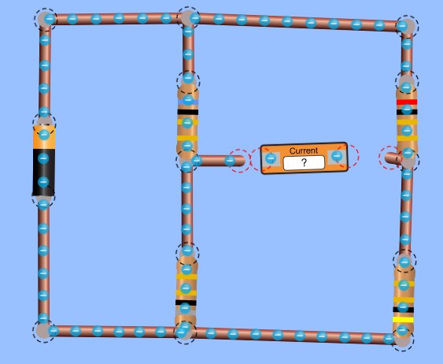
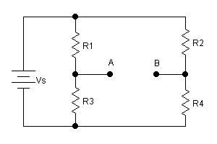

You are to play with the circuit to answer the following
- Is the bridge balanced or not? How can you decide?
- What is the current the ammeter measures?
- What is the current in R1, in R2, in R3, in R4, and in the power supply?

 | R1 | R2 | R3 | R4 | Power supply
Current(A)

- Change the value of R2 to balance the bridge, what is this new value?

- Keep the value of R2= 2 Ω, change the value of R1 to balance the bridge, what is the new value.
- Keep the values of resistors at their initial values, R1=6Ω, R2=2Ω, R3=8Ω, and R4=4Ω
Connect a new resistance to R1 in correct way (series or parallel) to balance the bridge, what is the new resistance, and how you connect it (series or parallel?

- Set the values of the resistors as follows :
R1=4Ω, R2=12Ω, R3=2Ω, and R4=6Ω

Answer the following questions

- Is the bridge balanced? How do you decide?

- What is the current in each resistance, and in the power supply?

 | R1 | R2 | R3 | R4 | Power supply
Current(A)

- Use voltmeter to measure the potential difference across all resistors?

 | R1 | R2 | R3 | R4
Voltage (A)

- What is the equivalent resistance of the circuit?

- Which two resistors will have the same current?

- Compare sum of the currents through R1 and R2, with the current through the power supply.

- Use the voltmeter to measure the potential difference between A and B.
- If you change the value of the power supply to 5 Volts, what is the current between A and B

- If you exchange the position of the power supply with the ammeter between A and B, what is the reading of the ammeter?
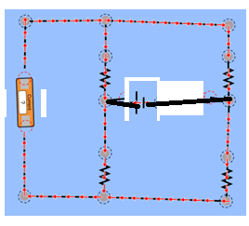
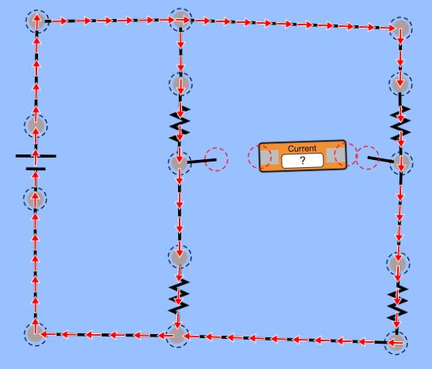

- Write your conclusion about the experiment?

