PhET Games for Remote Learning
(This‌ ‌lesson‌ idea is designed ‌for‌ ‌a‌ ‌student‌ ‌working‌ remotely‌.)‌
https://phet.colorado.edu/

Students can use the PhET simulation games for new learning, application, practice, or fun. On the second page, a general template is provided that teachers could use to make lessons quickly by just adding the name of the sim and the URL. Another idea is to tell the students to find a game they want to try and they could use the template and “make their own lesson”.

The following sims have games:
Chemistry
- Balancing Chemical Equations (HTML5) Check out this activity which includes specific learning goals and some guidance: Balancing_Chemical_Equations_Remote_Lab
- Build an Atom (HTML5) Check out these activities which includes specific learning goals and some guidance :Build an Atom_Remote_Lab and Build an Atom_Game
- Reactants, Products and Leftovers (HTML5) Check out this activity which includes specific learning goals and some guidance: RPAL Game Remote Lesson2
Physics
- Balancing Act (HTML5) Check out these activities which includes specific learning goals and some guidance: Balancing Act_Remote Lab and Balancing Act_Game
Math
- Area Builder (HTML5)
- Area Model Algebra (HTML5)
- Area Model Multiplication (HTML5)
- Arithmetic (HTML5) Check out this activity which includes specific learning goals and some guidance: Arithmetic Remote Lab
- Build a Fraction (HTML5)
- Equality Explorer (HTML5)
- Expression Exchange (HTML5)
- Fraction Matcher (HTML5)
- Fractions: Equality (HTML5)
- Fractions: Intro (HTML5)
- Fractions: Mixed Numbers (HTML5)
- Graphing Lines (HTML5)
- Graphing Slope-Intercept (HTML5)
- Make a Ten (HTML5)

(Sim Name and URL) Game Lesson
This lesson uses the PhET simulations from PhET Interactive Simulations at University of Colorado Boulder, under the CC-BY 4.0 license.
(insert simulation URL here)

Develop Your Strategies:
Play level 1 of the (sim name and URL here) game and write some strategies that might help you get good scores. Include screen captures from the simulation to help explain. You may want to go to other screens in the simulation to help you get good scores.
Test your Strategies:
- Play the first level.
  - Did you have to change your strategies or do you have other ideas to make you get a better score? Include screen captures from the simulation to help explain.

  - When you complete the level 1 game, capture the screen with your score. Paste it below like this: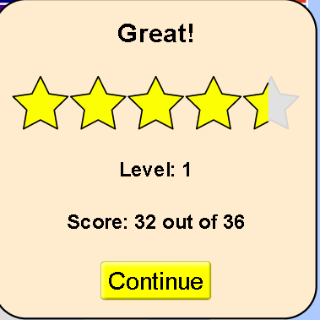
- Explore each level of the game one at a time. For each level:
Level 2 (copy and repeat this section for each level)
  - Explain what makes the level more difficult or different from previous levels. Do you have new strategy ideas? Include screen captures from the simulation to help explain.

  - Play the level 2 game. When you complete the level, capture the screen with your score and paste it below:

  - Did you have to change your strategies or do you have other ideas to make you get a better score? Include screen captures from the simulation as support.

Final Score:
After you play all levels of the game. Copy and paste your final results like this
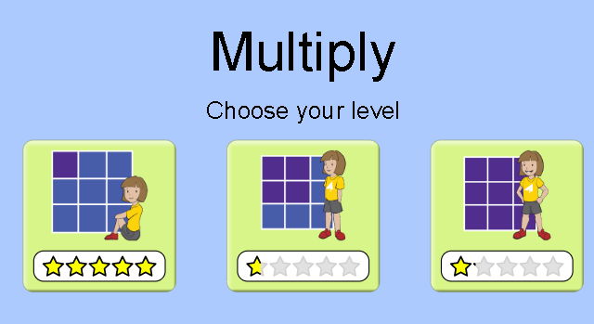
Extra challenge: (only some games have a timer) For an extra challenge, you can turn on the timer and see if you can improve your skills.

