Coulomb’s Law Remote Lab Electric Forces
(This‌ ‌lesson‌ is designed ‌for‌ ‌a‌ ‌student‌ ‌working‌ remotely‌.)‌

This lab uses the Coulomb’s Law simulation from PhET Interactive Simulations at University of Colorado Boulder, under the CC-BY 4.0 license.
https://phet.colorado.edu/sims/html/wave-interference/latest/wave-interference_en.html

Note about prior learning: Students should have completed Balloons and Static Electricity and John Travoltage Remote lab or lessons with similar learning goals.

Learning Goals: Students will be able to
- Determine what makes a force attractive or repulsive
- Explain Newton's third law for electrostatic forces
- Relate the electrostatic force magnitude to the charges and the distance between them
- Use measurements to determine Coulomb’s constant

Review your understanding:
1. Two balloons were rubbed on a sweater like in the Balloons and Static Electricity and then hung like in the picture below. Explain why you think they move apart and what might affect how far apart they will be.

Develop your understanding:
2. Open the Macro Scale screen and explore the forces between two charged bodies.
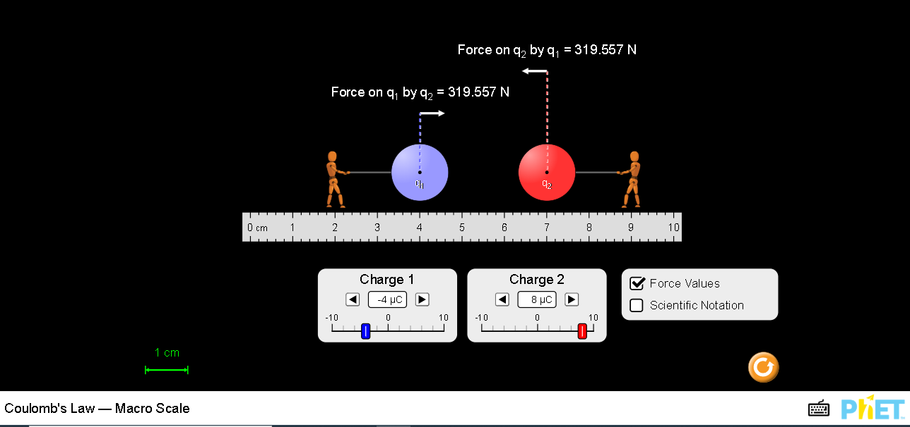

Explain your understanding:

3. By experiment, determine what makes a force attractive or repulsive. Describe your experiments and observations with some examples.

4. What evidence do you see that Newton's third law applies to electrostatic forces?

5. How does the value of the electrostatic force vary with the value of the charges?

6. How does the value of the electrostatic force vary with the distance between them?

Use your understanding:

7. Coulomb’s equation is used for determining the force between 2 charged bodies separated by a distance 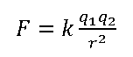
The variables are k (Coulomb’s constant), q (charge of body in Coulombs, C), r (distance between bodies in meters), and F (electrostatic force in Newton, N)

- Use measurements to determine Coulomb’s constant for at least 2 situations. Show your work and include an image of experiments. Verify your value with research and include citations.

- Using your value of k, determine the electrostatic force for these 2 situations:
  - -4µC charge is 3cm from a 5µC charge.
  - An electron has a charge of -1.6x10⁻¹⁹C and a proton has a charge of 1.6x10⁻¹⁹C. In a hydrogen atom, the distance between them is 5.3x10⁻¹¹m. Determine the electrostatic force between them.

- Open the full Coulomb’s Law simulation to check your work. Describe how you used the simulation and include images for support.

8. Explain how electric forces are like gravitation forces and how they differ.

