Charges and Fields Remote Lab Introduction to Static Electricity
(This‌ ‌lesson‌ is designed ‌for‌ ‌a‌ ‌student‌ ‌working‌ remotely‌.)‌

This lab uses the Charges and Fields simulation from PhET Interactive Simulations at University of Colorado Boulder, under the CC-BY 4.0 license.
https://phet.colorado.edu/sims/html/wave-interference/latest/wave-interference_en.html

Note about prior learning: Students should have completed Balloons and Static Electricity and John Travoltage Remote lab or lessons with similar learning goals.

Learning Goals: Students will be able to
- Determine the variables that affect how charged bodies interact
- Predict how charged bodies will interact
- Describe the strength and direction of the electric field around a charged body.
- Use free-body diagrams and vector addition to help explain the interactions.
- Compare electric fields to gravitational fields.

Review your understanding:
1. Two balloons were rubbed on a sweater like in the Balloons and Static Electricity and then hung like in the picture below. Explain why you think they move apart and what might affect how far apart they will be.

Explain your understanding:
2. Watch the short video demonstration of Electric Field Hockey .
- Why can you make a goal without hitting the puck?

- Why can you use either a positive charge or a negative charge to move the positively charged puck?

- What do you think would happen if you use 2 charges instead of one to make the puck move?

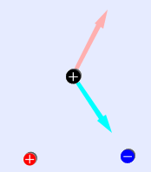
3. Examine the image with a positive and a negative charge on the playing field with the positive puck.
- What do you think the arrows on the puck are illustrating?

- How does the arrow from the positive charge compare and contrast to the one from the negative charge?

- Which way do you think the puck will move?

- How would the arrows look if the puck was negative?

4. Open Charges and Fields. In this simulation, a little different model is used. The little yellow “E field sensors” are like the hockey puck but they are on a high friction surface, so they stay in place allowing for measurements. Collect data by turning on Values & drag in the Tape Measure like in this image:
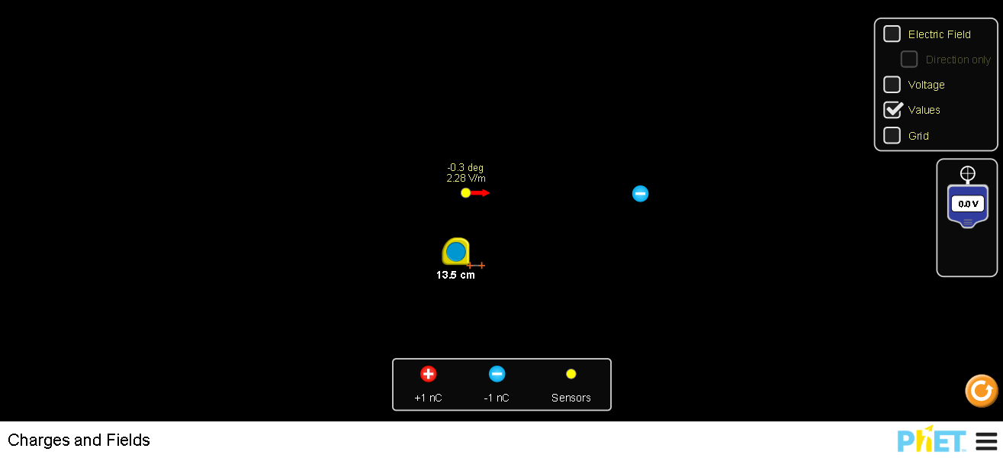
- Investigate to check your answers from #2 and #3. Write how the results of your investigation support or change your ideas.

- Determine the relationship between distance and the strength of the electric field around a charged body. Use a Google Spreadsheet to document your data, graph and determine the equation for the relationship. Insert your data table and graph from your spreadsheet.

- Determine the relationship between amount of charge and the strength of the electric field around a charged body. Use Google Spreadsheet to document your data, graph, and determine the equation for the relationship. You can stack charges on top of one another to make the amount of charge vary. Insert your data table and graph from your spreadsheet.

5. Explain how electric fields are like gravitation fields and how they differ. The Electric field may be helpful .

