TFCPHYSICS 91F
/ 9
Lab 4
Lab 4 - Hooke's Law

Part 1: Validating Hooke’s Law

Mass added (g) | Weight (N) | Extension (mm)
100g | 0.98 | 18
150g | 1.47 | 26
200g | 1.96 | 34
250g | 2.45 | 42
300g | 2.94 | 50
Table 1

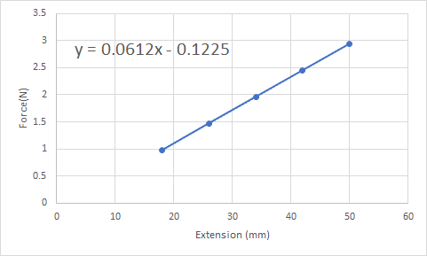
f)the spring constant = 0.0612$N{mm}^{-1}$
g) applied force v/s extension is a straight line

Part 2: Determining Unknown Masses

- Following the steps in part 1, place the red mass on the spring and determine the extension .
- Repeat the procedure 3 times and list the values as shown in the box below.
- Follow the same procedure for blue mass as well

Mass added (g) | Extension (mm)
red | 62
 | 62
 | 62
blue | 39
 | 39
 | 39

- Using the value of k from part 1 in the equation ,
$F = k x$
$k$= 0.0612$N{mm}^{-1}$
- For red mass, m * g = 0.0612 * 62
m = (0.0612 * 62) / 9.8
red mass = 387.183g

- For red mass, m * g = 0.0612 * 39
m = (0.0612 * 39) / 9.8
blue mass =243.551g

Part 3: Determining Unknown Value of Gravity

Mass added (g) | Extension (mm) | Unknown $g$
300g | 72 | 14.68
387.183g | 89 | 14.067
243.551g | 56 | 14.07

$F = k x$
$k$= 0.0612$N{mm}^{-1}$
unknown $g$ =$14.272 ms^{-2}$

Part 4: Analysing Systems of Springs

Two Springs in Parallel

$k_{1}$ ($Nm^{-1})$ | $k_{2}$ ($Nm^{-1})$ | F (N) | Extension (m) | Total $k$ ($Nm^{-1})$
200 | 200 | 100 N | 0.250 | 400
200 | 400 | 100 N | 0.167 | 598.802
400 | 600 | 100 N | 0.100 | 1000
200 | 600 | 100 N | 0.125 | 800
Table 2

d) F = kx
F_{total} = k1 x + k2 x
= (k1 + k2)x

Two Springs in Series

$k_{1}$ ($Nm^{-1})$ | $k_{2}$ ($Nm^{-1})$ | F (N) | Extension (m) | Total $k$ ($Nm^{-1})$
400 | 400 | 100 N | 0.500 | 200.00
200 | 400 | 100 N | 0.750 | 133.33
600 | 400 | 100 N | 0.417 | 239.81
200 | 600 | 100 N | 0.667 | 149.93
Table 3

h)

F = kx
F_{total} =(k1k2)/(k1+k2) x

Student 3 has correct model

