TFCPHYSICS 91F
/ 9
Lab 4
Lab 4 - Hooke's Law

Objectives:

- Validate Hooke’s Law
- Use Hooke’s Law to determine unknown masses and an unknown $g$ value.
- Analyse how different combinations of spring affect the stretching of a system.

Background:

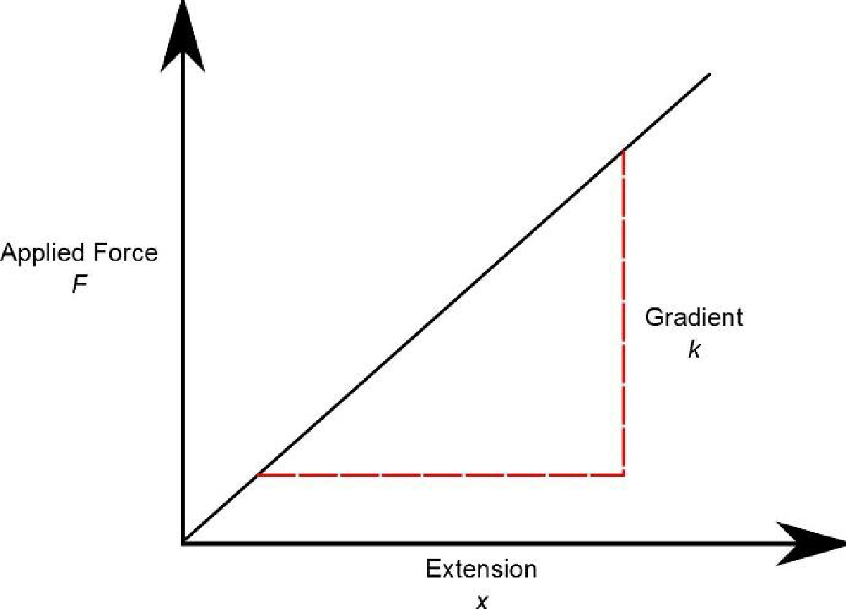
Hooke's law states that extension of a spring is proportional to applied force.

If a spring obeys Hooke's law, then a graph of applied force against extension will be a straight line, whose gradient (slope) is k:

The equation of the straight line is:
$$F = k x$$
where:
$F$= stretching force applied to the spring
$k$ = spring constant
$x$ = extension of the spring

Part 1: Validating Hooke’s Law

Open the following simulator and click the lab option:

https://phet.colorado.edu/sims/html/masses-and-springs/latest/masses-and-springs_en.html

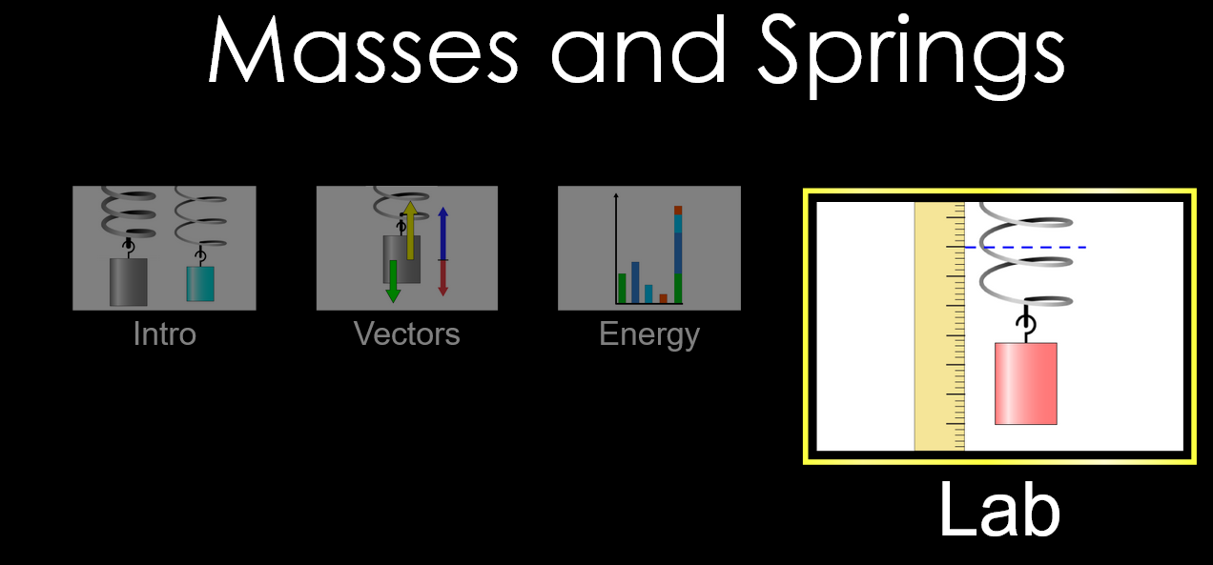

- Place the 100g mass onto the spring. The spring will begin to oscillate up and down. Stop this by clicking on the mass several times or increasing the ‘Damping’ value to ‘Lots’.
- Click the ‘Displacement’ and ‘Movable Line’ options on the right. Adjust the movable red line to the tip of the green arrow.

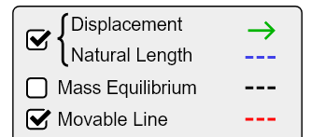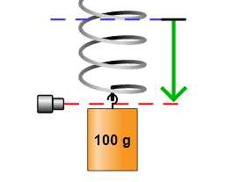

- Use the ruler tool (the units are in mm) on the bottom right to measure the extension of the spring with the 100g mass. Convert this mass to a weight (use $g=9.8 ms^{-2}$) and add this data to table 1. Remember to convert g to kg.

Mass added (g) | Weight (N) | Extension (mm)
100g

Table 1

- Using the slider at the top, change the mass and record 5 more results of weight and extension. Add your results to table 1.

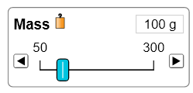

- Plot a graph (either on paper or using Excel) for Force (y-axis) against extension (x-axis). Draw a line of best fit through your points.

- Using your graph, determine the spring constant of your spring (in $N{mm}^{-1}$) by finding the gradient.

- What evidence from your graph shows that the spring obeys Hooke’s Law?

Part 2: Determining Unknown Masses

Using your value for the spring constant in part 1, determine the masses of the two unknown, red and blue masses in the simulation. Show your working and measurements taken for this part. To get a good average result, at least 3 measurements should be taken of each mass.

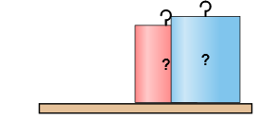

red mass = ............................. g

blue mass = ................................g

Part 3: Determining Unknown Value of Gravity

Change the ‘Gravity’ to ‘Planet X’.

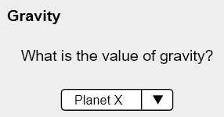

The value of $g$ is no longer $9.8 ms^{-2}$ but something unknown.

Using your spring constant from part 1, determine the unknown value of $g$ for this planet. Show your working and measurements taken for this part. To get a good average result, at least 3 measurements should be taken of each mass.

unknown $g$ = ......................................$ms^{-2}$

Part 4: Analysing Systems of Springs

Open the simulation below and press the systems open:

https://phet.colorado.edu/sims/html/hookes-law/latest/hookes-law_en.html

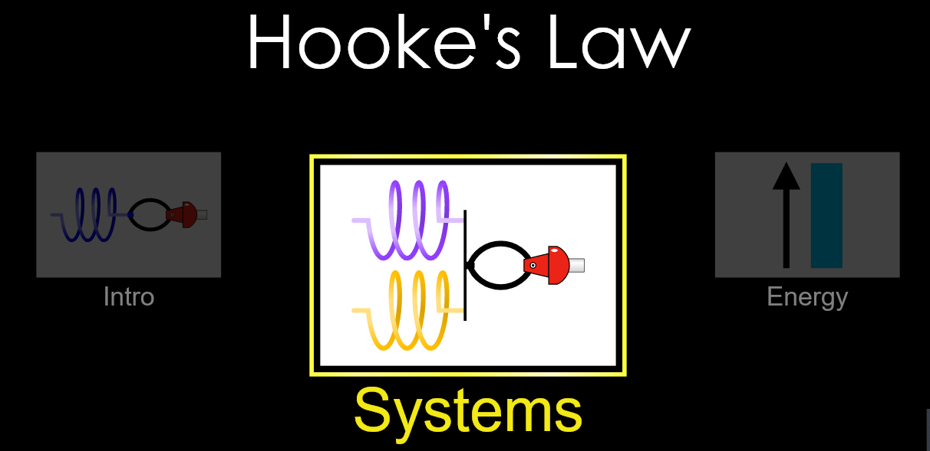

- Select the options ‘Displacement’, ‘Equilibrium Potion’ and ‘Values’. Make sure the option of two springs in parallel is selected so that the springs look like the setup in the image below.

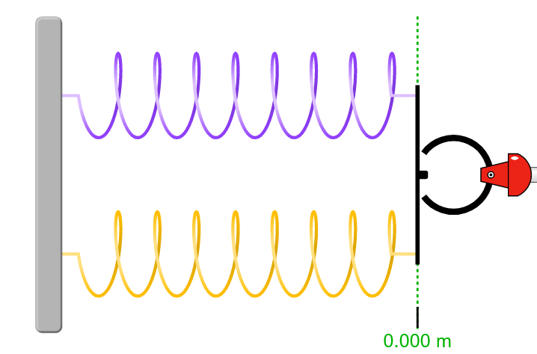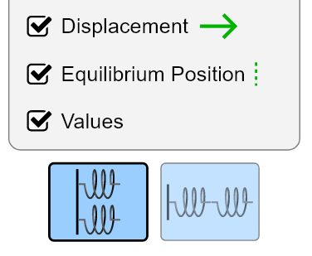

- Keep the top spring constant $k_{1}=200 Nm^{-1}$ and the bottom spring constant $k_{2}=200 Nm^{-1}$. Apply 100N of force to the right. Measure the extension and determine the total spring constant of the two springs in parallel ($\frac{Force}{Extension}$). Record your results in table 2.

Two Springs in Parallel

$k_{1}$ ($Nm^{-1})$ | $k_{2}$ ($Nm^{-1})$ | F (N) | Extension (m) | Total $k$ ($Nm^{-1})$
 |  | 100 N
 |  | 100 N
 |  | 100 N
 |  | 100 N
Table 2
- Repeat step b) three more times by changing the values of $k_{1}$ and $k_{2}$ and adding the results to table 2.

- Describe the relationship between the individual spring constants $k_{1}$ and $k_{2}$, and the total spring constant $k$for springs in parallel. Try and write this in the form of an equation.

- Press the series spring button so that the springs change their combination to look like the setup in the image below:

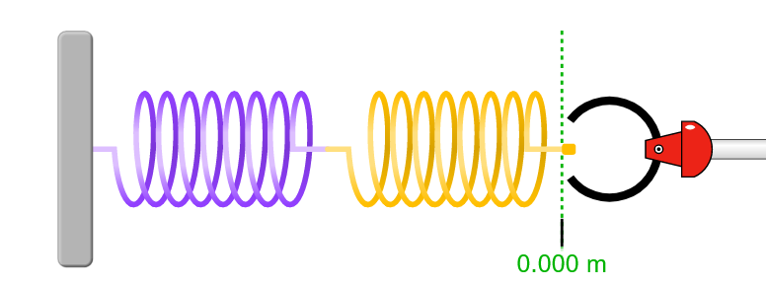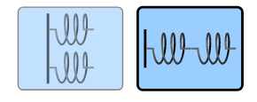

- Keep the left spring constant $k_{1}=400 Nm^{-1}$ and the right spring constant $k_{2}=400 Nm^{-1}$. Apply 100N of force to the right. Measure the extension and determine the total spring constant $k$ of the two springs in series ($\frac{Force}{Extension}$). Record your results in table 3.

Two Springs in Series

$k_{1}$ ($Nm^{-1})$ | $k_{2}$ ($Nm^{-1})$ | F (N) | Extension (m) | Total $k$ ($Nm^{-1})$
 |  | 100 N
 |  | 100 N
 |  | 100 N
 |  | 100 N
Table 3

- Repeat step f) three more times by changing the values of $k_{1}$ and $k_{2}$ and adding the results to table 3.

- Three students offer a model for finding the total spring constant $k$ for two springs in series:

- Student 1: $k=\frac{k_{1}+k_{2}}{k_{1}k_{2}}$
- Student 2: $k=\frac{{\left(k_{1}+k_{2}\right)}^{2}}{k_{1}+k_{2}}$
- Student 3: $\frac{1}{k}=\frac{1}{k_{1}}+\frac{1}{k_{2}}$

Explain which student’s model is correct based on your results.

