1: Reflection

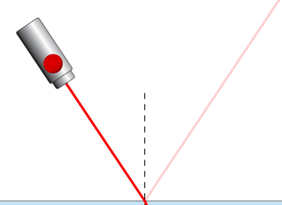
When waves hit a surface they can be reflected.
Angle of reflection

θr
Angle of incidence
θi
Normal line

Using the simulation answer the questions below.
phet.colorado.edu/sims/html/bending-light/latest/bending-light_en.html
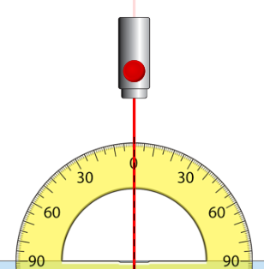

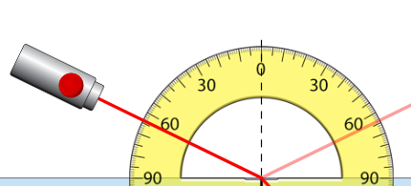

1.a. What is the relationship between the angles of incidence and reflection

1.b What do you notice about the strength of the reflected beam?

1.c Does changing the index of refraction (n) affect the angle of the reflected ray?

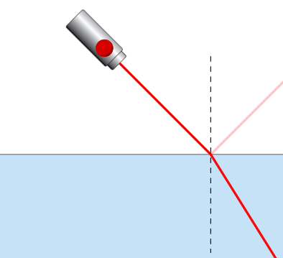
2 Refraction
Angle of refraction
Angle of incidence
θi
θr

Often part of the wave is transmitted.
If the wave changes speed it will bend.
This is called refraction.

Reset the simulation
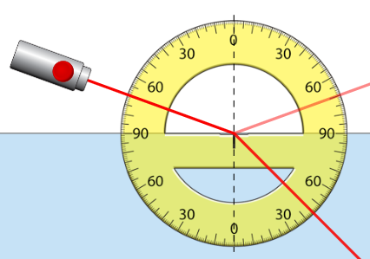
Set up the simulation with a protractor carefully placed centered on the normal.
phet.colorado.edu/sims/html/bending-light/
latest/bending-light_en.html

Complete the table below

Incident angle ,θ_{i} | Refracted angle ,θ_{r} | sin(θ_{i}) | sin(θ_{r}) | sin(θ_{i}) /sin(θ_{r})
10
20
30
40
50
60
70 | 45 | 0.940 | 0.707 | 1.____
80

2.a. What is the relationship between the angles of incidence and refraction

2.b What do you notice about how the strength of the refracted beam changes with θ_{i} ?

Now try changing the materials at the bottom only .
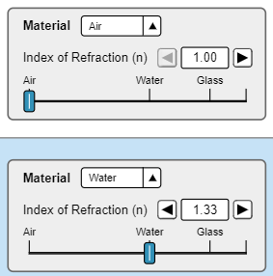
2.c What effect does increasing the index of refraction of the bottom material have?

2.d Does the ray bend toward or away from the normal?
Is that always true when air is the top material?

Now try changing both the materials .

2.e What patterns do you notice?

2.f How can you make the ray bend away from the normal?

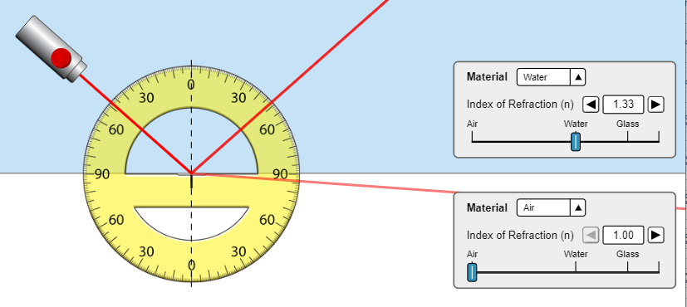
Now set up the materials as water on top and air on the bottom.

Move the laser back and forth

2.h Somewhere between 30º and 60º the behaviour changes.
What is the exact angle?

2.i What happens at this angle

3 Critical angle
When going from a more to a less dense material.

The light ray should be r________ away from the n_______

At the critical angle the behaviour suddenly changes and the totality of all light is reflected back internally into the water.

This is called _________ ___________ ________ion

Complete the table below (use air as the bottom material)

TOP Material | Refractive index (n) | critical angle ,θ_{c} /º | sin ,θ_{c} | 1 / sin θ_{c}
Water | 1.33 | 48 | 0.743 | 1.35
Glass
Mystery A

3.a. What effect does increasing the index of refraction have on the critical angle?

3.b. What equation can be used to calculate the critical angle c ?

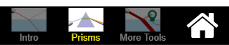
4 “Realistic” Practical (Into more dense)

Go to the Prisms page of the simulation
phet.colorado.edu/sims/html/bending-light/
latest/bending-light_en.html

Set up the square glass block, protractor and ray as shown.
Ensure the ray is pointed at the center of the rotated protractor.
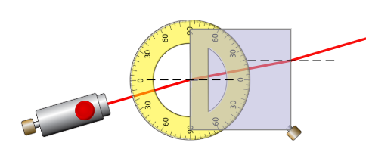

Copy your diagram here: Use: Win + Shift + S or snipping tool

Complete the table below (Use the environment air)
Target angle | Incident angle ,θ_{i} | Refracted angle ,θ_{r} | sin(θ_{i}) | sin(θ_{r}) | sin(θ_{i}) /sin(θ_{r})
15 | 13 | 8 | 0.225 | 0.139 | 1.61
30
45
60
75

4.a. What is the refractive index, n of the glass?

4.b Which results do you think are the most accurate, small angles or large angles?

4.c Extension: Calculate the refractive index of Mystery B.

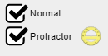
5 “Realistic” Practical (into LESS dense)

Set up the semi-circular glass block, protractor as shown.
Ensure the ray is pointed at the center of the rotated protractor.
Use the normal lines to check alignment
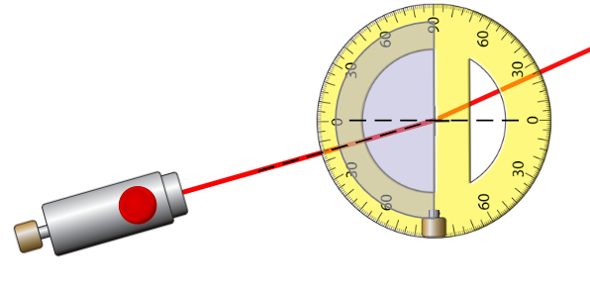

Try to complete the table below (Use the environment air)
Target angle | Incident angle ,θ_{i} | Refracted angle ,θ_{r} | sin(θ_{i}) | sin(θ_{r}) | sin(i_{i}) /sin(r) | sin(r) /sin(i)
10
15 | 16 | 24
20
30
40
50
60

5.a. What is the refractive index, n of the glass?

5.b State the largest angle you could find a result for?
What happened above this angle, why?

6 The PHYSICS :-)

Go to the More Tools page of the simulation
phet.colorado.edu/sims/html/bending-light/latest/bending-light_en.html
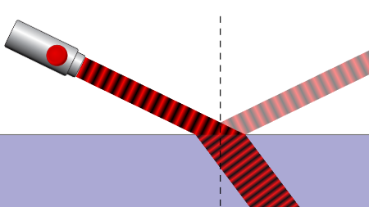
Use the Wave setting at 650nm.
Keep the top material as Air

6.a. Look at the wavefronts as they enter the glass.
What happens to the speed, wavelength and frequency of the wave? (by eye)
Speed:

Wavelength:

Frequency:

Use the Time tool to show the wave of the refracted and reflected rays
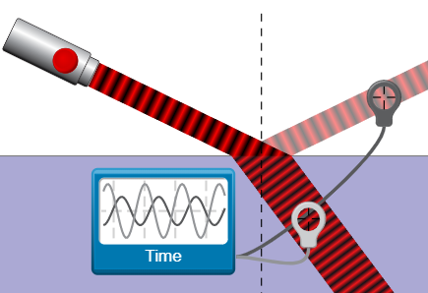
6.b. Are the frequencies of the refracted and reflected waves the same or different?

Use the Speed tool to find the velocity of incident, refracted and reflected rays
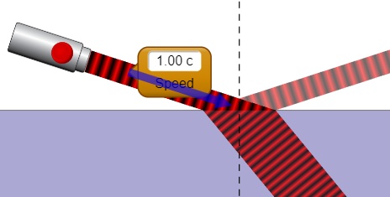
Bottom material |  |  | Wave Speed
Type | n | 1/n | Incident | Reflected | Refracted
Air
Water | 1.33 |  | 1.00 |  | 0.67
Glass

6.b. What happens to a wave as it enters a more dense medium.
What is the link between wave speed and index of refraction

Imagine yourself moving with the wavefronts of light
6.c.As the light enters the bottom material, which side of the ray will slow down first.

6.d As that side slows down, which way does the ray turn.

Extension:
6.e Can you imagine a similar situation. E.g. What if a car came off a road into a muddy field?

6.f Explain in your own words why waves refract when then enter a medium in which they travel more slowly.

7 The Dark side of the PhET

On the Prisms page of the simulation
phet.colorado.edu/sims/html/bending-light/
latest/bending-light_en.html
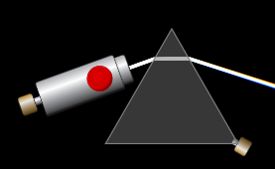
Select the white on black colour scheme

Set up the triangular block as shown.
Ensure the ray is pointed near the tip

7.a. Describe what you see.

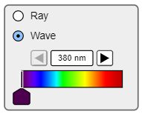
Go to the More Tools page of the simulation
Use the spectrum to
investigate how colour chages with wavelength

Complete the table
Wavelength nm | 400 | 450 | 525 | 580 | 600 | 650 | 700
Colour |  |  |  | Yellow

7.b. Describe the relationship between colour and wavelength.

7.c. Looking at the spectrum produced by the prism, which colour is bent more?

7.d. Use this to explain which colour slows down the most in a glass block

8 Rainbows (Extension)

On the Prisms page of the simulation
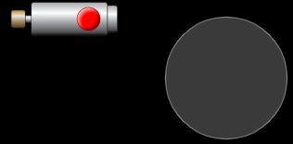
phet.colorado.edu/sims/html/bending-light/
latest/bending-light_en.html

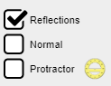
Turn on reflections and use a circular prism

See if you can produce a spectrum.

In a rainstorm lots of small spherical droplets fall from the clouds

Can you explain….

8.a. What conditions are needed for a rainbow

8.b. Is there only one position you might see a rainbow?

8.c. Why are they bows (arcs) [Think about the position of the sun and observer.]

8.d. If you were in a plane, what shape might a rainbow look?

8.e. Could you create one at home?

