CHE 145, LAB 10 Visible Spectrophotometry of Nickel (II) Chloride
(a printed version of this lab will be available in lab)
Learning Goals:
Become familiar with a visible spectrophotometer and how it works.
Use a simulated spectrophotometer to find $λ_{max}$ for NiCl₂(aq).
Use a simulated spectrophotometer to generate concentration-absorbance data for NiCl₂(aq).
Plot concentration-absorbance data to create a standard curve.
Use the standard curve to solve unknowns.

Demonstrations:
Concentration and Beer’s Law
The operation of a spectrophotometer

Process:
- Read the background and procedure. For prelab, you will test the link for the simulation needed for this lab. The link is found in the Prelab section in D2L.
- You will determine the value of the $λ_{max}$ for a solution of NiCl₂(aq).
- You will make a series of measurements that will be graphed to create a standard curve.
- You will use Beer’s Law to answer a number of questions about concentration and absorbance.

In this experiment, you will use a spectrophotometer to measure the absorption of visible light by a colored solution. You will first explore the features of a spectrophotometer. Next, you will determine the wavelength of maximum absorption, $λ_{max}$ for a solution of NiCl₂(aq). With the system characterized, you will vary the solution concentrations to measure the relationship between concentration and absorbance to create a standard curve. Finally, you will use the standard curve to answer a series of questions about absorbance and concentration.

Background. Relationship of Light Absorbed or Transmitted and Observed Color.

In the Stars Lab, you observed that light from the sun is composed of a continuum of energies and thus, of a continuum of wavelengths and frequencies. Most of the electromagnetic radiation continuum is invisible to humans; the portion we perceive is referred to as visible light. Wavelengths of visible light extend from about 400 nm (4.0$×$10⁻⁵ cm) to about 800 nm (8.0$×$10⁻⁵ cm). If this band of visible light is separated into narrow bands of wavelengths by a prism, we perceive the component colors, ranging in sequence starting with the shortest wavelengths and the highest energy: violet, indigo, blue, green, yellow, orange, red. Hence, red visible light has the lowest energy and longest wavelengths of the visible spectrum.

When visible light strikes a substance, the light can be scattered, reflected, transmitted, or absorbed by the substance (or a combination of these). The light energy that is absorbed causes such changes as atomic and molecular rotation, vibrations, and electron transitions to higher energy levels. As a result of this absorption, phenomena such as heat, fluorescence, phosphorescence, or color may be produced.

If a substance absorbs all wavelengths in the visible range, none of the light is reflected back to our eyes and the substance appears black. If the substance absorbs none of the incident visible light, the substance appears white (all light reflected) or colorless (all light transmitted). Colorless substances usually absorb in the UV or IR regions of the spectrum, on either side of the visible range, where we cannot observe without a device.

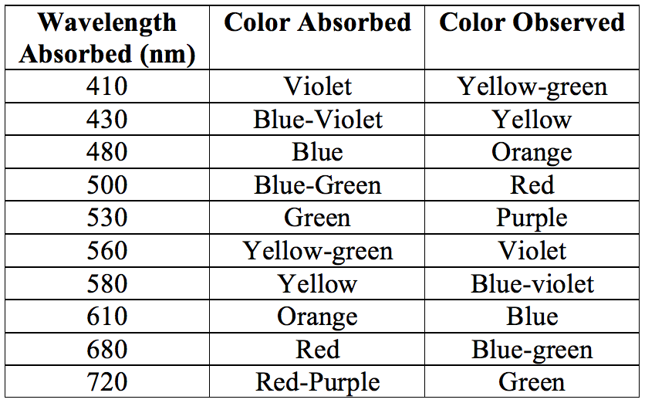
If a substance absorbs light in one wavelength range, the color you perceive will be a mixture of all the wavelengths which are not absorbed. For example, the indigo dye in blue jeans has its maximum absorbance in the 500 – 650 nm range. Because this absorbance is in the red-to-green region, the wavelengths which are not absorbed are in the 400-500 nm range, thus, the color observed is blue-violet. An aqueous solution that appears yellow, a narrow range around 550 nm, means that wavelengths on either side of yellow, primarily blues, greens and reds, are being absorbed. A green solution would be expected to transmit green wavelengths, while absorbing blues, yellows, and reds. The table to the left summarizes the relationship between the wavelengths of colors observed and colors absorbed.
Background: Spectroscopy

Spectroscopy is a technique that uses the interaction between matter and electromagnetic energy to either study matter, or to effect a change. A spectrometer is an instrument that separates electromagnetic radiation into wavelengths, passes these separated wavelength bands through a sample, and detects the intensity of the transmitted light. In visible spectroscopy, visible light is used, and the instrument is called a spectrophotometer.

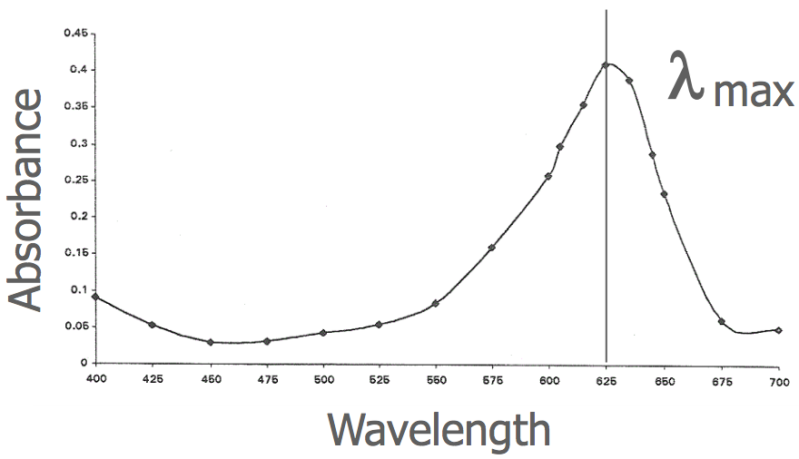
When analyzing a solution of a colored substance, a chemist will first measure the absorption spectrum, which is a plot of absorbance vs. wavelength for that system. An important feature of the absorption spectrum is the wavelength of maximum absorption ($λ_{max}$) at which the absorbance is the greatest. The figure to the right is an example of an absorption spectrum. The position of $λ_{max}$ is marked at 625 nm. The absorption spectrum is unique for each compound, much like your DNA is unique for you. The value $λ_{max}$ is always determined by experiment, because it can vary with solvents. Further absorbance measurements for a system will usually be determined at $λ_{max}$.

For a video on the theory and background for spectrophotometry including Beer’s Law which you will be using in this lab, see https://www.youtube.com/watch?v=VUupE9-u3nE (10 min).

Use the Spectrophotometer to Find $λ_{max}$.

In this part of the lab, you will be generating an absorption spectrum for a solution of NiCl₂(aq), and you will determine $λ_{max}$ for that solution. The spectrophotometer that we will use is a simulation based on the interior components of a benchtop spectrometer. Before you go to the simulation, view this video which shows how a spectrometer works in the lab: https://www.youtube.com/watch?v=kVC3D0pYkR4 (3.5 min).

The really good news for you is that the solutions are easy to make at home via a simulation. No measuring, mixing, or calculations are needed!

Follow the instructions, step-by-step, to generate the absorption spectrum and to find $λ_{max}$ for a solution of NiCl₂(aq).
- Open the online course content for this lab https://phet.colorado.edu/en/simulation/beers-law-lab. Use the PLAY button to open the application.
- The Beer’s Law Lab simulation has two panels. The 1st panel is a concentration game. You can add materials and water to the tank and change the concentration (drag the “cross-haired” meter to the tank to measure concentration). The 2nd panel is what we’re after, “Beer’s Law.” This will open the simulation of the interior of a spectrophotometer. You will see that the pieces inside the spectrometer are laid out on the screen. From left to right, you will find
  - The light source - a white light bulb that can be divided into the colors of the rainbow, one color at a time by adjusting the wavelength on the slider below the light source.
  - You will see the sample in its cuvette, but shown in cross-section. You can drag the ruler up to the cuvette to measure its width.
  - A meter that allows you to measure in absorbance or transmittance.
  - A benchtop where you can select the material being measured and adjust its concentration.
- Go ahead and click around for a while, to see what all the buttons do in the simulation. When you are finished exploring, set the simulation for the following settings:
  - In the benchtop, select the drop-down arrow to replace “drink mix” with NiCl₂. The concentration of 100 mM (millimolar) is OK. The cuvette should be filled with a green solution.
  - Set the wavelength to “Variable.” Start the wavelength at 780 nm by either clicking the arrows, or by dragging the bar.
  - Set the meter to measure “Absorbance.”
- Switch on the light by pressing the red on-button. Notice that the meter is measuring how much light passes through the cuvette with its sample of green NiCl₂ solution. Prepare a table in your notebook for recording the wavelength and the absorbance. Record the wavelength (780 nm) and the absorbance value in your notebook. Verify that the absorbance value you obtain is about 0.21. The absorbance is a measure of the log of how much light gets through the sample (I) compared to how much light was sent into the sample (I₀): $A = -log\left(\frac{I}{I_{0}}\right)$. The instrument computes this value for you with each measurement. Because absorbance is a ratio of light in vs. light out, there are no units.
- Decrease the wavelength to 760 nm, and record the absorbance at this wavelength. Continue to make measurements in 20-nm increments to find the gross absorption spectrum. Once you have finished all available measurements, observe: which wavelength gave you the highest point on the spectrum? Go to that region, and gather data over three 5-nm increments to each side of your highest point. The object here is to map out the region to find the $λ_{max}$ to the closest possible wavelength.
- Once you have found the highest absorbance for NiCl₂(aq), record both the absorbance value and the wavelength value. The wavelength value at the highest point is the $λ_{max}$.
- Graph this data with absorbance on the y-axis and wavelength (nm) on the x-axis. From the graph, verify that the value you selected for $λ_{max}$ matches the curve. There is a printable graph paper in the course materials online.

Beer’s Law: Concentration and Absorbance.

The higher the intensity of the color we perceive, the higher the concentration of the material that is responsible for the color we see. You intuitively understand this: more intense color corresponds to higher concentration. The relationship between concentration and absorption is a linear one at low concentrations. This relationship is named “Beer’s Law” or the “Beer-Lambert Law.” Beer’s Law states that the absorbance is proportional to the concentration: A $∝$ C. The complete expression is

$A = ϵ∙b∙C$ Beer’s Law

A is absorbance (which has no units, since it’s the log of a number with no units)
C is the concentration in mol/L or mmol/L
b is the path length of the cuvette, usually 1 cm, but can vary. You will be using a 1-cm cuvette.
$ϵ$ is the molar absorptivity, which is unique for each material and solvent. The higher the molar absorptivity, the more intensely colored the material is. The units are L•mol⁻¹•cm⁻¹ or L mmol⁻¹•cm⁻¹.

Return to the simulation: Explore the variables $ϵ$, b, and C for Beer’s Law by playing with the simulation. You have already worked with the light source. Have you tried changing the path length (width) of the cuvette yet? Also, change the kind of material that is being measured. Each material has its own $ϵ$ in Beer’s Law.

The Standard Curve.
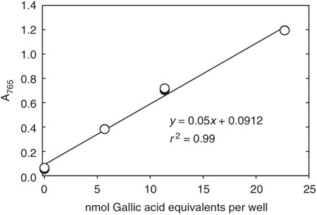
When Beer’s law is graphed with Absorbance on the y-axis and Concentration on the x-axis, a data set called a “Standard Curve” or “Calibration Curve” is created. The best-fit line for the data has a slope of $ϵ∙b$. Examine the expression for Beer’s law to satisfy yourself that the formula $A = ϵ∙b∙C$ corresponds to a linear expression y = m · x. You will notice that there is no y-intercept stated in Beer’s law. This is because the y-intercept should be zero, since a concentration of zero colored material will give an absorbance of zero for distilled water. See the graphed standard curve shown here for an example. In this example, the slope of the line corresponds to $ϵ∙b$, and y corresponds to absorbance and x corresponds to concentration.

The power of the standard curve is that it can be used to find, from any measured absorbance, what the concentration of that substance is. Here’s an example: In the city water lab, a standard curve for iron in drinking water is created. The analyst can then prepare any sample of water from any faucet in the city, measure its absorbance, and find out the concentration of iron in the water.

Create Your Standard Curve.
- Back to the Beer’s Law simulation. Let’s set up for this work.
  - Selected the NiCl₂ material.
  - Set the cuvette width to 1 cm.
  - Set the wavelength to the $λ_{max}$ value that you found in your earlier work. You will use this wavelength to measure the absorption of a series of NiCl₂(aq) solutions.
  - Create a table in your lab notebook with column headers for Concentration (mM) and Absorbance.
- Notice that the concentration of the solutions we are working with are given in mM, millimolar. This translates to millimoles per liter of solution. Slide the concentration for the NiCl₂ solution to 0 mM. Record the absorbance for this solution. Now add material to the cuvette in 25-mM jumps, and record the absorbance for each. Continue measuring the absorbance for each 25-mM step until you have reached 300 mM.
- You should now have a table of data in your notebook that includes a set of absorbance values for 13 different concentrations of green NiCl₂(aq) solution. Follow the Graphing Requirements (see Lab 2) to guide you in preparing your graph. You may either write the graph by hand on graph paper or you can use Excel (how-to’s are in the Graphing Requirements document). You should constrain the equation of the line to go through the origin (0, 0) if you can. Be sure to
  - Plot absorbance on the y-axis and concentration of the x-axis;
  - Draw the line of best linear fit for the data;
  - Find and report the value r².
  - Find and report the equation of the line as y = mx + b; display the equation on the graph.
  - Express the equation of the line in terms of Beer’s Law (i.e. replace y with A, m with $ϵ∙b$, and x with C). So if your equation of the line is y = 12x + 0.000, that would mean that your Beer’s Law line has y = A; slope 12 L/mmol = $ϵ∙b$; and x = C, so you would write A = 12,000 L/mol · C. -- Important! In this simulation, b = 1 cm, and C is in units of mM.
  - Find and report the value for $ϵ$, taking into account that slope = $ϵ∙b$.
  - Add the graph to the report to create one file (.pdf or .docx); submit the file to the course site. Also attach the graph to your notebook.
- Use Beer’s Law (the equation of the line) to complete the following table. Use your notebook as scratch paper to work out the calculations. Report the answer to the correct number of significant figures, and use units in your calculation, (that is, all numbers keep their units in the calculations; and you manipulate units in the calculation as needed). Problem a has been completed as a model.

Problem | Concentration | Absorbance
a | 80 mM | 0.43
b |  | 0.75
c | 180 mM
d |  | 1.29

Lab 10 – Visible Spectrophotometry. Report Sheet
Turn this sheet in before leaving lab for the day. The purpose of this sheet is to summarize some of the key data and conclusions from this experiment. You should keep a complete record of this lab in your own lab notebook. Report all data with the correct units and significant figures.

- Report the value you chose for the $λ_{max}$ for a solution of NiCl₂(aq). _________________________
- Explain why you chose this value for $λ_{max}$. Use complete sentences.
- Complete the following table, choosing 6 data points to report.
Data Collected for Beer’s Law Experiment
Concentration, mM | Absorbance

- Attach image of your standard curve graph to this report, and attach it to your lab notebook.
- Report r² for the equation of the line. ________________________________________________
- Report the value and units for $ϵ$. ________________________________________________
- Show your calculations and solution for problems (b) and (c) in the table on page 5 in the lab.

For example, if the highest point in your roughed-out absorption spectrum occurred at 650 nm, take measurements in 5-nm hops at 635, 640, 645 (15 nm below 650) and at 655, 660, and 670 (15 nm above 650).
The best standard curves are straight lines with an r² value closest to 1.0. “Curve.” Right.
For printable graph paper, http://www.printfreegraphpaper.com/. For this graph, change Setting 3 to Millimeters and Setting 4 to 5mm Cartesian Graph Paper.
Most calculators can do this, or go online at http://ncalculators.com/statistics/r-squared-calculator.htm

