Waves Interference‌ Remote Lab 3 Diffraction
(This‌ ‌lesson‌ is designed ‌for‌ ‌a‌ ‌student‌ ‌working‌ remotely‌.)‌

This lab uses the Waves Interference simulation from PhET Interactive Simulations at University of Colorado Boulder, under the CC-BY 4.0 license.
https://phet.colorado.edu/sims/html/wave-interference/latest/wave-interference_en.html

Note about prior learning: Students should have completed Waves Interference Remote Lab ‌2 or lessons with similar learning goals.

Learning Goals: Students will be able to:
- Compare light wave patterns made by light passing through slits to passing through holes.
- Explain how the aperture geometry relates to the diffraction pattern.
- Predict how changing the wavelength or aperture size affects the diffraction pattern.
Develop your understanding: Open the Diffraction screen, then explore to see what happens to light waves when they pass through different shaped holes. 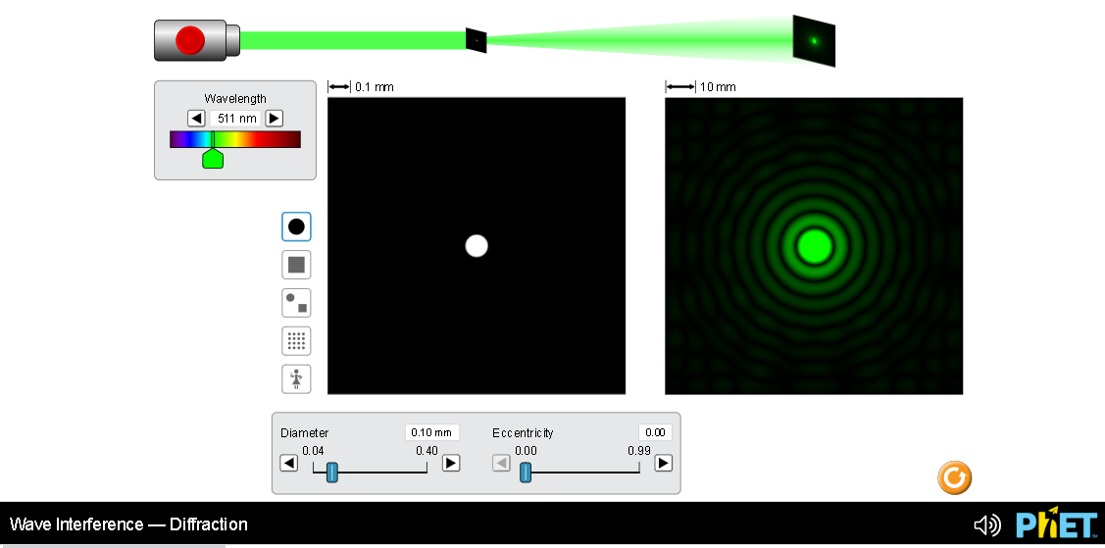

Explain your understanding:

- Open the full simulation Waves Interference so that you can experiment with both the Slits and Diffraction screens.
  - Use your ideas from Waves Interference Remote Lab ‌2 about what happens to waves passing through slits to help make sense of why light passing through a round hole makes a pattern. Explain what you think is happening including images for support.

  - Compare patterns of varying slit size to patterns of varying hole size. Include images for support.

  - Compare patterns of varying frequency through slits to patterns of varying wavelength through holes. Include images for support.

- Experiment with other shapes of apertures (holes) to find trends that help to meet these goals:
B. Explain how the aperture geometry relates to the diffraction pattern.
C. Predict how changing the wavelength or aperture size affects the diffraction pattern.

Write a summary of your understanding and include images for support.

6. Summarize key ideas that you want to remember about the relationships of interference patterns of light waves.

9. Summarize your understanding of waves as they pass through slits. Make sure you demonstrate meeting learning goal C “Put up a barrier to see how the waves move through one or two slits. What sort of pattern do the slits create? How can you change this pattern?”

