Bending Light Remote Lab
This‌ ‌lesson‌ is designed ‌for‌ ‌a‌ ‌student‌ ‌working‌ remotely‌.)‌
This lab uses the Bending Light simulation from PhET Interactive Simulations at University of Colorado Boulder, under the CC-BY 4.0 license.
https://phet.colorado.edu/sims/html/bending-light/latest/bending-light_en.html

Learning Goals
- Describe what happens to light when it shines on a medium.
- Explain light direction changes at the interface between two media and what determines the angle.
- Describe the effect of varying wavelength on the angle of refraction.
- Explain why a prism creates a rainbow.
- Apply Snell’s law to a laser beam incident on the interface between media.
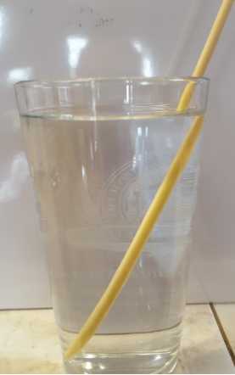
Everyday Physics in your life:
I put a chopstick in a glass of water like in the picture on the right. What do you notice?

Try this at home with some other things like a spoon or fork. Do you observe any different things?
( If you don’t have a clear glass, you can still see some interesting things. You might want to use a larger container like a bathroom sink).

What ideas do you have about why things look different under water?

Develop your understanding:
- Explore the Intro screen to find some things that happen when light rays shine into water. Figure out how to test what happens when the light rays come from underwater. Compare your ideas about why things look different under water to how light rays appear to “bend.”.
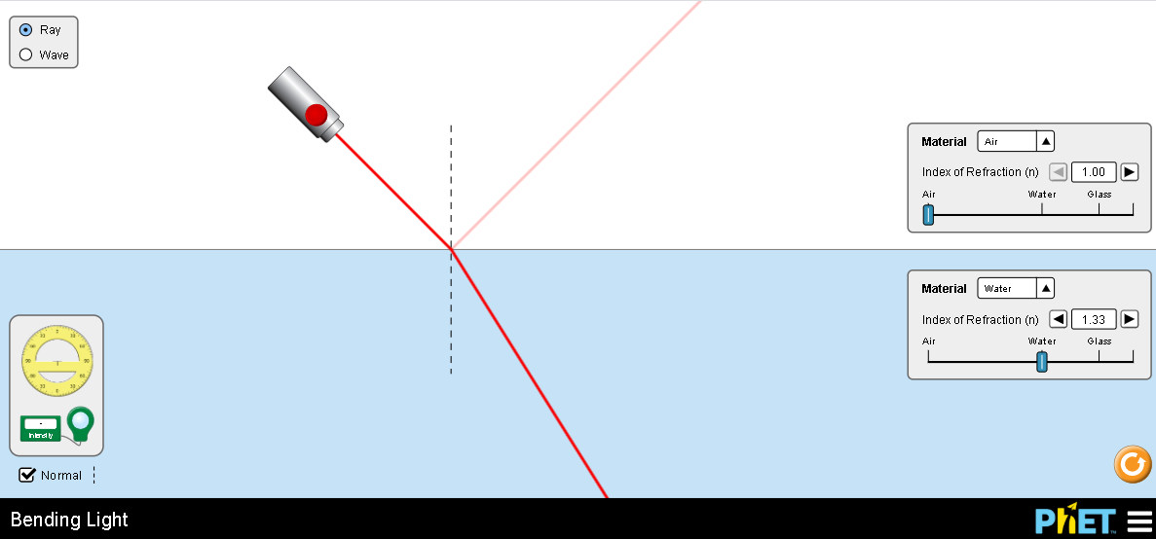

Explain your understanding:
- Experiment in the Intro screen using the tools to observe what happens to light when it shines on water.
Use both the Ray and Wave models for light. 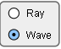

  - Write about how each tool helps investigate the behavior of light.

  - Describe the behavior of light when it shines on water. Provide examples for a variety of incident angles to support your description.

  - What changes if the light is underwater and the light goes into air?

  - What changes if you shine light on glass?

  - Test materials with other indexes of refraction to see if your ideas about the behavior of light seem comprehensive.

  - Write a summary description of what happens to light when it goes from one medium to another. Use the following vocabulary words in your summary: index of refraction, incident angle, reflected angle, and refracted angle.

- Use More Tools screen to observe variation in refraction as the wavelength (color) of incident light varies.
- The difference in refraction angles is small and difficult to detect in this simulation, so I have shown a possible experimental setup for you to try. How much does the angle of refraction change from 380nm to 700nm when the incident angle is 80?
Run some of your own experiments to see if you can detect a difference in refracted angles at other incident angles. Why did I choose 80 degrees?
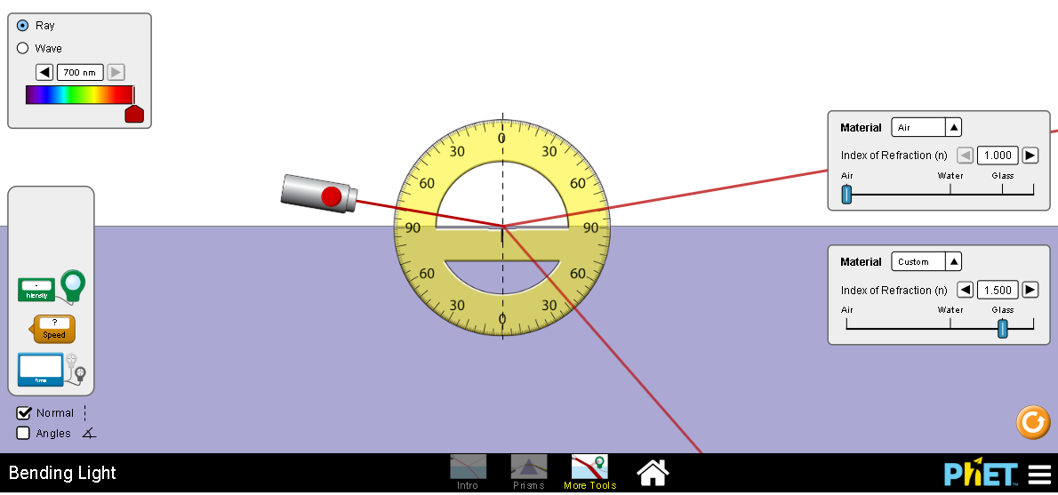
- Use the Speed tool as you vary the wavelength to help understand why the angle of refraction varies. Describe the results of your experiments

- Does the color of the color of the light change during refraction or reflection?

4. Explore the Prisms screen to see how your understanding of refraction applies when light travels through a medium like glass. Give specific examples and images from the simulation to explain how your understanding applies.
Simulation tip: Remember that the Normal dashed line and protractor will help take measurements..
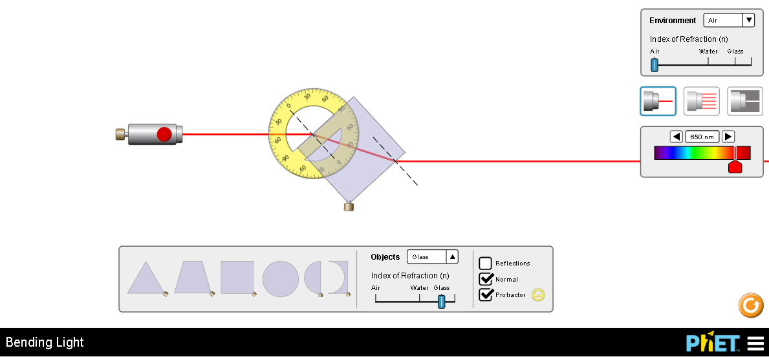

5. Experiment to find ways to make rainbows.
- Insert at least one setup where light passing through a prism gives a rainbow and describe why a rainbow is formed.

- Explain why only some types of light will yield rainbows.

Test your understanding and self-check
Open the full Bending Light simulation
- Show that you can use Snell’s Law ( n₁sinΘ₁ = n₂sinΘ₂) to predict the angle of reflection and angle of refraction for several scenarios. Show your work. After you have completed the calculations, use simulation to check your work
For incident angle of 30 degrees light shining
- from air into water
- from water into air
- from air into glass
- from water into glass
- from air into a medium with an index of 1.22

