Charges and Fields

Name:

- Play with the simulation (Charges and Fields) and get oriented with all of the different options. This should help you understand the lab better.
Activity 1
- From the box at the bottom of the screen, drag a red +1 nC charge into the middle of the screen.
- If not already selected: Select ‘Electric Field’. How does the brightness of the arrow relate to the strength of the field? What happens when you check/uncheck ‘Direction only’? Which way do the arrows point for a positive charge?

- Drag the red +1 nC charge back into the box at the bottom, and then drag a blue –1 nC charge onto the screen. Which way do the electric field arrows point for a negative charge?

- Click on the yellow Sensor at the bottom and drag it across the electric field. What information do the Sensors show?

- What happens to the electric field as you move further from the charges?

- Take the Voltage meter (labeled ‘0.0 V’). What information does the voltmeter give? What information is given when you click on the pencil (you should have a green circle)? What does the green circle represent? (If you’re not sure, move on and come back to this later.)

Activity 2
(If you want to reset the screen, click on the orange circle arrow in the bottom right corner. Do this before each activity)
- How can you make a charge of +2q? How can you make a charge of -3q?

- Determine what charges (magnitude and positive/negative) would give you the electric field lines shown below?
(You may need to try different combinations to determine the magnitudes of each charge.)
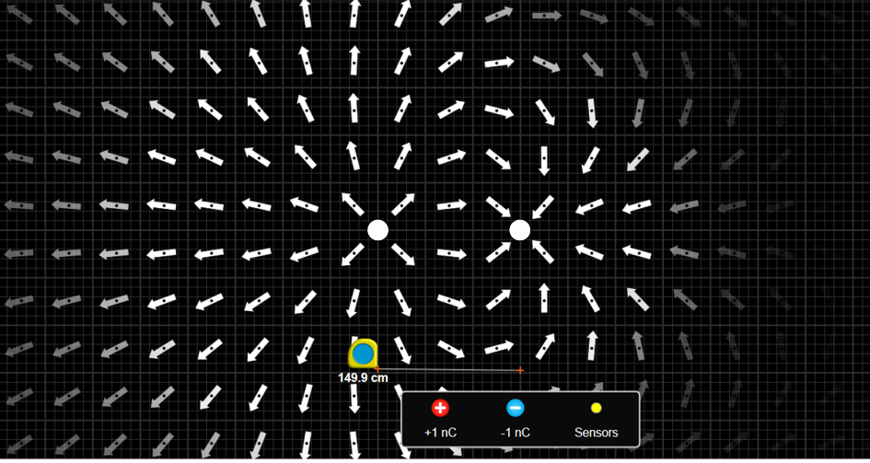

- When you have two opposite but equal magnitude charges along a horizontal line (similar to the picture above), where is the electric field the greatest? Is there ever a point where the field will be zero?

- When you have two of the same charges along a horizontal line, where is the electric field the greatest? Is there ever a point where the field will be zero?

- Determine what charge/charges (magnitude and positive/negative) would give each the lines of equipotential shown below?
(For each situation, turn the ‘Electric Field’ on and off to see how the electric field lines compare to the equipotential lines)
a) 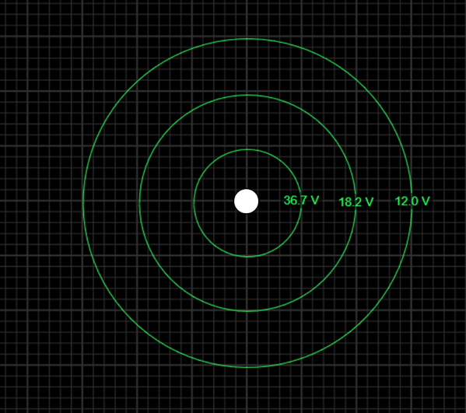 b) 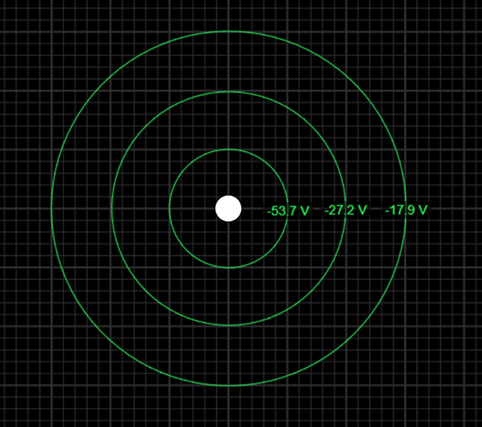

c) 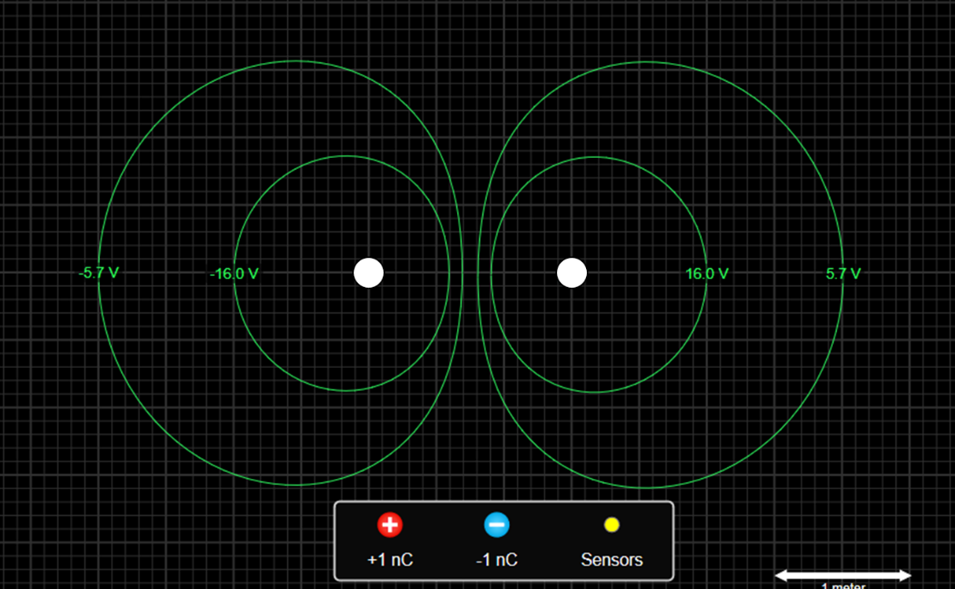
d) 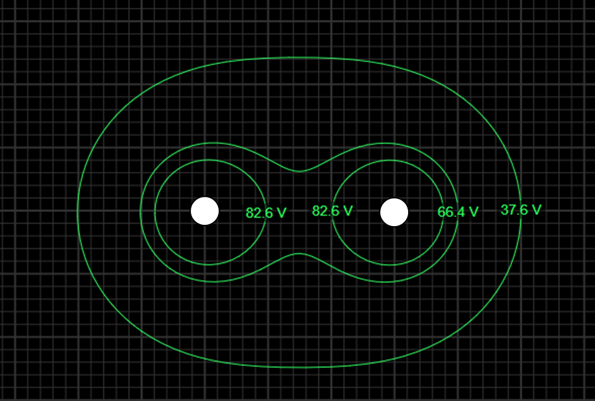

- When you have two opposite but equal magnitude charges along a horizontal line (similar to the picture above), where is the potential the greatest? Is there ever a point where the potential will be zero?

- When you have two of the same charges along a horizontal line, where is the potential the greatest? Is there ever a point where the potential will be zero?

Activity 3
- Make a long vertical line of positive charges by placing them very close together, similar to what’s shown to the right. How does the electric field change as you move around the line of charges?

- Make a long vertical line of negative charges 2 meter from the positive charges similar to what’s shown below. This is your parallel-plate capacitor. How does the strength of the electric field change between the two lines? How does the direction of the electric field change between the two plates?
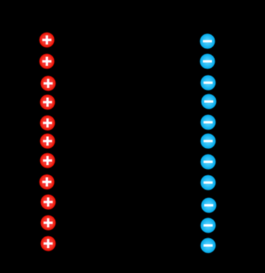

- Place sensors at 3 different locations between the lines to get readings of the electric field, each at different distances from the lines.
- Use the voltmeter to draw lines of equal potential at the locations of the three sensors by clicking on the pencil button on the voltmeter. When you have the voltmeter at each distance, click this button. Doing so will record the potential V and draw a green line on the screen. Include a screenshot of your capacitor with 3 sensors and 3 green lines/circles.

- Fill in the table below for each of the locations. (In order to see the potentials, you may need to move the sensors.)

Location | Distance from  positive plate (m) | Electric field E (V/m) | Potential V (V)
1
2
3

Activity 4
r (m) | E (V/m)
1
2
3
4
5
6
7
8
- Place six +1 nC charges on top of each other somewhere on the left side of the screen.
(It can go anywhere, but there needs to be enough space to measure 8 m away.)

- From the box at the bottom, drag a Sensor and place it 1 m to the right of your charge. This sensor measures the E field at the location of its placing. In the table at right, record the E field magnitude at a distance r of 1 m. Ignore the degrees.

- Drag the Sensor to the other distances shown in the table, then record the E field measurements.

r (m) | V (V)
1
2
3
4
5
6
7
8
- Drag your Sensor back and replace it in the box at the bottom of the screen.

- Using the voltmeter, record the potential V by drawing a green line on the screen at each distance. Fill in the table at the far right. Include a screenshot with all of the green circles.

- Write the equation for the electric field at any distance r from a point charge q:

- Write the equation for the potential at any distance r from a point charge q:

- Using the table above, make a graph in Excel of electric field E and distance r to determine Coulomb’s constant k using the appropriate trendline.
(Hint: there are 2 ways to do this. Either make a graph and then create the appropriate trendline, or figure out how to make the graph into a straight line and then use a linear trendline. Once you have a trendline, compare the equation written above to the equation of the trendline to find k)

- Insert the graph below and write down the k value that you found. Compare this value to the known value found on the equation sheet or in class slides using percent error or percent difference (whichever is most appropriate)?

- Using the table above, make a graph in Excel of voltage V and distance r to determine the constant k again using the appropriate trendline.
(The same hint as above applies, but the work will be slightly different because the equation is different.)

- Insert the graph below and write down the k value that you found. Compare this value to the known value using percent error/difference?

