Concentration – Understanding Molarity and Parameters affecting Molarity Remote Lab
(This‌ ‌lesson‌ is designed ‌for‌ ‌a‌ ‌student‌ ‌working‌ remotely‌.)‌
This lab uses the Concentration and Molarity simulations from PhET Interactive Simulations at University of Colorado Boulder, under the CC-BY 4.0 license.
https://phet.colorado.edu/sims/html/concentration/latest/concentration_en.html
https://phet.colorado.edu/sims/html/molarity/latest/molarity_en.html

Learning Goals
- Describe the relationships between volume and amount of solute to solution concentration.
- Predict how solution concentration will change for any action (or combination of actions) that adds or removes water, solute, or solution, and explain why.
Develop your understanding: Explore the Concentration simulation. Try to find all the ways you can change the concentration of the solution in the beaker.
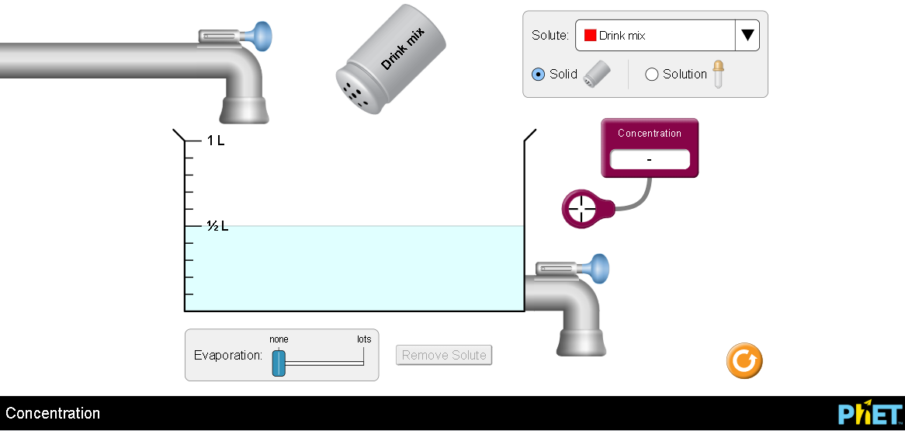

Explain your understanding:
- Mole calculation review. Show your work:
  - How many moles is
55 g of NaCl?
0.025 g of NaCO₃?
  - How many grams is
0.5 moles of NaCl?
2.11 moles of NaCO₃?

- There are several ways to measure Concentration. This simulation uses Molarity (mol/L).
  - What does mol/L mean?

  - Describe in your own words how mol/L compares to grams/liter. (similarities and differences)

- Describe at least 2 ways in the simulation to change each of the parameters:
  - Volume of solution
  - Amount of solute
  - Concentration of solute in solution

- Volume effects on concentration:
  - Is dilution directly or indirectly related to Molarity?
Explain how you used the sim to determine the relationship and give evidence of measurements you made to support your ideas.

  - How is evaporation related to Molarity? Use your own words to describe why the relationship makes sense based on the data you used to support the dilution relationship.

  - What is one way to change the volume without changing the concentration? Describe why the concentration doesn’t change.

- Does the concentration change in the same way if you used solid or liquid to add solute? Explain why your observation makes sense using things from your everyday life like table salt.

Summarize your understanding:
- What are all the things that affect Concentration measured in mol/L (parameters in the sim).
List here and identify if the variable is directly or indirectly related to the concentration:

- Explore the Molarity simulation and consider how it compares (similarities and differences) to Concentration. Write down your observations.

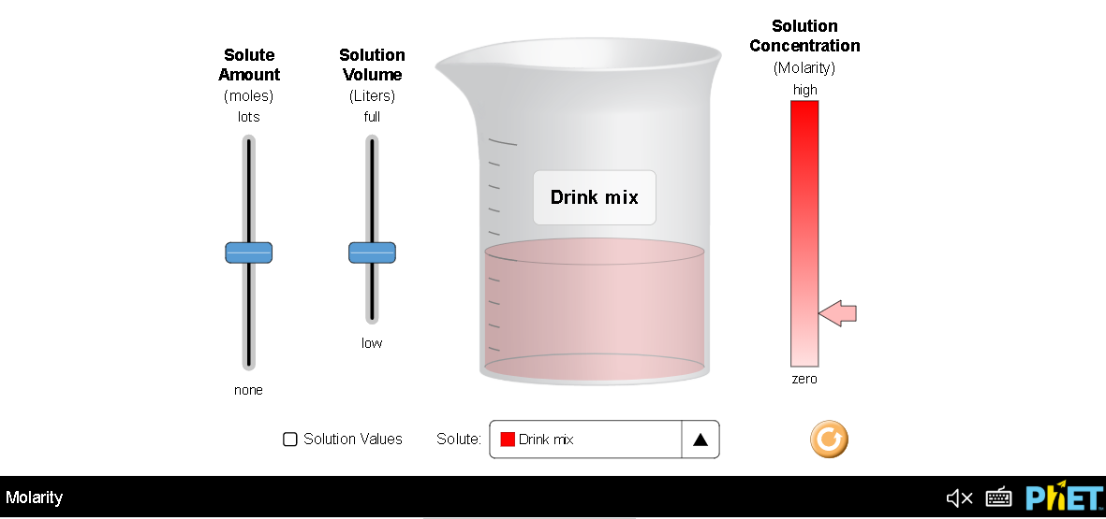

Test your understanding:
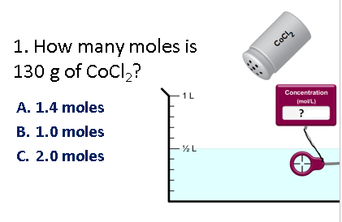1. Show your work:

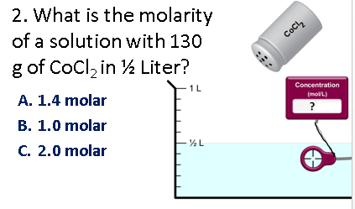2. Show your work:

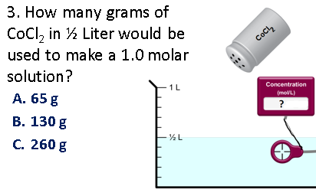3. Show your work:

For #4-8, predict your answer and support your answer with an explanation.
Then use the Concentration simulation to verify and add screen captures to your explanation.

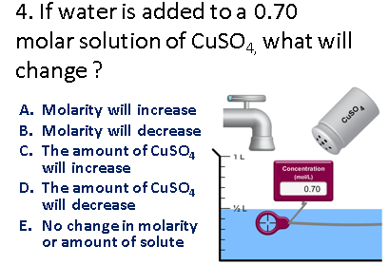
4. Prediction and explanation with support

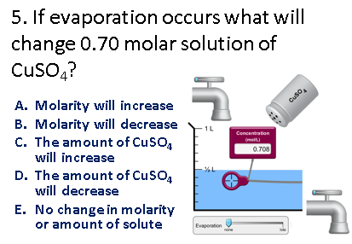
5. Prediction and explanation with support

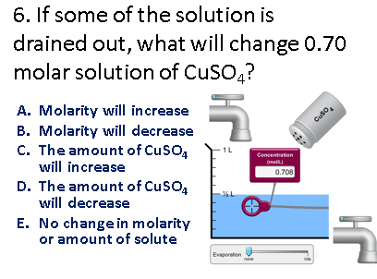
6. Prediction and explanation with support

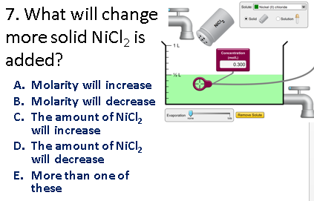
- Prediction and explanation with support

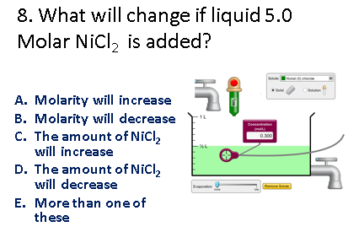
- Prediction and explanation with support

