pH Scale Basics Remote Lab
(This‌ ‌lesson‌ is designed ‌for‌ ‌a‌ ‌student‌ ‌working‌ remotely‌.)‌
This lab uses the pH Scale Basics simulation from PhET Interactive Simulations at University of Colorado Boulder, under the CC-BY 4.0 license.
https://phet.colorado.edu/sims/html/ph-scale-basics/latest/ph-scale-basics_en.html

Learning Goals: Students will be able to:
- Determine if a solution is acidic or basic using pH.
- Relate liquid color to pH.
- Predict if dilution and volume will increase, decrease or not change the pH
- Organize a list of liquids in terms of acid or base strength in relative order with supporting evidence.
Everyday Chemistry in your life:
- List some common liquids that you think are acidic or basic. For example, do you think orange juice is acid or base? Why do you think each liquid is an acid or base?
- orange juice is ( Acid or base) and (Why do you think so?)
- #2 is ( Acid or base) and (Why do you think so?)
- etc
- .
- .

- Do you think the amount of the liquid changes how acidic or basic it is? Explain your thinking.

- What do you think adding water (dilution) changes how acidic or basic the liquid is? Explain your thinking.

Develop your understanding:
- Use pH Scale Basics to test your ideas about some common things that are acids or bases.
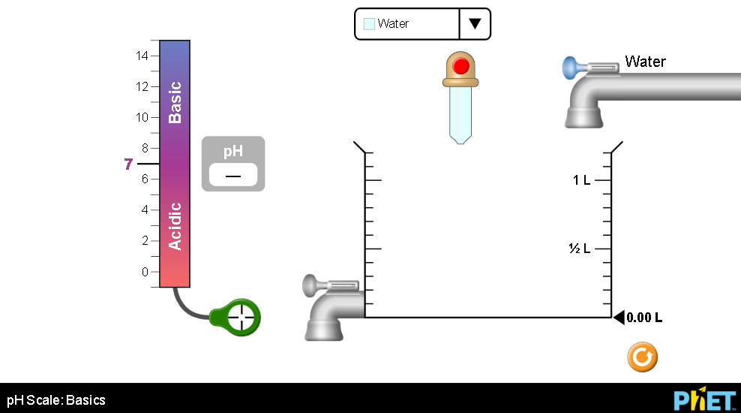
- Describe your tests and results.

- Were all of the liquids you listed in #1 in the simulation? If not, research to find the pH and identify each as acid or base. If all your items were in the simulation, look up a few other common things. (cite references)

- Experiment to check your ideas from #2 about how color or volume help identify whether something is acid, base, or neutral. Describe your tests and results with specific examples.

- Experiment to check your ideas from #3 about whether dilution will increase, decrease or not change the pH.
  - Does every solution behave the same way?

  - Explain how you can use pH to help predict what dilution does to an acid or base solution.

- Consider some common drinks.
Alkaline water 8.0, Fruit juice 6.8, Gatorade 3.0, Green tea 9.0, Gatorade 3.0, Vinegar 3.5,

- Organize this list of foods with pH from most basic to most acidic.

- Which will have a higher pH if you dilute it with water?

Test your understanding and self-check: For each question, predict your answer and support your answer with an explanation. Then use pH Scale Basics to verify and add screen captures to your explanation.

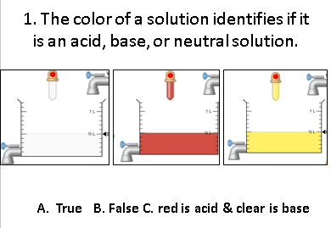
- Prediction and explanation with support

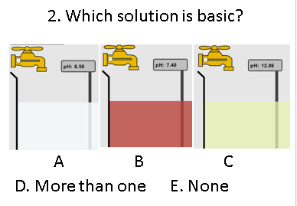
- Prediction and explanation with support

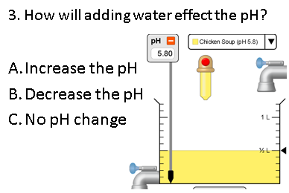
- Prediction and explanation with support

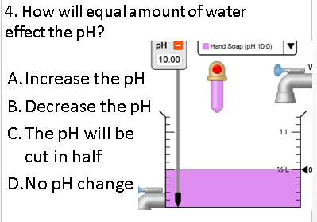
- Prediction and explanation with support

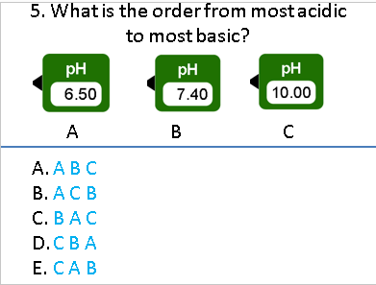
- Prediction and explanation with support

