Capacitor Lab: Basics: Inquiry into Capacitor Design
(This‌ ‌lesson‌ is designed ‌for‌ ‌a‌ ‌student‌ ‌working‌ remotely‌.)‌
This lab uses the Capacitor Lab: Basics simulation from PhET Interactive Simulations at University of Colorado Boulder, under the CC-BY 4.0 license.
https://phet.colorado.edu/sims/html/capacitor-lab-basics/latest/capacitor-lab-basics_en.html

Learning Goals:
Students will be able to:
- Identify the variables that affect the capacitance and how each affects the capacitance.
- Determine the relationships between charge, voltage, and stored energy for a capacitor.
- Relate the design of the capacitor system to its ability to store energy.
- Explain how to use a capacitor to light a bulb.
- Describe what happens as charge drains away from a capacitor into a light bulb

Develop your understanding: Open the Capacitance screen, then explore to develop your own ideas about how a capacitor is designed.
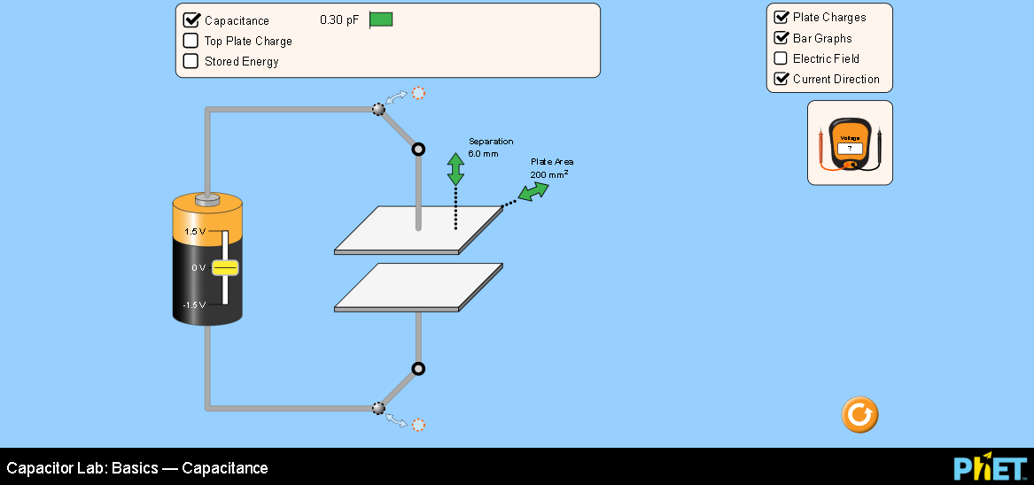

Explain your understanding: Use your own words and captured images from the simulation to show you can:

- Identify what features of a capacitor can be maximized or minimized to make a capacitor with the greatest capacitance.

  - What features of the simulation did you use to help you?

- Design experiments to find the relationships between charge, voltage, and stored energy for a capacitor. Summarize your experimental procedures and findings.

  - What features of the simulation did you use to help you?

- If you wanted to design a capacitor system to store the greatest energy, what would you use?

Develop your understanding: Explore the Light Bulb screen to investigate how to use a capacitor to turn on a light bulb.
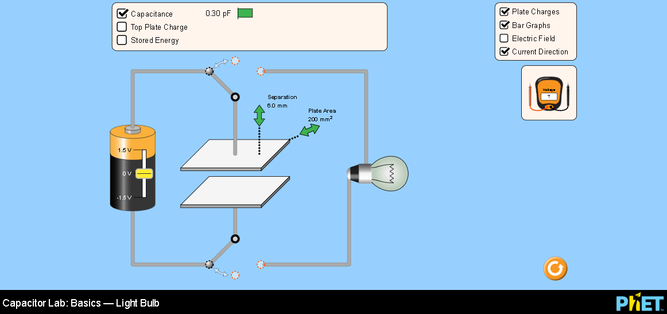

Explain your understanding: Use your own words and captured images from the simulation to show you know how to use a capacitor to light a bulb.

- What are the required components to use a capacitor to light a bulb and how does the system operate?

- How would using a capacitor to light a bulb compare to using just a battery as shown:
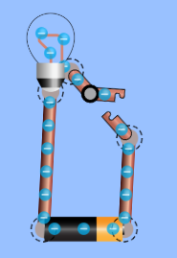
- Use Circuit Construction Kit Intro screen to test your ideas and provide supporting evidence.

- Describe what happens as charge drains away from a capacitor into a light bulb. Include the use of as many tools in the simulation as possible in your observations.

  - What features of the simulation did you use to help you?

- Research to find a practical application where the energy stored in a capacitor is used. (cite references)

