Sandwich Stoichiometry Name __________________

Part I : Cheese Sandwiches

- Go to the PhET simulation website:
https://phet.colorado.edu/sims/html/reactants-products-and-leftovers/latest/reactants-products-and-leftovers_en.html
- Select “Sandwiches”
- Select “Cheese” at the top
- Use the arrows to enter the following under reactants on the left (“Before Reaction”):

Before Reaction
8 pieces of bread
8 pieces of cheese

5. Fill in the number of products and leftovers under “After Reaction” in the table below.

Products Leftovers -------------------------------
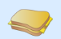
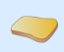

#

How many pieces of bread and how many pieces of cheese do you need to make exactly 3 sandwiches with no leftovers?
_____ pieces of bread _____ pieces of cheese

Part II : Meat and Cheese Sandwiches

- Go to the PhET simulation website: Select “Sandwiches”
- Select “Meat and Cheese” at the top
- Use the arrows to enter the following under reactants on the left (“Before Reaction”):

- Before Reaction
5 pieces of bread
5 pieces of meat
5 pieces of cheese

- Fill in the number of products and leftovers under “After Reaction” in the table below.

Products ------------------- Leftovers

#

- Before Reaction
8 pieces of bread
3 pieces of meat
4 pieces of cheese

After Reaction

Products ----------------------------- Leftovers ------------------------------

#

How many pieces of bread, meat, and cheese do you need to make exactly 3 sandwiches with no leftovers?

_____ pieces of bread _____ pieces of meat _____ pieces of cheese

Part III: Water

- Go to the PhET simulation website: https://phet.colorado.edu/sims/html/reactants-products-and-leftovers/latest/reactants-products-and-leftovers_en.html
- Select “Molecules”
- Select “Water” at the top
- Use the arrows to enter the following under reactants on the left (“Before Reaction”):

Before Reaction
6 H₂
4 O₂

5. Fill in the number of products and leftovers under “After Reaction” in the table below.

Products ------------------------------ Leftovers -------------

 | H₂O | H₂ | O₂
#

How many H₂ and O₂ molecules do you need to make exactly 4 water molecules with no leftovers?

_____ H₂ _____ O₂

Part IV: Ammonia

- Go to the PhET simulation website:
- Select “Molecules”
- Select “Ammonia” at the top
- Use the arrows to enter the following under reactants on the left (“Before Reaction”):

Before Reaction
5 N₂
5 H₂

5. Fill in the number of products and leftovers under “After Reaction” in the table below.

Products ------------------------------ Leftovers -------------

 | NH₃ | N₂ | H₂
#

How many N₂ and H₂ molecules do you need to make exactly 2 ammonia molecules with no leftovers?

_____ N₂ _____ H₂

Part V: Methane

- Go to the PhET simulation website:
- Select “Molecules”
- Select “Combust Methane” at the top
- Use the arrows to enter the following under reactants on the left (“Before Reaction”):

Before Reaction
6 CH₄
6 O₂

- Fill in the number of products and leftovers under “After Reaction” in the table below.

-------------- Products ----------------------------------- ----------------------- Leftovers ---

 | CO₂ | H₂O | CH₄ | O₂
#

How many CH₄ and O₂ molecules do you need to make exactly 1 CO₂ and 2 H₂O molecules with no leftovers?

_____ CH₄ _____ O₂

Now use the ‘Reactants, Products & Leftovers – Game’
Part VI: Game time

- Go to the PhET simulation website:
- Select “Game”
- Play Levels 1 first, then level 2 (if you like the game you can try level 3)

Level 1: You need to score a 6 or better on level 1. Your score: ______
Level 2: You need to score a 6 or better on level 2. Your score: ______
- Take a snap shot of your final screen (see sample below). Paste it below my sample.
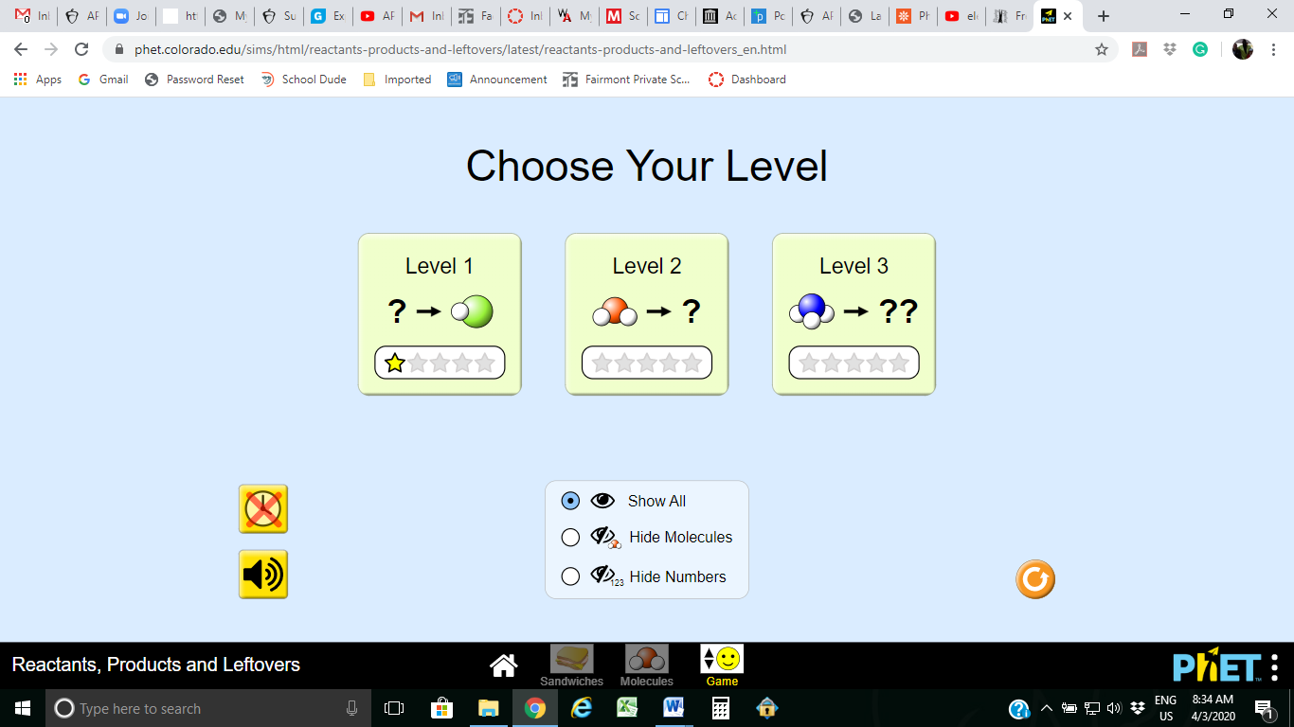

Save your document as a PDF file and upload it in the assignment portal.

prt sc
fn
Note: on my PC I take a screen snap shot by pressing + ,
v
ctrl
Then +

