Introduction to Circuits Remote Lab
(This‌ ‌lesson‌ is designed ‌for‌ ‌a‌ ‌student‌ ‌working‌ remotely‌.)‌

This lab uses the Circuit Construction Kit DC simulation from PhET Interactive Simulations at University of Colorado Boulder, under the CC-BY 4.0 license.
https://phet.colorado.edu/sims/html/circuit-construction-kit-dc/latest/circuit-construction-kit-dc_en.html

Learning Goals
- Explore basic electricity relationships.
- Explain basic electricity relationships in series and parallel circuits.
- Use an ammeter and voltmeter to take readings in circuits.
- Provide reasoning to explain the measurements and relationships in circuits.

Prediction Questions
Consider the pictures of each of these circuits, then answer the questions below.
Series Circuit Parallel Circuit Complex Circuit
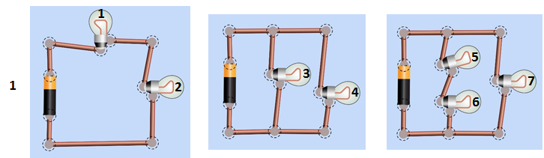
- From the circuits above, predict which bulb (or bulbs) will be the brightest. Why do you think that?

- Current is the flow of charge (measured in coulombs/sec = amps) in a circuit. Describe how you think current will flow in the different types of circuits above.

Develop your understanding:
- Explore the Intro screen of Circuit Construction Kit DC
  - Build a circuit that shows how to make a light bulb light up.
  - Figure out how to measure current and voltage.
  - Insert an image of your circuit with the current and voltage measured.

- Imagine you’re an engineer making a string of battery powered holiday lights. If a bulb burns out current cannot flow through that bulb any longer like if the wire at the bulb has been cut. Figure out how to hook up 2 light bulbs and a battery so that when one bulb burns out or is disconnected the other stays lit.
  - Insert images to illustrate that your circuit works as expected.

  - Explain why you think it works.

- Imagine that you want to make sure the battery for your string of lights will last as long as possible. A battery will last longer if it powers a circuit with low current. How could you hook up a battery and 2 light bulbs so the least amount of current flows through the battery? Use the measurement tools in the simulation to check your design.
  - Insert images to illustrate that your circuit works as expected.

  - Explain why you think it works.

Develop your understanding Part 2
Instructions: Your goal in this part is to write rules to describe how patterns of current and voltage in a circuit relate to the structure of the circuit. You will need to measure current and voltage in multiple places on several different circuits.
Examples:
Measuring Current | Measuring Voltage
“Current” is the flow of charge, measured in Amps (Coulombs/s). An ammeter measures the current past a single point in the circuit.  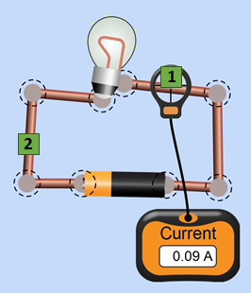  The current flowing through point 1 can be written as:  I₁ = 0.09 A. | “Voltage” is a measure of the difference in electric potential between two points. The voltmeter measures this difference by placing the two leads (pronounced “leeds”) at two different points.  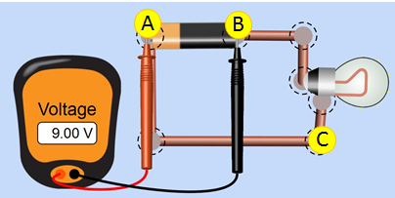  The voltage between points A and B can be written as V_{AB} = 9 V.
Use the table below to record your measurements and patterns you notice. You decide where will be the most useful places to take measurements, and how many to take.
Circuit  Label the places where you decide to measure current and voltage. Try several places. | Current Measurements (Amps) | Voltage Measurements (Volts)  . | What patterns do you notice?  - Where is the current the same? Where is it different?  - Where does the voltage change? Where doesn’t it change?  - How do the different circuits compare?
- Simple Circuit  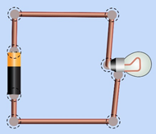  Label on the picture the places where you measure (See examples above ). | Example:  I₁ = ______ A  ____________________________________________________________________________________ | Example:  V_{AB} = ______ V.  ____________________________________________________________________________________
2) Series Circuit  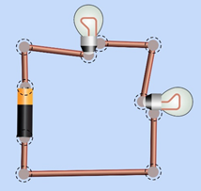 | ____________________________________________________________________________________ | ____________________________________________________________________________________
3) Parallel Circuit  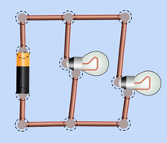 | ____________________________________________________________________________________ | ____________________________________________________________________________________
4) Complex circuit  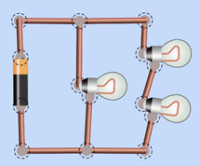 | ________________________________________________________________________________________________ | ________________________________________________________________________________________________

Summarize your understanding:
6. Compare the patterns you see in a series circuit to the ones you see in parallel and complex circuits. Write rules about voltage and current for each type of circuit.
For example, “In a series circuit, I see that the current ….., whereas in a parallel circuit I see… ”.

Test your understanding
7. Predict from your rules above, the order of the light bulbs in these circuits from brightest to dimmest. Some bulbs might be the same brightness.
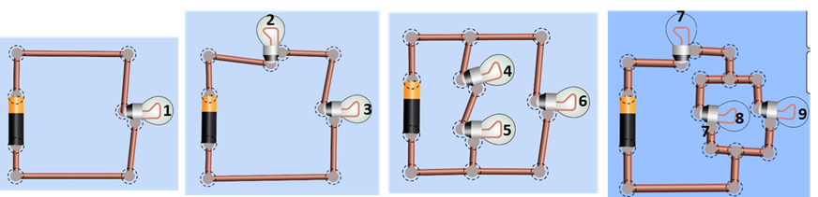
- (order the bulbs by brightness)

- After you make your rankings, build circuits to check your answers and list the correct ranking below. Insert images from the simulation to support your sequence.

- Did your rules allow you to correctly rank the bulb brightness? If not, correct your rules in #6.

- Did you use any meters to help you make your list? If so, explain why.

8. If you want to make a flashlight and have two batteries and a lightbulb.
- Predict how you would hook them up to make the brightest flashlight, and explain why.
- Build circuits to check your answer and insert images from the simulation for evidence.

