Resistance in a Wire Remote‌ Lab ‌
This lab is designed ‌for‌ ‌a‌ ‌student‌ ‌working‌ remotely‌ after completing Ohm’s Law Remote lab.

This lab uses the Resistance in a Wire and Circuit Construction Kit DC simulation from PhET Interactive Simulations at University of Colorado Boulder, under the CC-BY 4.0 license.
https://phet.colorado.edu/sims/html/resistance-in-a-wire/latest/resistance-in-a-wire_en.html
https://phet.colorado.edu/sims/html/circuit-construction-kit-dc/latest/circuit-construction-kit-dc_en.html

Learning Goals:
- Explore the characteristics of a resistor that are variable in this model.
- Identify how each characteristic affects the resistance and current flow.
- Explain your ideas about why the characteristics change the resistance and current flow.
- Use understanding to make predictions about a circuit with lights and batteries.

Develop your understanding:
- Open Resistance in a Wire, then explore to develop your own ideas about how the construction of a resistor affects its resistance and also ability to allow current to flow.
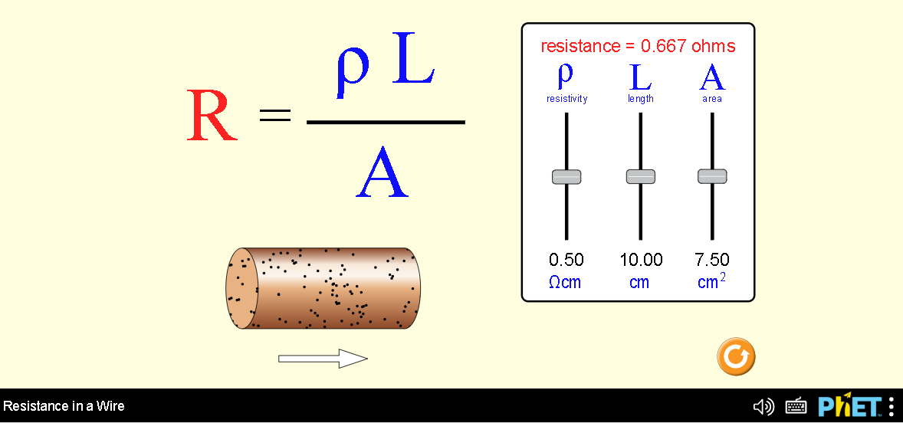
Describe several of your experiments and your observation with captured images from the simulation.
- .
- etc

Demonstrate your understanding:
Directions: As you answer the questions, explain in your own words why your answer makes sense and provide evidence from your #1 experiments. Add more experiments to #1 if you need to get better evidence.

2. If you change the cross sectional area of the resistor, how does
- the resistance change? (answer, explain, evidence)

- the current through a circuit change? (answer, explain, evidence)

3. If you change the length of the resistor, how does
- the resistance change? (answer, explain, evidence)

- the current through a circuit change? (answer, explain, evidence)

4. If you change the resistivity of the resistor, is the effect like changing the length or changing the area? (answer, explain, evidence)

5. During manufacturing, how is the resistivity of a resistor changed? Cite your references

6. Consider the two circuits below in which the left resistor is and the right one is
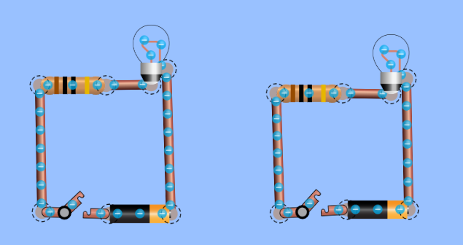

Use your understanding of voltage, resistance, and current to answer these questions:
- What do you think will happen when the switches are turned closed?
(answer, explain, evidence)

- How do you think the lights’ brightness will compare?

- Open the Intro screen of Circuit Construction Kit DC. Build the 2 circuits and check your answers. Insert a capture of the circuits with the switch closed for supporting evidence.

