Balancing Act Game ‌
(This‌ ‌lesson‌ is designed ‌for‌ ‌a‌ ‌student‌ ‌working‌ remotely‌.)‌

This lab uses the Balancing Act simulation from PhET Interactive Simulations at University of Colorado Boulder, under the CC-BY 4.0 license.
https://phet.colorado.edu/sims/html/balancing-act/latest/balancing-act_en.html

Learning Goals: Students will be able to:
- Describe the factors that determine whether two objects will balance each other
- Predict how changing the position of a mass on the balance will affect the motion of the balance
- Use a balance to the find the masses of unknown objects

Open the full simulation Balancing Act, then open the Game screen. Use ideas you have from the learning goals. You may need to use the Intro and Balance Lab screens to learn.

- Play Level 1
  - Did you have to change your thinking or do you have other ideas to make you get a better score? Include screen captures from the simulation to help explain.

  - When you complete the level 1 game, capture the screen with your score. Paste it below like this: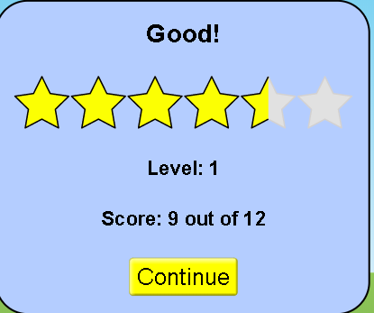
- Play Level 2
  - Explain what makes the level more difficult or different from previous levels. Do you have new strategy ideas or rules? Include screen captures from the simulation to help explain.

  - When you complete the level, capture the screen with your score and paste it below:

- Play Level 3
  - Explain what makes the level more difficult or different from previous levels. Do you have new strategy ideas or rules? Include screen captures from the simulation to help explain.

  - When you complete the level, capture the screen with your score and paste it below:

- Play Level 4
  - Explain what makes the level more difficult or different from previous levels. Do you have new strategy ideas or rules? Include screen captures from the simulation to help explain.

  - When you complete the level, capture the screen with your score and paste it below:

Final Score:
After you play all levels of the game. Copy and paste your final results like this
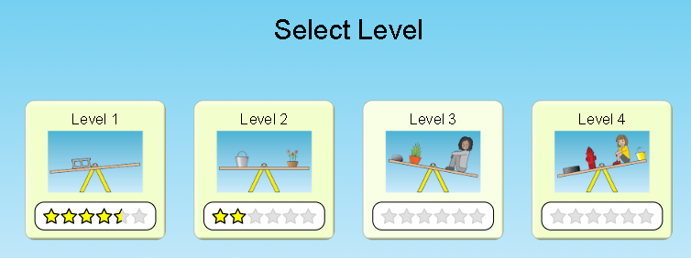
Extra challenge: For an extra challenge, you can turn on the timer and see if you can improve your skills.

