Balancing Act ‌Lab ‌
(This‌ ‌lesson‌ is designed ‌for‌ ‌a‌ ‌student‌ ‌working‌ remotely‌.)‌

This lab uses the Balancing Act simulation from PhET Interactive Simulations at University of Colorado Boulder, under the CC-BY 4.0 license.
https://phet.colorado.edu/sims/html/balancing-act/latest/balancing-act_en.html

Learning Goals: Students will be able to:
- Describe the factors that determine whether two objects will balance each other
- Predict how changing the position of a mass on the balance will affect the motion of the balance
- Use a balance to the find the masses of unknown objects

Develop your understanding: Explore the Intro screen, then explore to develop your own ideas about what determines how objects balance each other.
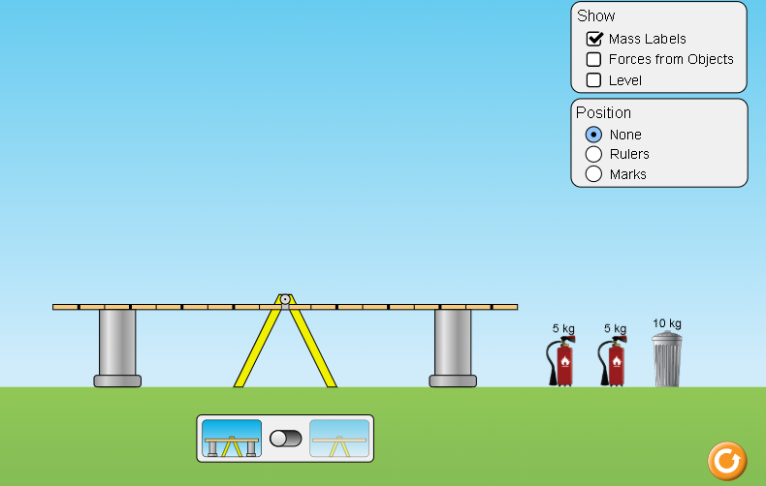

Explain your understanding: Use your own words and captured images from the simulation to show you can:

- Make two same mass objects balance in at least two different ways.
  - Place captured images here

  - Explain why it makes sense that there is more than one way to make the objects balance.

  - What tools did you use to help you and why did they help?

- Make two different mass objects balance in at least two different ways.
  - Place captured images here

  - Explain why it makes sense that there is more than one way to make the objects balance.

  - Did you use different tools? What tools did you use to help you and why did they help?

Test your understanding: Open the Balance Lab screen, use some different objects and masses to apply your ideas.
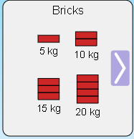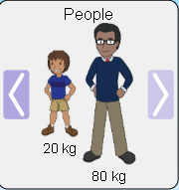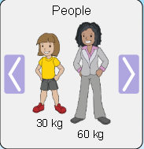
- Make two same mass objects balance in at least two different ways.
  - Place captured images here

  - How did your explanations and tool use ideas from #1 help you?

- Make two different mass objects balance in at least two different ways.
  - Place captured images here

  - How did your explanations and tool use ideas from #2 help you?

Expand your understanding: Use the Balance Lab screen, to meet these challenges.

- Balancing a single mass on one side with two other masses. Show at least two experiments.
  - Place captured images here

  - What strategies did you use? Include screen images to help your description.

- Consider this situation without using the simulation:
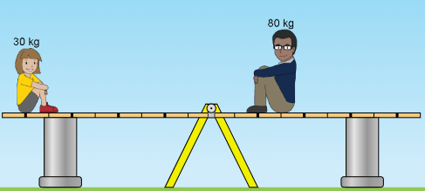
- Predict what will happen when the supports are removed and explain your reasoning.

- Predict what will happen if the 80 kg adult was further from the pivot (more right) and explain your reasoning.

- Predict what will happen if the 30 kg child was closer to the pivot (more right) and explain your reasoning.

- Test your predictions in the Balance Lab. Make notes about any ideas you have that need to be changed.

- What are some rules you could use to make predictions for other situations where masses are on a balance?

- Test your rules with some situations in the lab. Make corrections if needed, then show evidence that your rules work.

Demonstrate your Understanding

7. Select three mystery objects and determine each mass.
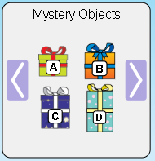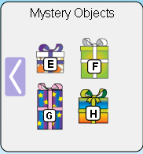
Provide screen captures for evidence and explain how you used your answers in #1-6
- answer and explain here

- answer and explain here

- answer and explain here

Balancing Act Game

Test your understanding and use the rules you have developed:
Open the full simulation Balancing Act, then open the Game screen.

- Play Level 1
  - Did you have to change your rules or do you have other ideas to make you get a better score? Include screen captures from the simulation to help explain.

  - When you complete the level 1 game, capture the screen with your score. Paste it below like this: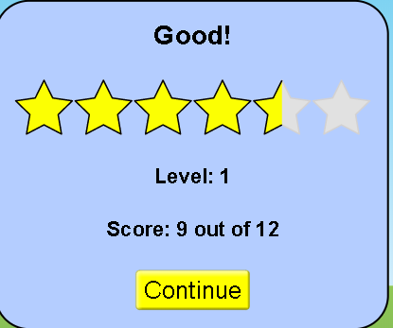
- Play Level 2
  - Explain what makes the level more difficult or different from previous levels. Do you have new strategy ideas or rules? Include screen captures from the simulation to help explain.

  - When you complete the level, capture the screen with your score and paste it below:

- Play Level 3
  - Explain what makes the level more difficult or different from previous levels. Do you have new strategy ideas or rules? Include screen captures from the simulation to help explain.

  - When you complete the level, capture the screen with your score and paste it below:

- Play Level 4
  - Explain what makes the level more difficult or different from previous levels. Do you have new strategy ideas or rules? Include screen captures from the simulation to help explain.

  - When you complete the level, capture the screen with your score and paste it below:

Final Score:
After you play all levels of the game. Copy and paste your final results like this
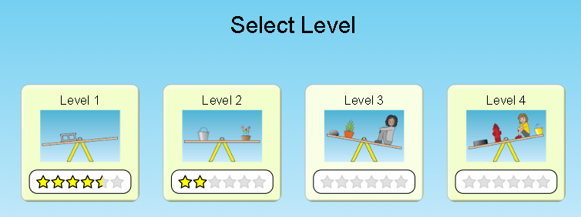
Extra challenge: For an extra challenge, you can turn on the timer and see if you can improve your skills.

