Build an Atom Game ‌

This lab uses the Build an Atom simulation from PhET Interactive Simulations at University of Colorado Boulder, under the CC-BY 4.0 license.
https://phet.colorado.edu/sims/html/build-an-atom/latest/build-an-atom_en.html

Learning Goals: Students will be able to
- Make atom models that show stable atoms or ions.
- Use given information about subatomic particles to
- Identify an element and its position on the periodic table
- Draw models of atoms
- Determine if the model is for a neutral atom or an ion.
- Predict how addition or subtraction of a proton, neutron, or electron will change the element, the charge, and the mass of their atom or ion.
- Describe all vocabulary words needed to meet the goals.
- Use a periodic symbol to tell the number of protons, neutrons, and electrons in an atom or ion.
- Draw the symbol for the element as you would see on the periodic table

Test your understanding and use the rules you wrote to play a game.
- Play Level 1of the Build an Atom game
  - Did you have to change your rules or do you have other ideas to make you get a better score? Include screen captures from the simulation to help explain.

  - When you complete the level 1 game, capture the screen with your score. Paste it below like this: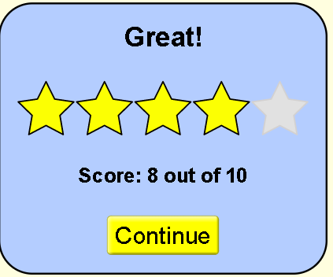
- Play Level 2 of the game
  - Explain what makes the level more difficult or different from previous levels. Do you have new strategy ideas or rules? Include screen captures from the simulation to help explain.

  - When you complete the level, capture the screen with your score and paste it below:

- Play Level 3 of the game
  - Explain what makes the level more difficult or different from previous levels. Do you have new strategy ideas or rules? Include screen captures from the simulation to help explain.

  - When you complete the level, capture the screen with your score and paste it below:

- Play Level 4 of the game
  - Explain what makes the level more difficult or different from previous levels. Do you have new strategy ideas or rules? Include screen captures from the simulation to help explain.

  - When you complete the level, capture the screen with your score and paste it below:

Final Score:
After you play all levels of the game. Copy and paste your final results like this
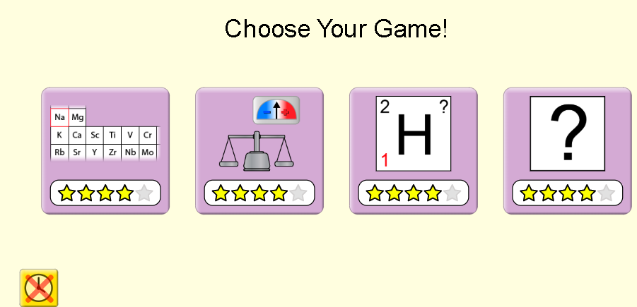
Extra challenge: For an extra challenge, you can turn on the timer and see if you can improve your skills.

