TFCPHYSICS 91F
/ 9
Lab 2
Refraction of Light
Objectives:

- Verify Snell’s Law and use it to identify an unknown material.
- Determine how intensity changes when light is refracted.

Background: How does light bend?

Light travels at different speeds in different media. As light passes at an angle from one medium to another, it changes direction at the boundary between the two media. The index of refraction of a medium, n, is the ratio of the speed of light in a vacuum, c, to its speed in the substance, v.

$$n = \frac{c}{v}$$

When light enters a medium with a higher index of refraction than the medium it is leaving, it bends toward the normal. When light enters a medium with a lower index of refraction than the medium it is leaving, it bends away from the normal. This change of direction of light at the boundary of two media is called refraction.
For any light that is traveling from one medium of index of refraction $n_{1}$, at angle of incidence $θ_{1}$, to another medium of index of refraction $n_{2}$, Snell’s law of refraction describes the angle of refraction, $θ_{2}$, experienced by the light.

$$n_{1}sinθ_{1}=n_{2}sinθ_{2}$$

In this lab, you confirm Snell’s Law by taking simple measurements. You will also investigate what happens to the intensity of the light as it refracts, and you will determine the refractive index of two unknown materials.

For this lab, you are required to submit a short lab report, containing the answers to all questions in Parts One, Two and Three. Your submission simply needs to contain the answers, data tables, graphs and sketches, similar to how you submit the assignments. You may hand write your answers and take photos of your work, or you may use Word, Google Docs etc...

You must submit a single pdf document on Canvas under ‘Assignments -> Lab 2: Refraction’.

For this lab you will be using an online simulator from the University of Colorado Boulder. Click on the link below to get to the website:

https://phet.colorado.edu/sims/html/bending-light/latest/bending-light_en.html

Once you get there, click on ‘Intro’.

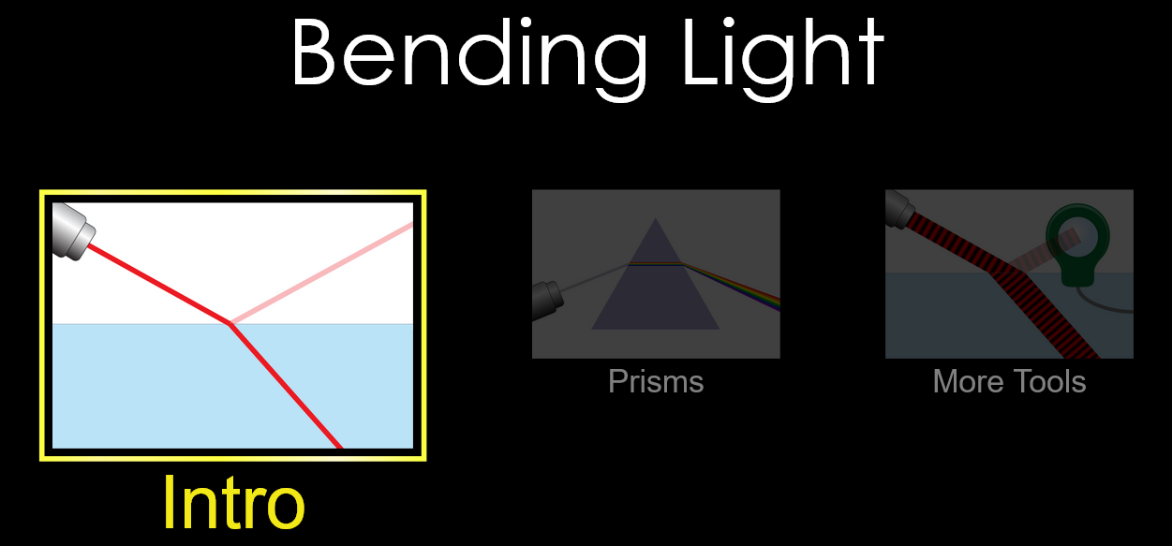

Part 1: Confirming Snell’s Law

- When the simulator window opens, you should notice a laser pointing at a 45º angle downwards to the right. Look to the right of the window and notice that the two information boxes are explaining the mediums that are shown on the screen.
What are the two mediums on the simulator window currently?

………………………………………………………………………………………………………

- Click on the RED button on the laser. What two things does the light do as it hits the surface of the water?

……………………………………………………………………………………………………
- Change the material of the second medium (where the refracted ray is) to Glass using the menu box on the bottom right.
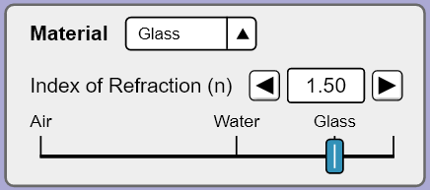
Choose the protractor tool and place the protractor over the vertical normal line so that the dotted line runs straight through zero. Set the laser (click on it and move it when the green arrows appear) to an angle of incidence $θ_{1}$, at 30°. Recall: angles are always measured from the Normal.
Ignore the reflected ray (the ray that remains in air). Using the protractor, measure the angle of refraction $θ_{2}$, of the laser and record this in Table 1.
Repeat these steps for 5 more angles of incidence of your own choosing. Record the results in Table 1 (or create a table of your own).

$$θ_{1} (°)$$ | $$θ_{2} (°)$$ | $$sinθ_{1}$$ | $$sinθ_{2}$$ | $$n_{2}$$
30
Table 1
- Calculate $sinθ_{1}$, $sinθ_{2}$ and $n_{2}$ for each of your results and add them to table 1. Keep your results to 2 or 3 significant figures.

- Compare the values for index of refraction of glass for each trial (values in last column). Is there good agreement between them? Would you conclude that index of refraction is a constant for a given medium?
……………………………………………………………………………………………………
……………………………………………………………………………………………………
……………………………………………………………………………………………………
……………………………………………………………………………………………………
……………………………………………………………………………………………………
- Determine the average value of $n_{2}$ from your results.

average $n_{2}$ = ……………………….

- Compare your calculated $n_{2}$ with the given index of refraction of the glass (1.50). Do they agree? Explain why it does or doesn’t.
……………………………………………………………………………………………………
……………………………………………………………………………………………………
……………………………………………………………………………………………………
……………………………………………………………………………………………………
……………………………………………………………………………………………………

Part 2: Further Investigation of Light Intensity

- On the bottom left side of the simulator window, you should notice that you have two tools available for you to use. Select the bottom tool that looks a bit like a magnifying glass labelled ‘Intensity’. Move the tool into the general water area.

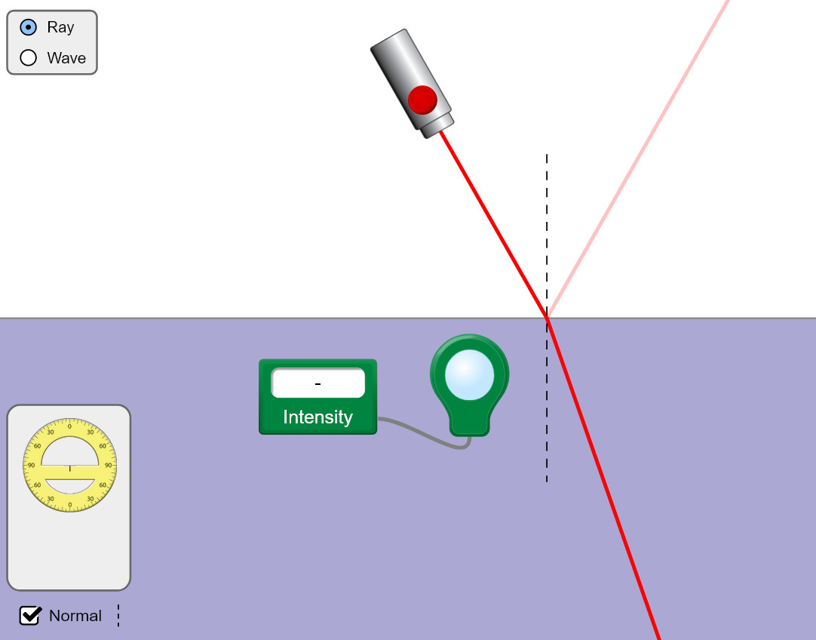

- Take the LENS and drag it directly over the light coming from the laser BEFORE it hits the surface of the water. Notice you can measure the intensity of the light when the lens is placed over the beam. It should read ‘100.00%’

- Move the lens out of the way and select the protractor tool from the toolbox. Set the laser to comes in at a 10º angle.

Using the intensity tool, measure the Intensity of Refracted Light and Intensity of Reflected Light and record these in Table 2.

Repeat these steps for 5 more angles of incidence (over a large range) of your own choosing. Record the results in Table 2 (or create a table of your own).

$$θ_{1} (°)$$ | Intensity of Refracted Light (%) | Intensity of Reflected Light (%)
10
Table 2

- Complete the sentences below to describe your observations choosing from the following – ‘increases’, ‘decreases’, ‘stays the same’:

As the angle of incidence increases, the intensity of the refracted light

…………………………

As the angle of incidence increases, the intensity of the reflected light

…………………………

As the angle of incidence changes, the total intensity (refracted + reflected)

…………………………

Part 3: Refractive Index of a Mystery Material
- Change the material of the first (incident) medium to ‘Mystery A’ and the second medium to Glass $(n_{2} = 1.50$).
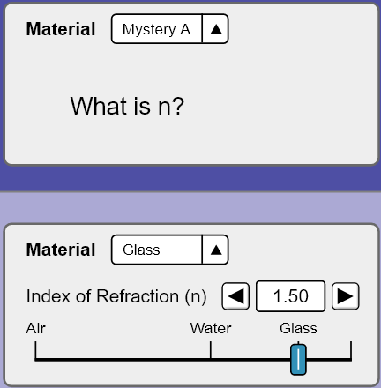
- Change the incident angle of the laser $θ_{1}$ and record six sets of results for $θ_{2}$, $sinθ_{1}$ and $sinθ_{2}$ in table 3.

$$θ_{1} (°)$$ | $$θ_{2} (°)$$ | $$sinθ_{1}$$ | $$sinθ_{2}$$
Table 3

- Plot a graph of $sinθ_{1}$ on the y-axis and $sinθ_{2}$ on the x-axis. You can do this on the figure below, on your own piece of graph paper or using Excel.
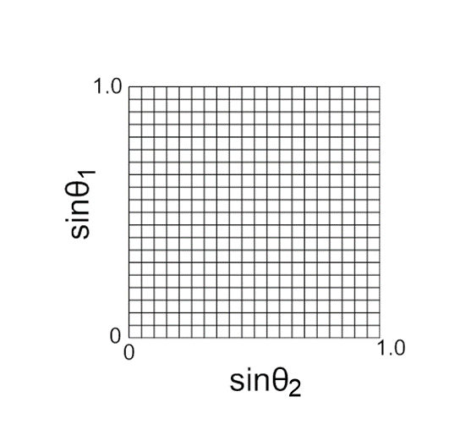

- Draw a line of best fit through your points, using a ruler. Refer to the introduction video for guidance on this.

Find the slope or ‘gradient’ of your line. The figure below give an example of how to this. Show your working.
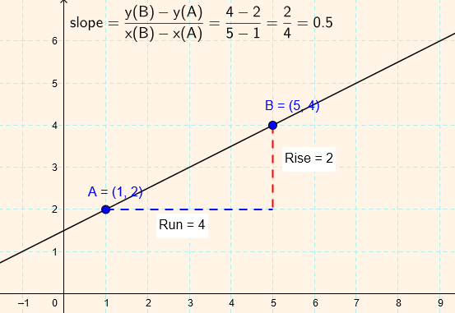

gradient = ………………………………….
- The gradient represents the ratio of $sinθ_{1}$ and $sinθ_{2}$
$$gradient= \frac{sinθ_{1}}{sinθ_{2}}$$
Using Snell’s Law ($n_{1}sinθ_{1}=n_{2}sinθ_{2}$), your gradient value, and the refractive index of glass $n_{2}$, determine the refractive index of the mystery material. Show your working.

refractive index = ……………………

- Using the table below, determine what the mystery material might be:
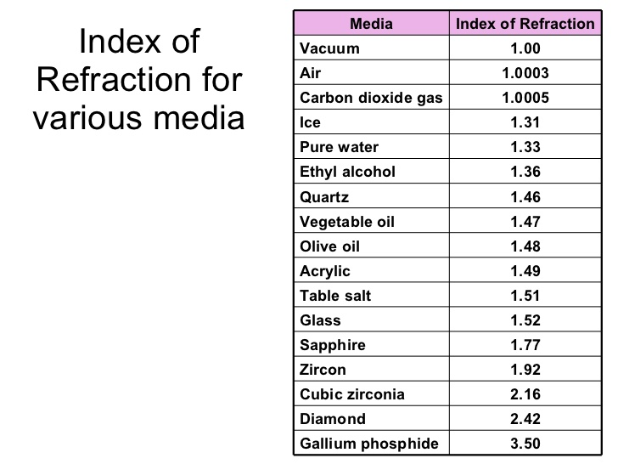

mystery material = ……………………...
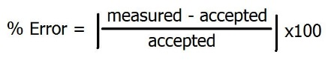
- Find the percent error of your observed value (slope) using the identified index of refraction as your accepted value. This is an indication as to how ‘good’ your result is. Show your working.

percent error = …………………………….....

