Energy Transfers Simulation
- Open the pHet simulation: Energy Forms and Changes and the “Systems” tab. Be sure to click the box with “energy symbols” so you can see the energy types
- Arrange the simulation to create each of the different configurations pictured below. Then, run the simulation for at least 30 seconds.
- Describe what occurred and then name the transformations that you saw

Configuration | Description of what occurred | Transformation
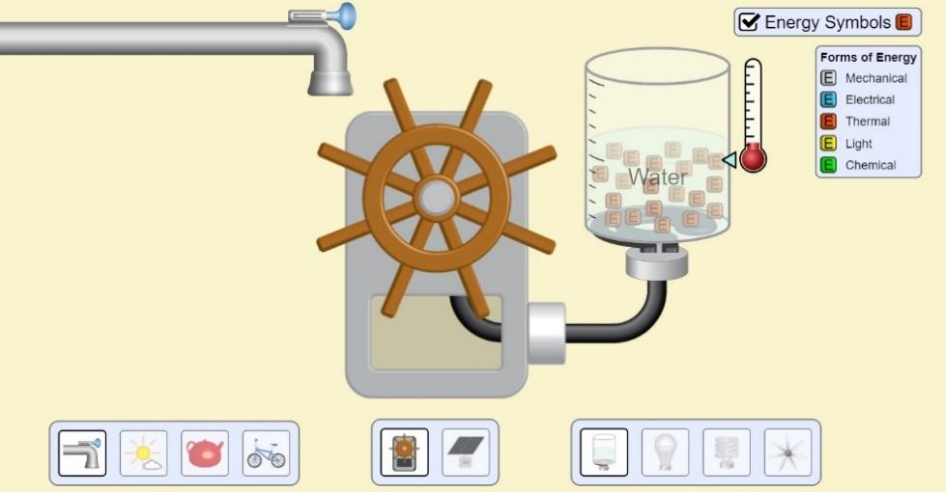  Tap on high, water wheel, heating beaker of water |  | - Mechanical → Electrical  - Electrical →
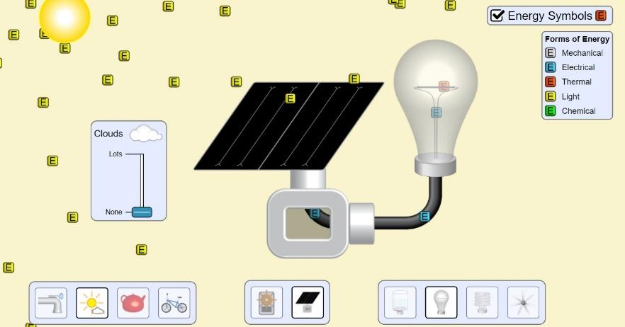
Sun without clouds, solar panel, incandescent light
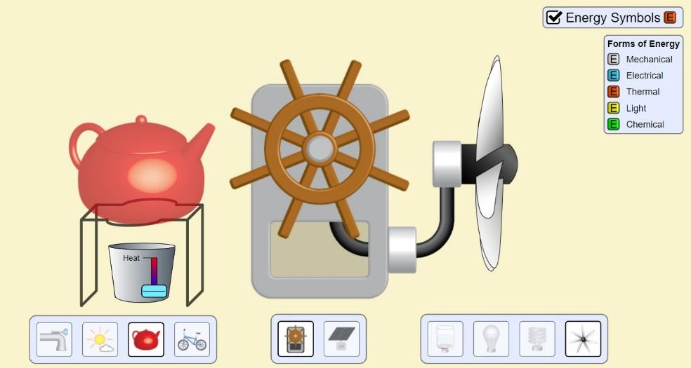
Kettle, water wheel, fan
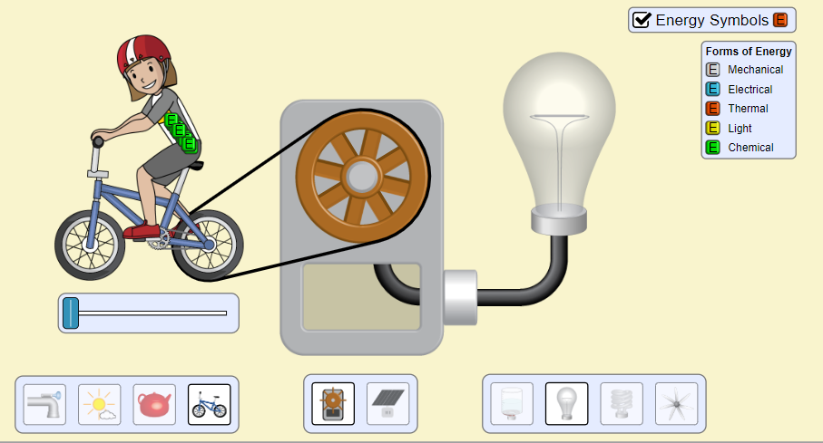
Bike, water wheel, incandescent light
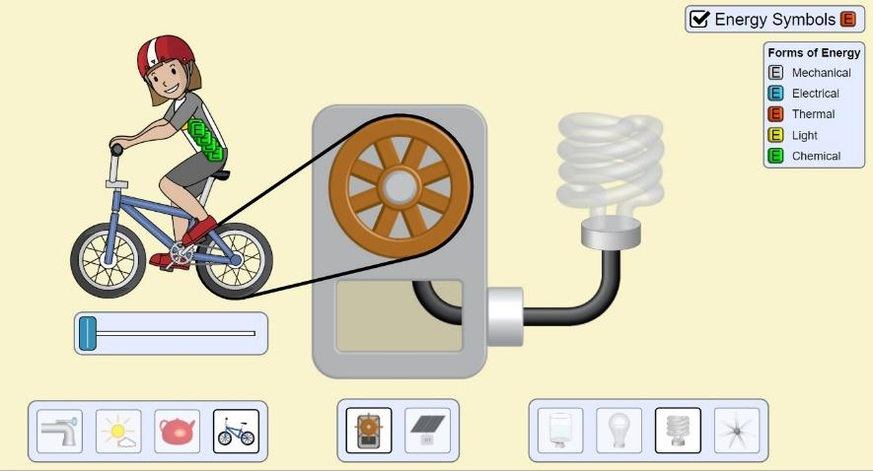
Bike, water wheel, fluorescent light

Questions:
- Which is more efficient, the incandescent or fluorescent bulb? Explain your choice
- Why did you have to feed the biker?
- There are 5 forms of energy in this simulation, but we discussed 9 in class
  - Which 4 are missing?
  - Of those 4, should any of them be included in this simulation? Explain why/why not.

