Name _____________________________________ Period _________ Date ____________

Energy Systems, Forms, & Changes Simulation

Getting Started
- Get a chromebook, open a web browser, and navigate to the following url: https://phet.colorado.edu/en/simulation/energy-forms-and-changes

You should see a page that looks like the following:
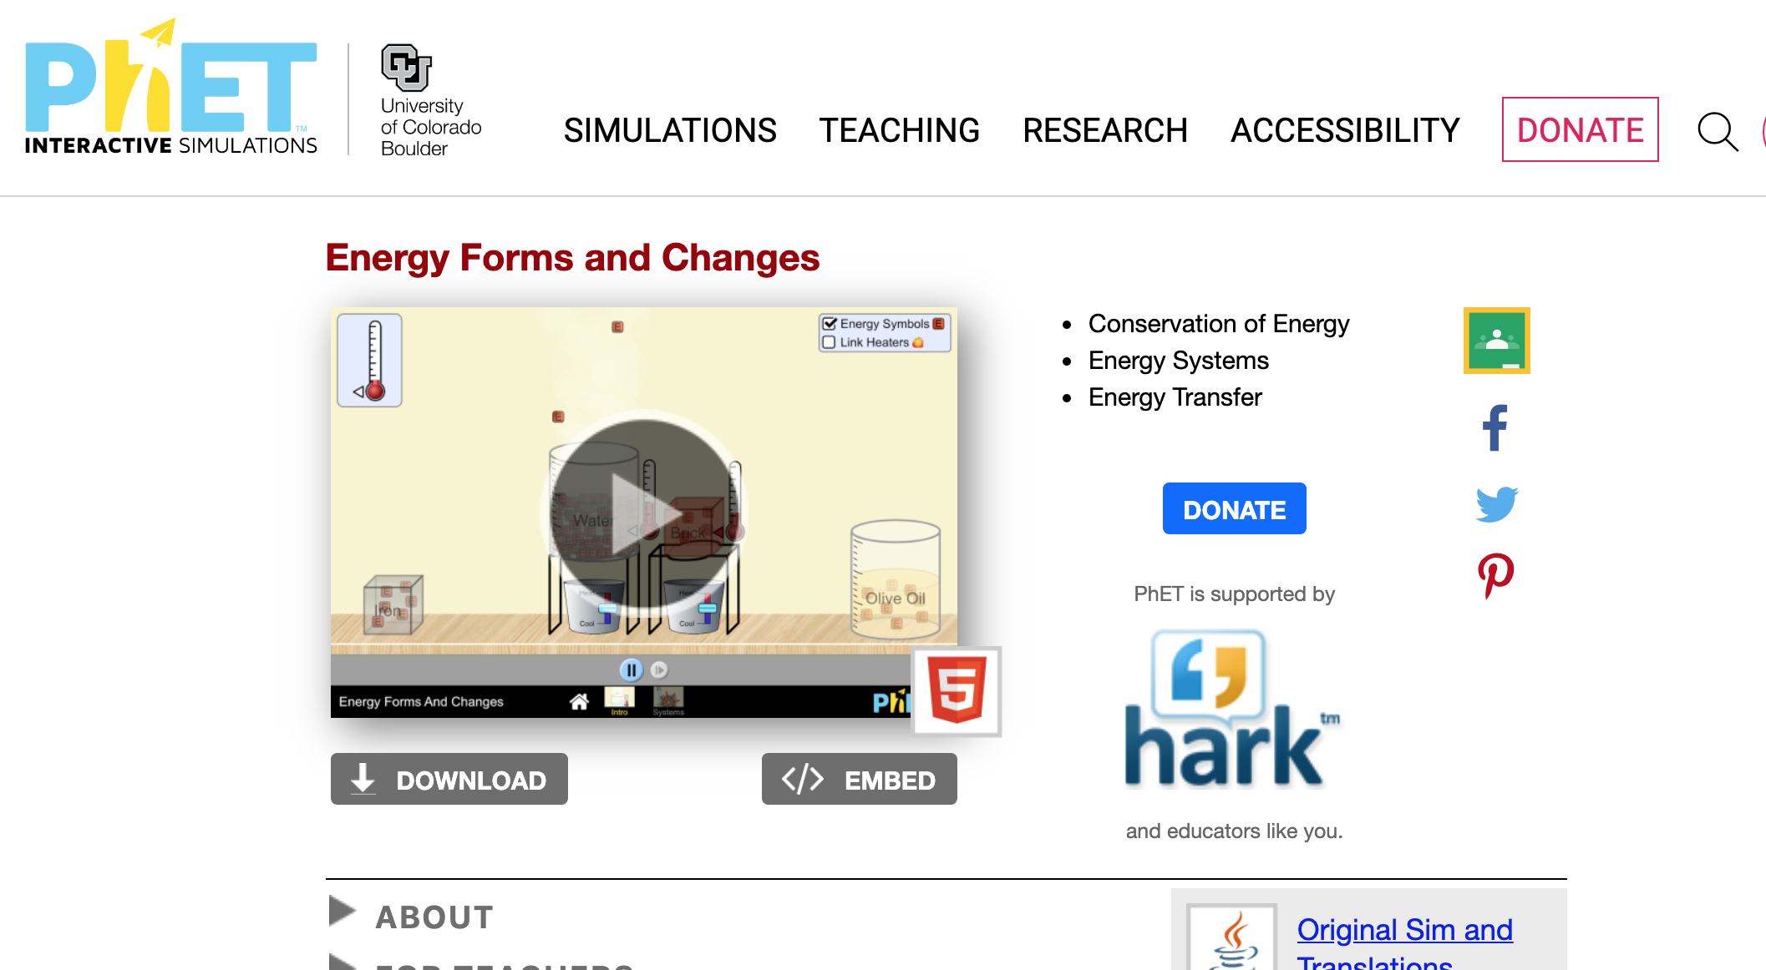

Click on the go button. You’ll be taken to a page that looks like the one below. Click on the box labeled “Systems”.

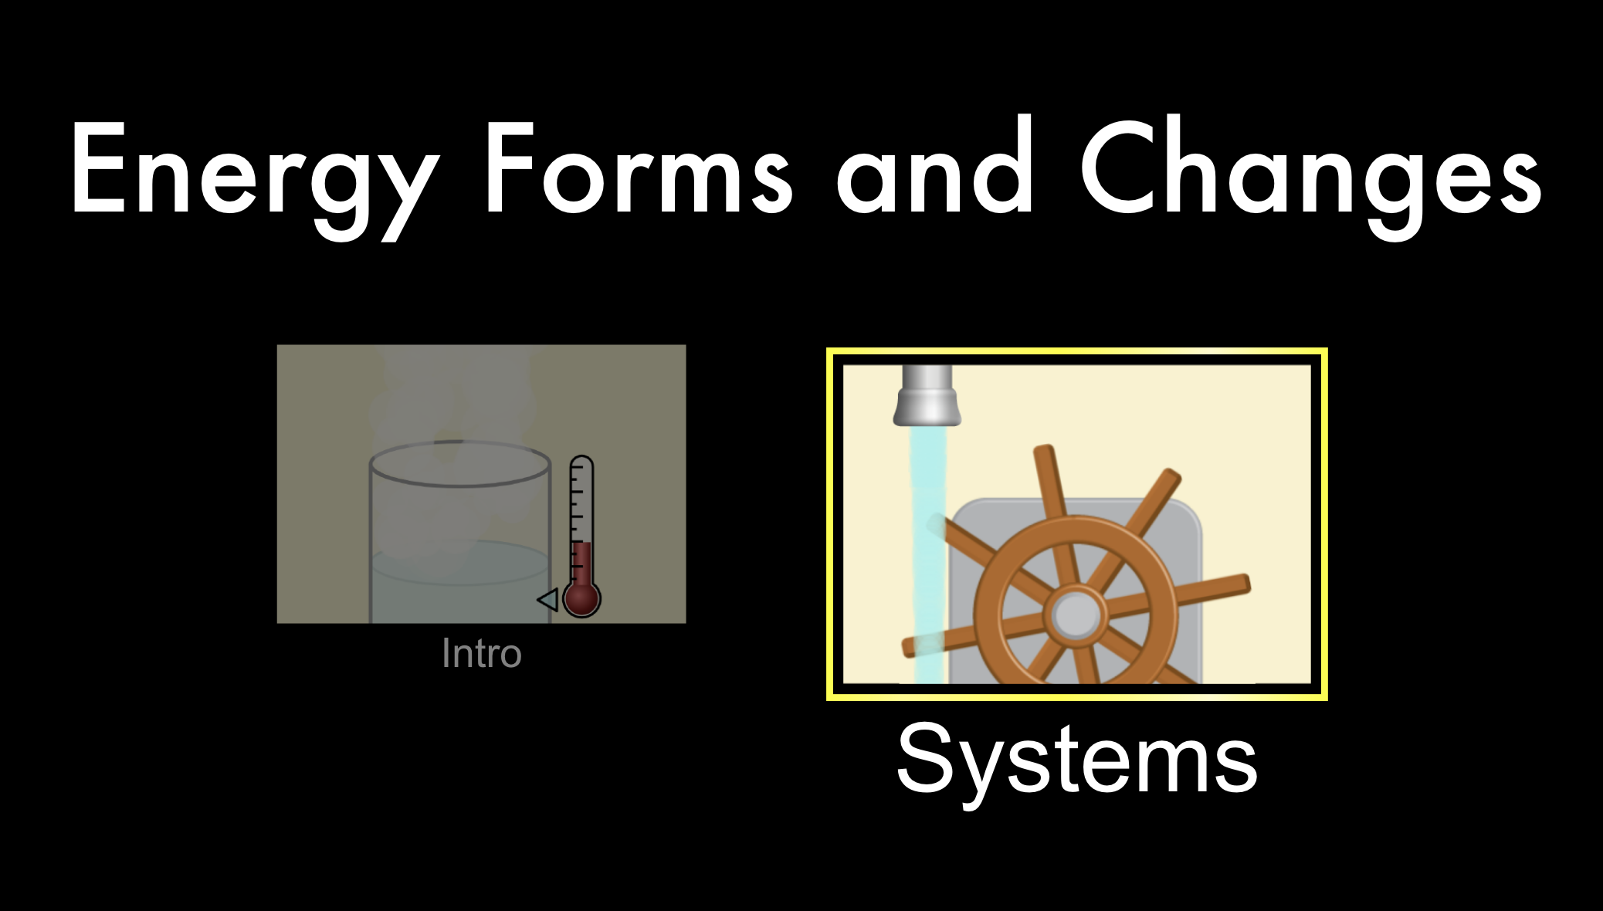

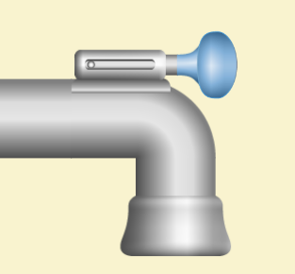
First Simulation: Faucet
You’ll be brought to simulation of a faucet, water wheel, and container of water. In the top right corner, there is an “Energy Symbols” box. DO NOT select this box yet.

Click and drag the blue faucet handle toward the right to start the flow of water. Wait for 20-30 seconds to observe what happens.

- List the objects in the system, then draw a system schema of the simulation.

Objects in the system:

System schema:

- List all the changes you see happening in the system.

- Predict what forms of energy are changing different parts of the system and explain why.

- Now select the “Energy Symbols” box. You should see little squares representing different forms of energy moving throughout the system. What are the energy transformations occurring in this system? Answer this question by filling in the spaces below.

____________________ ____________________ ____________________

- Based on what you see now, were your energy predictions correct? If not, explain why.

- Do you still agree with your original system schema? If not, make changes to your schema in #3 in a different colored pen.

Second Simulation: Biker
- In the bottom right-hand corner of the simulation, click on box with a picture of a bike. That will take you to a different simulation.

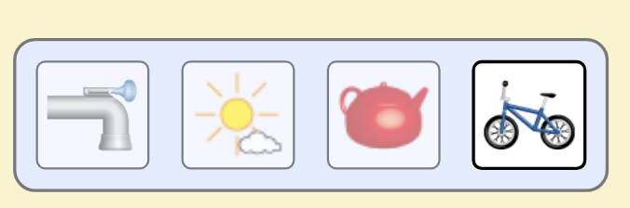

- You should now see the simulation shown below.

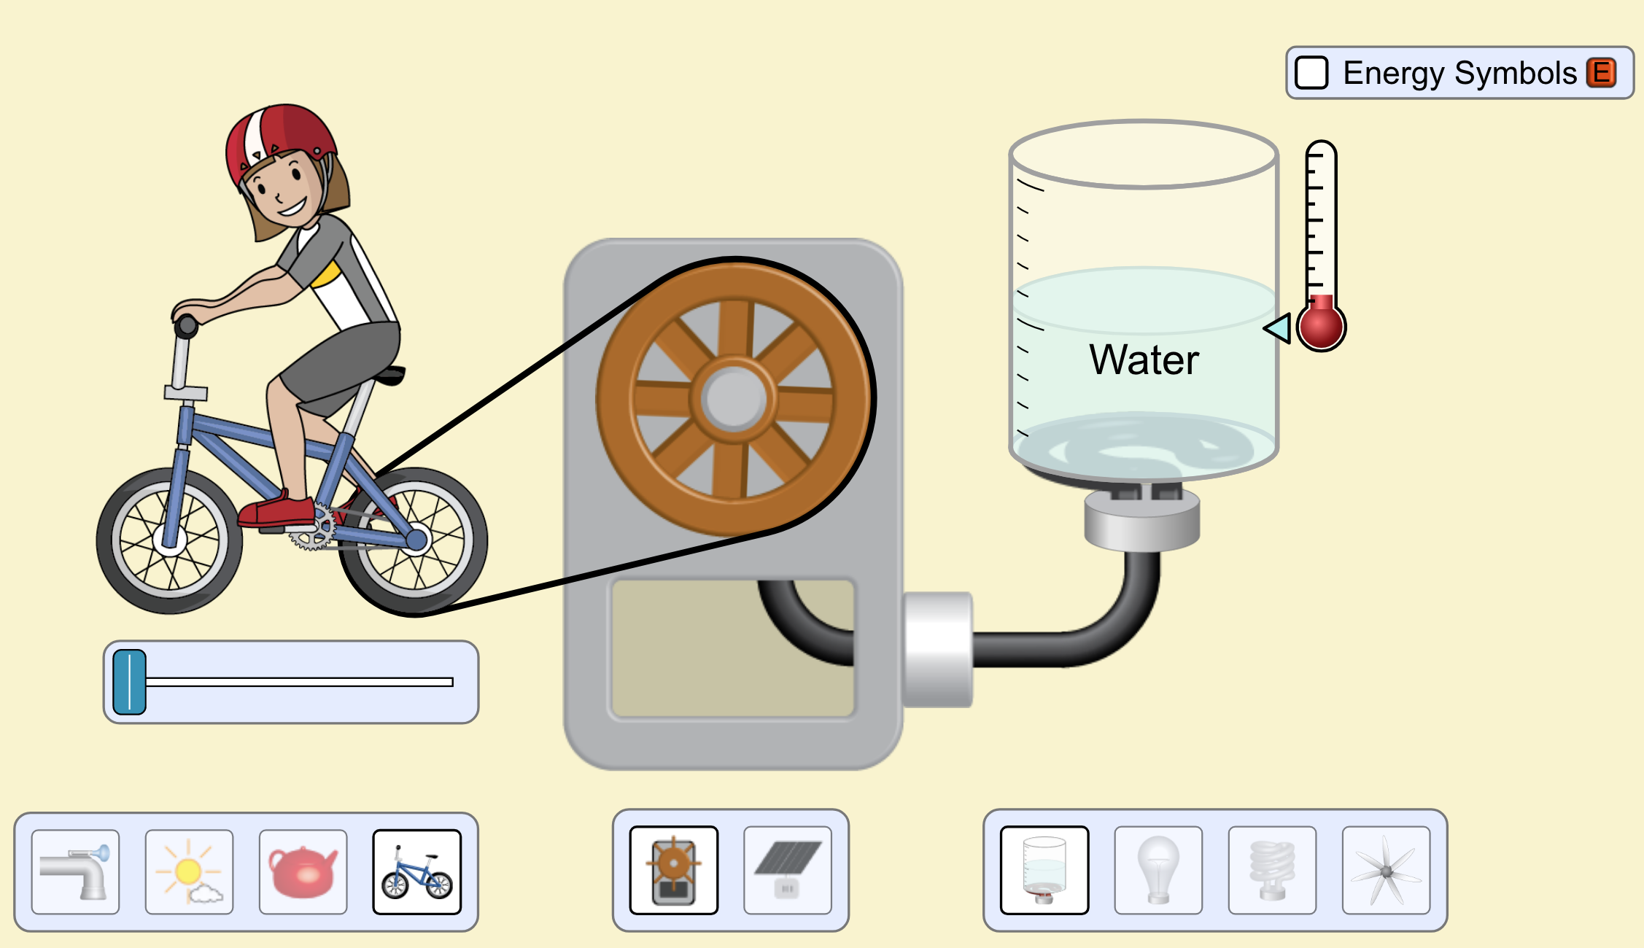

Like the previous activity, DO NOT select the “Energy Symbols” box yet. To begin the simulation, click, hold, and pull the slider under the biker toward the right. The further the slider is to the right, the faster the biker will bike.

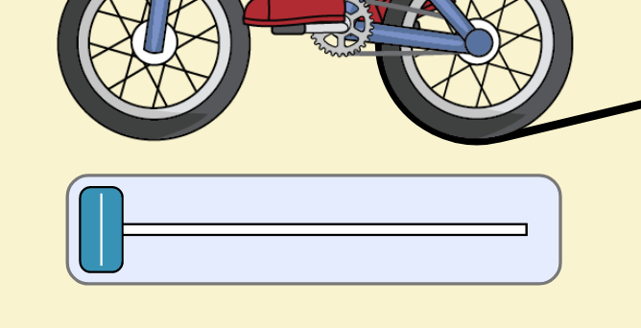

- List the objects in the system, then draw a system schema of the simulation.

Objects in the system:

System schema:

- Are there any different changes that are happening in this system compared to the first simulation with the faucet? Why or why not?

- Predict if the forms of energy changing this system are different from those in the first simulation with the faucet. Why or why not?

- Now select the “Energy Symbols” box. You should see little squares representing different forms of energy moving throughout the system. What are the energy transformations occurring in this system? Answer this question by filling in the spaces below.

____________________ ____________________ ____________________

- Based on what you see now, were your energy predictions correct? If not, explain why.

- Do you still agree with your original system schema? If not, make changes to your schema in #12 in a different colored pen.

- In both simulations you may have noticed matter and/or energy moving off your screen. What does this mean for the total energy of our system? Our surroundings?

