PHET GRAPHING LINES
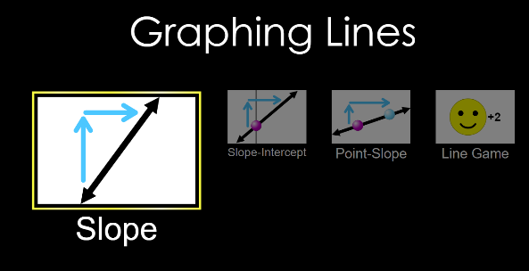
Name
Date
-Google “PHET GRAPHING LINES” or type in (https://phet.colorado.edu/en/simulation/graphing-lines)
-Click on the lab (it has a ‘play arrow’ on a picture)
-4 options should appear; slope, slope-intercept, point-slope, line graph
-SELECT SLOPE
SLOPE
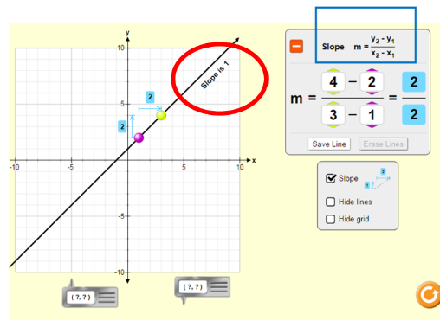
This portion will allow us to manipulate data points and find slope.
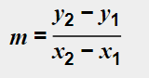
SLOPE (m) is ‘rise over run’ and your change in y value divided by your change in x. To put it in a formula, look on your screen and find

For this activity, you can change your slope several ways. You can change the numbers in the formula or move the data points on the graph. The slope will be shown next to the line.
- Play with the program until you feel comfortable with it.
- USING EITHER THE DATA POINTS OR YOUR FORMULA move and find slope for the following.
- When you have manipulated the graph to fit the data points below, record the formula and slope below
- If you can’t find slope, it is next to the slope line, circled in the image above.

- (-2, 0), (3,4) 2. (0,0), (2,1) 3. (0,0), (1,2)
m= 4 – 0 =
3- -2

4. (0,0), (-1,2) 5. (0,0), (-2,1) 6. (6,4), (-7,-3)

7. The top three problems all have + answers for slope. The bottom three all have – answers. Describe what is different about a positive slope compared to a negative slope:

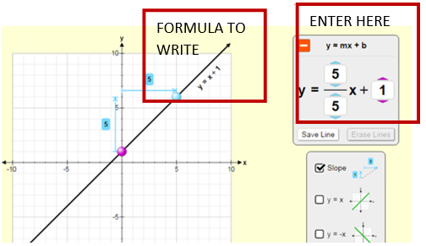
SLOPE-INTERCEPT

On the bottom of the page select ‘SLOPE-INTERCEPT’ it is found in the black bar on the bottom of the screen.
Slope intercept is ‘y=mx+b’ We will be using this A LOT this year.
m is your value for slope,
b is your value for y-intercept
When we have a specific graph we plug in the slope value for m, and the y-intercept value for b. So m and b become numbers.
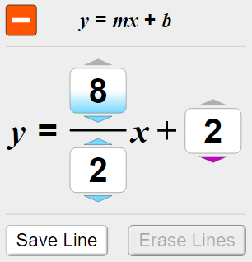
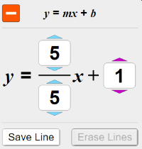
Put the requested numbers into the formula, then write the formula that appears next to the line (shown in image).
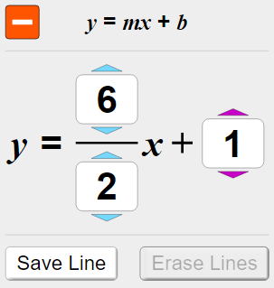
1 2 3

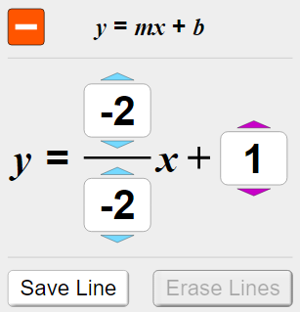
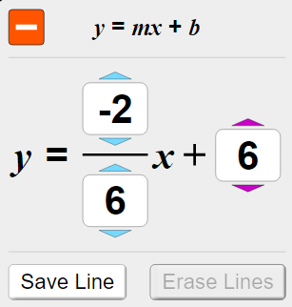
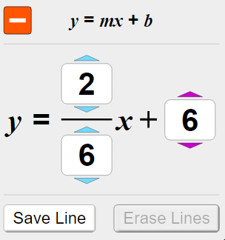
4 5 6

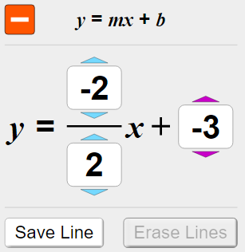
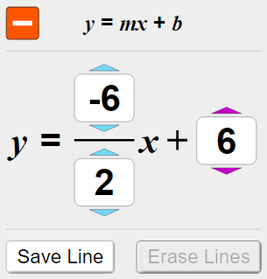
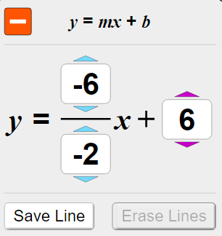
7 8 9

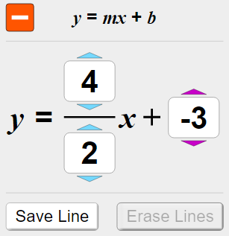
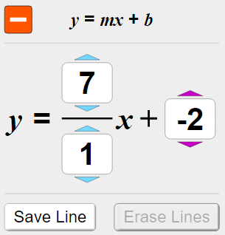
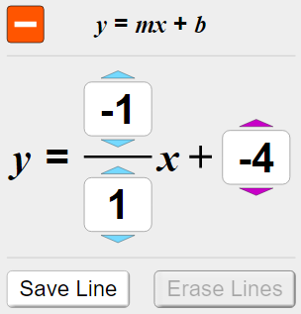
10 11 12

13. On the previous page tell me what happens when you change your y-intercept to a negative number: redo the problems if you need to see what occurs.

GRAPH FROM A MODEL
Given a model (y=mx+b)
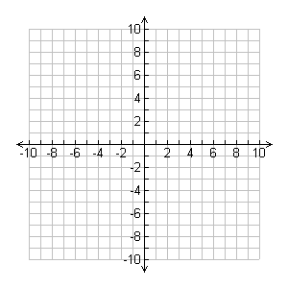
GRAPH y=3x+2 (hint, 3 is really 3/1 for slope) GRAPH y=-2x -1

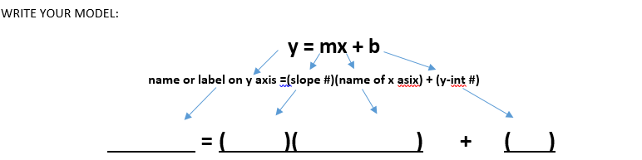
Slope intercept form allows us to create a mathematical model, this skill will be used frequently. On the graphs below plot the given points, draw a straight line, and then make your slope-intercept form formula. You may use the PHET program to help. For this activity, the y-axis and x-axis are simply labeled ‘y’ and ‘x’

DRAW THE FOLLOWING GRAPHS FROM POINTS:
METHOD 1
- To plot the point, find each point on the graph, you may move the gray box to the point(s) to help
- Manipulate the graph to get the line to pass through the two points
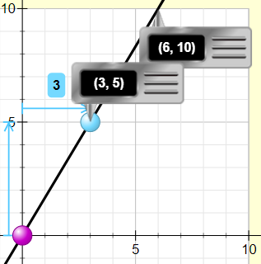
- If you used the gray boxes, move out of the way to see the y = mx + b model
METHOD 2
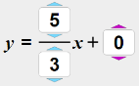
- Determine the slope and y-int values and enter it into the y = mx+ b box
METHOD 3
- Plot on paper directly; plot the points given, draw a straight line, and then make the formula
(3, 5), (6, 10) (-2,4), (-6, 6)

For the line above, write the slope intercept y=mx+b For the line above, write the slope intercept y=mx+b

USING A MODEL TO SOLVE:
In the first graph you made with the points (3, 5), (6, 10) you should have the model shown below. This is basically a formula or equation, and how we develop our own physics equations.
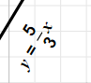
y = (5/3) x + 0 or y = (5/3)x
If you did not get this as your model for your first graph, go back and redo the two graphs above until correct.

SOLVE
- Using your model (formula) from the first graph, if x is 20 what would y be?

- Using your model for the first graph, if y is -6.5, what would x be?

- Using your model from the second graph [ data points (-2,4), (-6, 6) ], if x is --60, what would y be?

- Using your model from the second graph, if y were 405.8, what would x be?

