Masses and Springs
https://phet.colorado.edu/en/simulation/mass-spring-lab

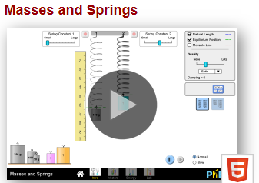
NAME DATE

Google “PHET and SPRING”

SELECT INTRO

1.Put a 100 g mass on the first and the second springs. They should hang at the same level and move similarly. Always carefully place the mass on the spring, NEVER PUSH UP OR STRETCH
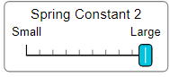
- Remove the mass from spring 2
- Increase the SPRING CONSTANT 2 (make large, aka make the spring stiffer)
- Put the 100 g mass back on the second spring

2. What happens when the stiffness (constant) of spring 2 is increased?

3. Remove the second mass, make the value small for Spring Constant 2, and place the mass back on. What happens when the stiffness (constant) is decreased?

ON THE BOTTOM, SELECT ENERGY:
SET DAMPING to NONE

- When you put the 100 g mass on the spring, describe what happens to the
  - KE as the spring bounces

  - PEgrav as the spring bounces:

  - PEelas as the spring bounces:

  - Etotal as the spring bounces:

Note we are ignoring Etherm for now

- Remove the mass, make the SPRING CONSTANT 1 Small, and place the mass back on.

  - What changes about the springs motion?

  - What changes about the springs energy bars?

- Remove the mass, make the SPRING CONSTANT 1 Large, and place the mass back on.

  - What changes about the springs motion?

  - What changes about the springs energy bars?

- RESET
- Set Damping (friction) to Zero.
- Add the 100 g mass to the Spring, it should bounce or osculate up and down.
- Slow down the time

5.Where does the spring have maximum gravitational potential energy?
6. Where is the gravitational potential energy the least?
7. Where is the kinetic energy zero (may be MORE than one point)?
8. Where is the kinetic energy the highest (at its maximum)?
9. Where is the elastic potential energy zero?
10. Where is the spring when elastic potential energy is at its maximum?
11. While bouncing does the total energy ever change?
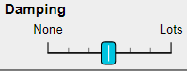
12. SET Friction (Damping) to the middle and return time to NORMAL:
a. What changes about the springs motion when Friction is on?

b. What changes about the energy bars when Friction (damping) is on?
SELECT LAB:
-PUT THE RULLER SO ZERO is lined up with the bottom of the spring.
-DAMPING to LOTS
-SELECT SLOW and DISPLACEMENT NATURAL LENGTH
-To CHANGE MASS use the sliding bar at the top. CHANGE MASS BEFORE PUTTING ON SPRING
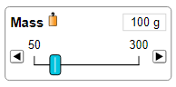
- Place the weights below on the end of spring and fill in the data table below.
-To measure, use ruler to measure from the zero on ruler to the bottom of the spring (not the mass)
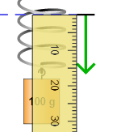
Mass (g) | Mass (kg) | FORCE of GRAVITY (N)  mass (kg) x 9.8 m/s² = weight | x = Distance spring stretched (cm)  today leave in cm, in the future we will convert
50 | 0.050 | 0.050 kg x 9.8 m/s² = 0.49 N
100 | 0.100
250 | 0.250

10. Using Hooke’s Law (Force = elasticity x distance or F=kx) calculate the spring constant value (k) of this spring. Today the unit will be in N/cm. The three k values above should be about the same value, but there could be error in your ruler reading.

Average k=

UNKNOWN:
PICK EITHER RED, or BLUE (you only need to do one!). Use your ‘k’ answer from above. Measure the displacement stretched, solve for weight (Force) in F=kx using the ‘k’ value from above based on how far the red or blue displace the spring

 | weight (N)  mass (kg) x 9.8 m/s² = weight | Distance spring stretched (cm) | k
red
blue

Color picked

Force of gravity is

Fg=(9.8)m find mass

M=

