Name _____________________________________ Period _________ Date ____________

Energy Forms & Changes Simulation
http://phet.colorado.edu/en/simulation/energy-forms-and-changes

In this simulation, you will be able to “see” several different forms of energy and the changes (transfers) that can occur between them. You are also able to work with a system where you can manipulate the energy input, observe the process of electrical energy generation and manipulate the output.

Google “Phet energy forms”. Click the first link which will load the University of Colorado’s PHET page. Click the play triangle button.

Click on the “Energy Systems” tab. We will do all of our work here. Be sure to click the “Energy Symbols” box so the different types of energy will be visible throughout the process.

Getting Familiar With The Options

Please experiment with the different source, generation and output options – there are many combinations to play with – then complete the questions below.

- Which energy sources (input) can cause the turbine (wooden wheel) to spin and generate electrical energy? ________________________________________________________________________

- Which energy sources (input) cause the solar panels to generate electrical energy? ___________

- Which energy output objects work with the turbine? ____________________________

- Which energy output objects work with the solar panels? ________________________

- What happens to the amount of electrical energy that is generated when the:
Specify “a little” or “a lot”
  - Faucet is on high? _____________________
  - Faucet is on low? _____________________
  - There are no clouds? _____________________
  - There are lots of clouds? _____________________
  - Low heat on the kettle? _____________________
  - High Heat on the kettle? _____________________
  - The girl pedals slowly? _____________________
  - The girl pedals quickly? _____________________

- Explain why the cyclist must be fed in order to continue to pedal?

_________________________________________________________________________________

- The Law of Conservation of Energy states that ___________________________________________

________________________________________________________________________________.

Exploring Energy Transfer
Set up your system as shown in the picture. Let it run for a while and then complete the sentences using the energy symbols to help you “see” the flow of the energy within each system. HINT: Make sure to check the Energy Symbols box. Use the color of the “E” boxes to know what form the energy is.

- Turbine Moved by Medium Water Flow from Faucet With A Water Heater System

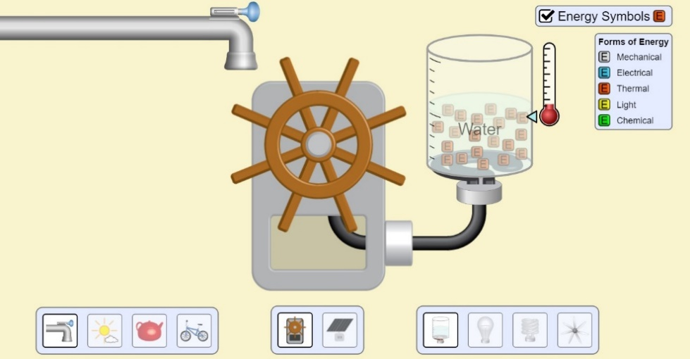
In this system, ______kinetic_______ energy from the moving water of the faucet turns the turbine. The ___________________ energy of the spinning turbine generates ___________________ energy which is transformed into ___________________ energy that causes the temperature of the water to increase. The water then becomes steam and gives off more ___________________ energy into the atmosphere.

- Solar Panel in No Cloud Cover With An Incandescent Light Bulb System

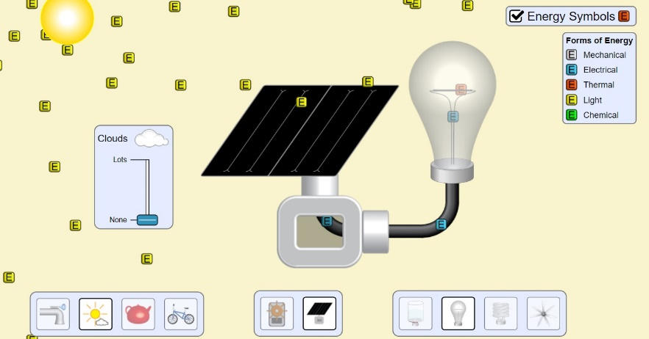

In this system, ___________________ energy from the sunlight causes the solar panel to create ___________________ energy which flows into the incandescent light bulb. In the light bulb, the ___________________ energy is transformed into two different types of energy: ___________________ energy and ___________________ energy.
- Turbine Moved by Steam from Medium Heat Kettle With A Fan

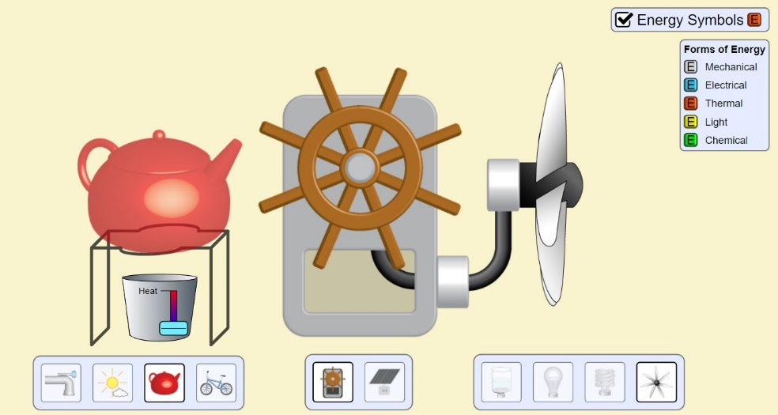

In this system, ___________________ energy from the flames of the fire transfer energy to the kettle causing the liquid to become steam. The thermal energy of the steam spins the turbine (_________________ energy) which generates ___________________ energy that is used to operate the fan. The moving electric motor and the spinning fan blades are a form of ______________________ energy. After running for a while, the fan becomes hot to the touch, and ever so often releases ___________________ energy into the air.
*Note* Another form of energy is released from the kettle. What is it? ______________

- Turbine Moved by Cyclist Pedaling at Medium Speed With A Fluorescent Light Bulb System

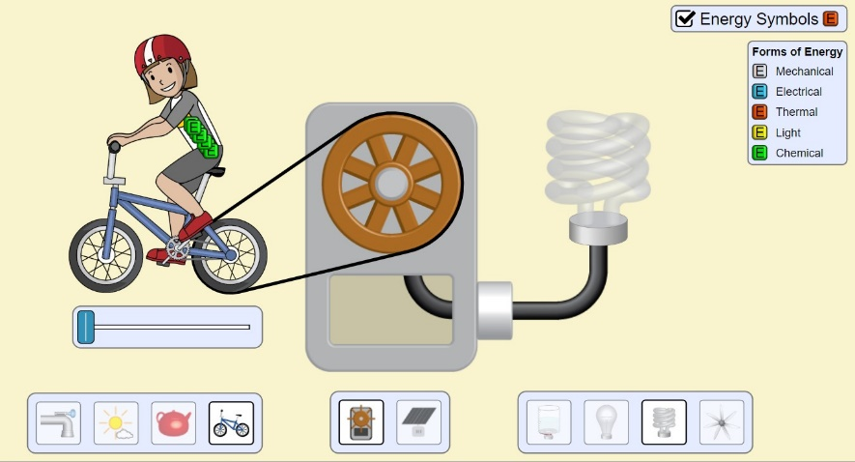

In this system, ___________________ energy from the cyclist is converted to a lot of ___________________ energy and a little bit of ___________________ energy. The ___________________ energy from the turning bicycle wheel spins the turbine which generates ___________________ energy. The fluorescent light bulb converts this energy into two new forms: a lot of ___________________ energy and very little ___________________ energy.
- Switch out the fluorescent bulb (curly one) with the incandescent bulb (rounded) and observe the energy output. What do you notice about the difference in the energy and output of these two bulbs?

________________________________________________________________________

In your opinion, which light bulb is more efficient? ______________________________

Explain how you know this. ________________________________________________

- What common form of energy (not including kinetic or potential) is not included in the “Energy Symbols” key that would normally be present in these examples?
__________________________________

- Look carefully at each of the four systems shown above. Knowing what we have discussed about energy conversions, identify (list) at least three different places where this form of energy (sound) should be “produced”.
___________________________________________________________________________________

___________________________________________________________________________________
- In the space below, explain why this simulation is a good way to illustrate the Law of Conservation of Energy. Use a specific example to support your answer.

____________________________________________________________________________________
____________________________________________________________________________________
____________________________________________________________________________________
____________________________________________________________________________________
____________________________________________________________________________________
____________________________________________________________________________________
____________________________________________________________________________________
- Application question: In Lancaster county, Pennsylvania, it is common for members of the Amish community to use wind mills to pump water from underground to fill a tank for drinking water. The wind causes the turbine blades to spin, rotating a shaft, which is transferred through some gears to operate a pump, which pumps water up from deep below the ground to fill an above ground tank. Identify the energy conversions happening at each step below.

- Wind blows (_______________________ energy)

- causing the turbine to turn, rotating shaft works pump(____________________ energy)

- Motion of water moving up from well (________________________ energy)

- Water in tank which is positioned 5 feet above the ground level ( ________________________ potential energy)

