Name: _______________________ Section (1 or 2): ______
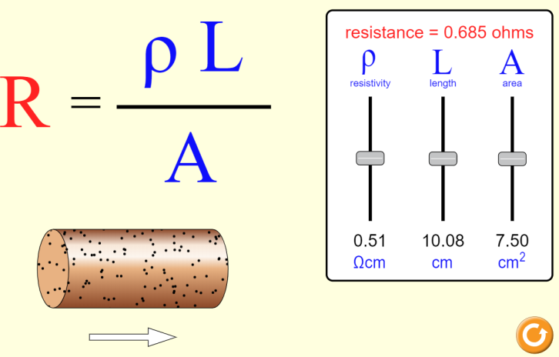
Resistor structure PhET activity

In this activity, we will explore the effects of resistivity, length, and area on resistance.

- a) Start by increasing the resistivity ρ of the wire. How does this affect the resistance, and why?

b) Now, decrease the resistivity ρ of the wire. How does this affect the resistance, and why?

- a) Increase the length L of the wire. How does this affect the resistance, and why?

b) Decrease the length L of the wire. How does this affect the resistance, and why?

- a) Increase the area A of the wire. How does this affect the resistance, and why?

b) Decrease the area A of the wire. How does this affect the resistance, and why?

- Use the simulation to create 3 different resistors, each with a resistance of 1 Ω. List the values that you used for each of the 3 resistors below, and use the equation R = ρL/A to confirm the value of each resistance.

- (Real-world application question) When buying a charging cable for your phone, describe a cable that would charge your phone the fastest.

